Our Lady of Peace Catholic Primary and Nursery School



**Year 6**

**Term: Advent 2**

**Homework Booklet**

**Welcome to your homework booklet for this half term.**



In this booklet you will find six weeks’ worth of spellings. You need to learn these spellings carefully by using the look, say, cover and write method. You can also login to your **‘Spelling Shed’** account to practise your spellings. You then have some space at the bottom of the page to put each of your spelling words into a sentence.

Your teacher will test you on your spellings each week.



Login to your **‘Times Tables Rock Stars’** account to practise your times tables!

Your teacher will test you on your times tables each week.



Login to your ‘**Bug Club’** account for online reading challenges!

**Maths for Advent Term 2**

 

Your project for this half-term is…

In our Geography lessons, we will be studying the continent of **South America.**

Your project must be about a feature of life in South America. You may choose to focus on its wildlife, landscape, people or culture. You may also decide whether to focus on a single South American country or a variety of countries.

**To be handed in: Monday 17th December 2018**

**BRAIN BUILDERS**

**Fractions**

Use common factors to simplify fractions; use common multiples to express fractions in the same denomination.

Compare and order fractions, including fractions > 1

Generate and describe linear number sequences (with fractions)

Add and subtract fractions with different denominations and mixed numbers, using the concept of equivalent fractions.

Multiply simple pairs of proper fractions, writing the answer in its simplest form [for example x = ]

Divide proper fractions by whole numbers [for example ÷ 2 = ]



Log-in to your **‘My Maths’** account and, each week, complete the activity listed in the table below.

|  |
| --- |
| Pupils should use their login details to access the MyMaths website.  They must complete all the tasks that have been assigned.  All tasks will allow the pupils to deepen their understanding of fractions, our unit of work for Advent Term 2. |

**Additional Mathematics and English Homework**

Some parents may wish their children to undertake additional maths and English homework.

The school endorses the use of ‘Workabooks’, which are carefully planned to support children with their learning, consolidate classroom teaching and provide an organisational structure which will enable pupils to manage homework effectively with positive results. Parents can order and purchase these books directly from Workabook at [http://www.workabook.co.uk](http://www.workabook.co.uk/). Parents can access the answers to each activity through the Workabook website.

Please note that Workabooks are intended for home-use only. There is no requirement for children to bring their Workabooks into school.

A sample of the Workabooks can be viewed at the main school office or alternatively more information can be found at http://www.workabook.co.uk

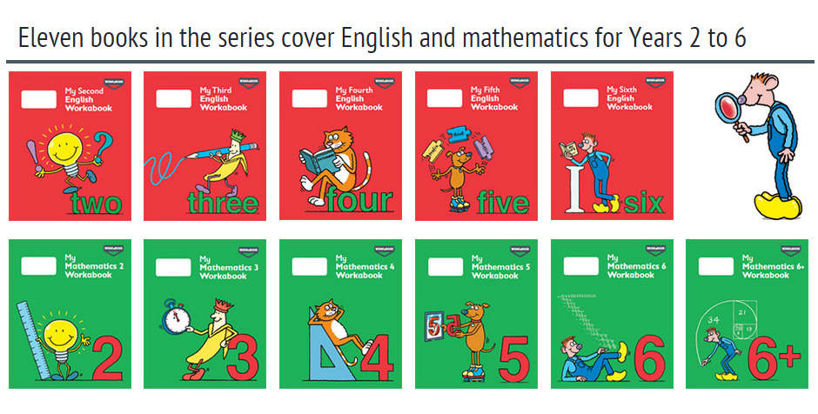

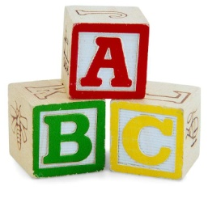[](http://www.google.co.uk/imgres?q=clipart+abc&safe=active&hl=en&biw=1280&bih=827&tbm=isch&tbnid=5R_iloF6PLG7QM:&imgrefurl=http://www.illustrationsof.com/1112353-royalty-free-abc-clipart-illustration&docid=lRG4ss-PISLCDM&imgurl=http://www.illustrationsof.com/royalty-free-abc-clipart-illustration-1112353.jpg&w=400&h=420&ei=eJTmUaPgDuzn7AaIi4DoBg&zoom=1&iact=hc&vpx=368&vpy=270&dur=1516&hovh=230&hovw=219&tx=134&ty=135&page=1&tbnh=145&tbnw=138&start=0&ndsp=38&ved=1t:429,r:26,s:0,i:163)

**Spelling practise:** Look, say, cover, write, check

**Week 1**

Spellings

|  |  |  |  |  |  |  |
| --- | --- | --- | --- | --- | --- | --- |
| **Look** | **Say** | **Cover** | **Write** | **Check** | **Write** | **Check** |
| **example** |  |  | ***exampel*** | **🗶** | ***example*** | **✓** |
| guarantee |  |  |  |  |  |  |
| harass |  |  |  |  |  |  |
| hindrance |  |  |  |  |  |  |
| identity |  |  |  |  |  |  |
| immediate |  |  |  |  |  |  |
| immediately |  |  |  |  |  |  |
| individual |  |  |  |  |  |  |
| interfere |  |  |  |  |  |  |

**Sentence practise:** Now use your spellings in a sentence.

1)__________________________________________________________

2)__________________________________________________________

3)__________________________________________________________

4)__________________________________________________________

5)__________________________________________________________

6)__________________________________________________________

7)__________________________________________________________

8)__________________________________________________________

4.

5.

6.

7.

8.

|  |  |  |  |  |  |  |
| --- | --- | --- | --- | --- | --- | --- |
| **Look** | **Say** | **Cover** | **Write** | **Check** | **Write** | **Check** |
| **example** |  |  | ***exampel*** | **🗶** | ***example*** | **✓** |
| interrupt |  |  |  |  |  |  |
| language |  |  |  |  |  |  |
| leisure |  |  |  |  |  |  |
| lightning |  |  |  |  |  |  |
| marvellous |  |  |  |  |  |  |
| mischievous |  |  |  |  |  |  |
| muscle |  |  |  |  |  |  |
| necessary |  |  |  |  |  |  |

**[](http://www.google.co.uk/imgres?q=clipart+abc&safe=active&hl=en&biw=1280&bih=827&tbm=isch&tbnid=5R_iloF6PLG7QM:&imgrefurl=http://www.illustrationsof.com/1112353-royalty-free-abc-clipart-illustration&docid=lRG4ss-PISLCDM&imgurl=http://www.illustrationsof.com/royalty-free-abc-clipart-illustration-1112353.jpg&w=400&h=420&ei=eJTmUaPgDuzn7AaIi4DoBg&zoom=1&iact=hc&vpx=368&vpy=270&dur=1516&hovh=230&hovw=219&tx=134&ty=135&page=1&tbnh=145&tbnw=138&start=0&ndsp=38&ved=1t:429,r:26,s:0,i:163)**

Spellings

**Week 2**

**Spelling practise:** Look, say, cover, write, check

**Sentence practise:** Now use your spellings in a sentence.

1)__________________________________________________________

2)__________________________________________________________

3)__________________________________________________________

4)__________________________________________________________

5)__________________________________________________________

6)__________________________________________________________

7)__________________________________________________________

8)__________________________________________________________

1

2.

3.

4.

5.

6.

7.

8.

|  |  |  |  |  |  |  |
| --- | --- | --- | --- | --- | --- | --- |
| **Look** | **Say** | **Cover** | **Write** | **Check** | **Write** | **Check** |
| **example** |  |  | ***exampel*** | **🗶** | ***example*** | **✓** |
| neighbour |  |  |  |  |  |  |
| nuisance |  |  |  |  |  |  |
| occupy |  |  |  |  |  |  |
| occur |  |  |  |  |  |  |
| opportunity |  |  |  |  |  |  |
| parliament |  |  |  |  |  |  |
| persuade |  |  |  |  |  |  |
| physical |  |  |  |  |  |  |

**[](http://www.google.co.uk/imgres?q=clipart+abc&safe=active&hl=en&biw=1280&bih=827&tbm=isch&tbnid=5R_iloF6PLG7QM:&imgrefurl=http://www.illustrationsof.com/1112353-royalty-free-abc-clipart-illustration&docid=lRG4ss-PISLCDM&imgurl=http://www.illustrationsof.com/royalty-free-abc-clipart-illustration-1112353.jpg&w=400&h=420&ei=eJTmUaPgDuzn7AaIi4DoBg&zoom=1&iact=hc&vpx=368&vpy=270&dur=1516&hovh=230&hovw=219&tx=134&ty=135&page=1&tbnh=145&tbnw=138&start=0&ndsp=38&ved=1t:429,r:26,s:0,i:163)**

Spellings

**Week 3**

**Spelling practise:** Look, say, cover, write, check

**Sentence practise:** Now use your spellings in a sentence.

1)__________________________________________________________

2)__________________________________________________________

3)__________________________________________________________

4)__________________________________________________________

5)__________________________________________________________

6)__________________________________________________________

7)__________________________________________________________

8)__________________________________________________________

1

2.

3.

4.

5.

6.

7.

8.

**[](http://www.google.co.uk/imgres?q=clipart+abc&safe=active&hl=en&biw=1280&bih=827&tbm=isch&tbnid=5R_iloF6PLG7QM:&imgrefurl=http://www.illustrationsof.com/1112353-royalty-free-abc-clipart-illustration&docid=lRG4ss-PISLCDM&imgurl=http://www.illustrationsof.com/royalty-free-abc-clipart-illustration-1112353.jpg&w=400&h=420&ei=eJTmUaPgDuzn7AaIi4DoBg&zoom=1&iact=hc&vpx=368&vpy=270&dur=1516&hovh=230&hovw=219&tx=134&ty=135&page=1&tbnh=145&tbnw=138&start=0&ndsp=38&ved=1t:429,r:26,s:0,i:163)**

**Spelling practise:** Look, say, cover, write, check

Spellings

**Week 4**

|  |  |  |  |  |  |  |
| --- | --- | --- | --- | --- | --- | --- |
| **Look** | **Say** | **Cover** | **Write** | **Check** | **Write** | **Check** |
| **example** |  |  | ***exampel*** | **🗶** | ***example*** | **✓** |
| prejudice |  |  |  |  |  |  |
| privilege |  |  |  |  |  |  |
| profession |  |  |  |  |  |  |
| programme |  |  |  |  |  |  |
| pronunciation |  |  |  |  |  |  |
| queue |  |  |  |  |  |  |
| recognise |  |  |  |  |  |  |
| recommend |  |  |  |  |  |  |

**Sentence practise:** Now use your spellings in a sentence.

1)__________________________________________________________

2)__________________________________________________________

3)__________________________________________________________

4)__________________________________________________________

5)__________________________________________________________

6)__________________________________________________________

7)__________________________________________________________

8)__________________________________________________________

2.

3.

4.

5.

6.

7.

8.

**[](http://www.google.co.uk/imgres?q=clipart+abc&safe=active&hl=en&biw=1280&bih=827&tbm=isch&tbnid=5R_iloF6PLG7QM:&imgrefurl=http://www.illustrationsof.com/1112353-royalty-free-abc-clipart-illustration&docid=lRG4ss-PISLCDM&imgurl=http://www.illustrationsof.com/royalty-free-abc-clipart-illustration-1112353.jpg&w=400&h=420&ei=eJTmUaPgDuzn7AaIi4DoBg&zoom=1&iact=hc&vpx=368&vpy=270&dur=1516&hovh=230&hovw=219&tx=134&ty=135&page=1&tbnh=145&tbnw=138&start=0&ndsp=38&ved=1t:429,r:26,s:0,i:163)**

Spellings

**Spelling practise:** Look, say, cover, write, check

**Week 5**

|  |  |  |  |  |  |  |
| --- | --- | --- | --- | --- | --- | --- |
| **Look** | **Say** | **Cover** | **Write** | **Check** | **Write** | **Check** |
| **example** |  |  | ***exampel*** | **🗶** | ***example*** | **✓** |
| relevant |  |  |  |  |  |  |
| restaurant |  |  |  |  |  |  |
| rhyme |  |  |  |  |  |  |
| rhythm |  |  |  |  |  |  |
| sacrifice |  |  |  |  |  |  |
| secretary |  |  |  |  |  |  |
| shoulder |  |  |  |  |  |  |
| signature |  |  |  |  |  |  |

**Sentence practise:** Now use your spellings in a sentence.

1)__________________________________________________________

2)__________________________________________________________

3)__________________________________________________________

4)__________________________________________________________

5)__________________________________________________________

6)__________________________________________________________

7)__________________________________________________________

8)__________________________________________________________

1

2.

3.

4.

5.

6.

7.

8.

**[](http://www.google.co.uk/imgres?q=clipart+abc&safe=active&hl=en&biw=1280&bih=827&tbm=isch&tbnid=5R_iloF6PLG7QM:&imgrefurl=http://www.illustrationsof.com/1112353-royalty-free-abc-clipart-illustration&docid=lRG4ss-PISLCDM&imgurl=http://www.illustrationsof.com/royalty-free-abc-clipart-illustration-1112353.jpg&w=400&h=420&ei=eJTmUaPgDuzn7AaIi4DoBg&zoom=1&iact=hc&vpx=368&vpy=270&dur=1516&hovh=230&hovw=219&tx=134&ty=135&page=1&tbnh=145&tbnw=138&start=0&ndsp=38&ved=1t:429,r:26,s:0,i:163)**

**Week 6**

Spellings 

**Spelling practise:** Look, say, cover, write, check

|  |  |  |  |  |  |  |
| --- | --- | --- | --- | --- | --- | --- |
| **Look** | **Say** | **Cover** | **Write** | **Check** | **Write** | **Check** |
| **example** |  |  | ***exampel*** | **🗶** | ***example*** | **✓** |
| sincere |  |  |  |  |  |  |
| sincerely |  |  |  |  |  |  |
| soldier |  |  |  |  |  |  |
| stomach |  |  |  |  |  |  |
| sufficient |  |  |  |  |  |  |
| suggest |  |  |  |  |  |  |
| symbol |  |  |  |  |  |  |
| system |  |  |  |  |  |  |

**Sentence practise:** Now use your spellings in a sentence.

1)__________________________________________________________

2)__________________________________________________________

3)__________________________________________________________

4)__________________________________________________________

5)__________________________________________________________

6)__________________________________________________________

7)__________________________________________________________

8)__________________________________________________________

2.

3.

4.

5.

6.

7.

8.