4Th April 2019

Dear Parent/Carer,

Fruit Club – K.S.2. pupils only.
K.S.1. pupils are entitled to receive free fruit.

If you would like your child to have fresh fruit at break time and join the fruit club, please complete the slip below and return to the school office by Tuesday 30th April 2019.

The cost for this term remains unchanged at £10.

Cheques should be made payable to Our Lady of Peace Primary and Nursery School. Please write your child’s name, class and fruit club on the reverse of the cheque.

This payment will cover the cost of the fruit until Friday 19th July 2019.

If you wish to provide your child with your own fruit, then this is, of course, acceptable.

Yours sincerely,
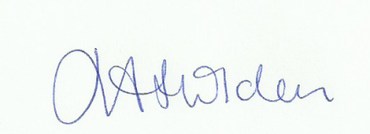
Mrs J. Holden
Deputy Headteacher

To: SCHOOL OFFICE

FRESH FRUIT CLUB –LENTEN TERM

Child’s Name:___________________________________ Class__________________

I would like my child to have fresh fruit at break time. I enclose £10 for the term.

Signed (parent)__________________________________________________________

