**Our Lady of Peace Catholic Primary and Nursery School**



**Year 3 2020**

**Term: Spring 1**

**Homework Booklet**

**Welcome to your homework booklet for this half term.**



In this booklet you will find six weeks’ worth of spellings. You need to learn these spellings carefully by using the look, say, cover and write method. You can also login to your **‘Spelling Shed’** account to practise your spellings. You then have some space at the bottom of the page to put each of your spelling words into a sentence.

Your teacher will test you on your spellings each week.

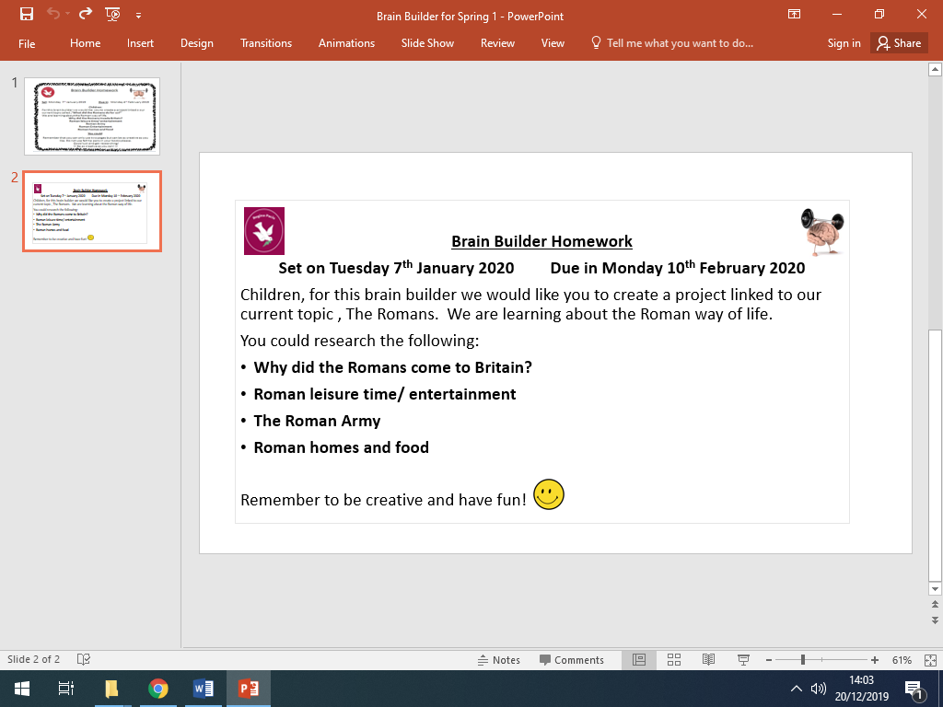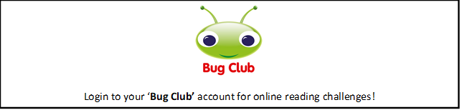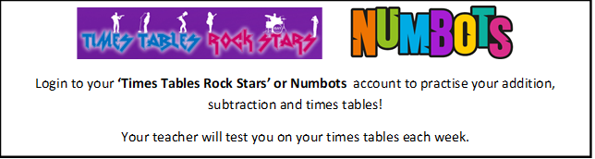

**BRAIN BUILDERS**

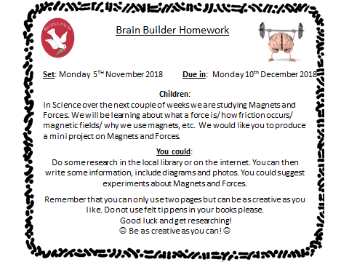**Maths for Spring 1**

Written multiplication and division: Multiply numbers between 10 and 25 by 1-digit numbers using the grid method; divide multiples of 10 by 1-digit numbers using known times tables facts; see the relation between multiplication and division

Mental addition and Subtraction: Use counting up as a strategy to perform mental subtraction; subtract pounds and pence from five pounds; use counting up as a strategy to perform mental subtraction of amounts of money; subtract pounds and pence from ten pounds.

Fractions: Identify 1/2s, 1/3s, 1/4s, 1/6s, and 1/8s; realise how many of each make a whole; find equivalent fractions; place fractions on a 0 to 1 line; find fractions of amounts

Measurement:

Length and perimeter measure, compare, add and subtract: lengths (m/ cm/mm); mass (kg/g); volume/capacity (l/ml). Measure the perimeter of simple 2D shapes.

Problem Solving: Within each of the strands above, the children will continue to develop their problem solving skills.



Log-in to your **‘My Maths’** account and, each week, complete any activities provided.

Every week, we will be testing the children on the following times tables.

|  |  |  |  |  |  |
| --- | --- | --- | --- | --- | --- |
| Week 1 | Week 2 | Week 3 | Week 4 | Week 5 | Week 6 |
| 3X  Times tables | 4x,  Times tables | 8x  Times tables | 3 & 4x,  Times tables | 4 & 8  Times tables | 3, 4 and 8  Times tables |

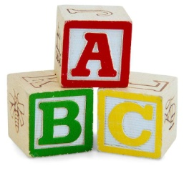[](http://www.google.co.uk/imgres?q=clipart+abc&safe=active&hl=en&biw=1280&bih=827&tbm=isch&tbnid=5R_iloF6PLG7QM:&imgrefurl=http://www.illustrationsof.com/1112353-royalty-free-abc-clipart-illustration&docid=lRG4ss-PISLCDM&imgurl=http://www.illustrationsof.com/royalty-free-abc-clipart-illustration-1112353.jpg&w=400&h=420&ei=eJTmUaPgDuzn7AaIi4DoBg&zoom=1&iact=hc&vpx=368&vpy=270&dur=1516&hovh=230&hovw=219&tx=134&ty=135&page=1&tbnh=145&tbnw=138&start=0&ndsp=38&ved=1t:429,r:26,s:0,i:163)

**Spelling practise:** Look, say, cover, write, check

**Week 1**

Spellings

|  |  |  |  |  |  |  |
| --- | --- | --- | --- | --- | --- | --- |
| **Look** | **Say** | **Cover** | **Write** | **Check** | **Write** | **Check** |
| **example** |  |  | ***example*** | **🗶** | ***example*** | **✓** |
| myth |  |  |  |  |  |  |
| gym |  |  |  |  |  |  |
| Egypt |  |  |  |  |  |  |
| pyramid |  |  |  |  |  |  |
| mystery |  |  |  |  |  |  |
| hymn |  |  |  |  |  |  |
| system |  |  |  |  |  |  |
| symbol |  |  |  |  |  |  |

**Sentence practise:** Now use your spellings in a sentence.

1)__________________________________________________________

2)__________________________________________________________

3)__________________________________________________________

4)__________________________________________________________

5)__________________________________________________________

6)__________________________________________________________

7)__________________________________________________________

8)__________________________________________________________

4.

5.

6.

7.

8.

|  |  |  |  |  |  |  |
| --- | --- | --- | --- | --- | --- | --- |
| **Look** | **Say** | **Cover** | **Write** | **Check** | **Write** | **Check** |
| **example** |  |  | ***example*** | **🗶** | ***example*** | **✓** |
| gardener |  |  |  |  |  |  |
| gardening |  |  |  |  |  |  |
| limited |  |  |  |  |  |  |
| limiting |  |  |  |  |  |  |
| offering |  |  |  |  |  |  |
| offered |  |  |  |  |  |  |
| benefited |  |  |  |  |  |  |
| benefiting |  |  |  |  |  |  |

**[](http://www.google.co.uk/imgres?q=clipart+abc&safe=active&hl=en&biw=1280&bih=827&tbm=isch&tbnid=5R_iloF6PLG7QM:&imgrefurl=http://www.illustrationsof.com/1112353-royalty-free-abc-clipart-illustration&docid=lRG4ss-PISLCDM&imgurl=http://www.illustrationsof.com/royalty-free-abc-clipart-illustration-1112353.jpg&w=400&h=420&ei=eJTmUaPgDuzn7AaIi4DoBg&zoom=1&iact=hc&vpx=368&vpy=270&dur=1516&hovh=230&hovw=219&tx=134&ty=135&page=1&tbnh=145&tbnw=138&start=0&ndsp=38&ved=1t:429,r:26,s:0,i:163)**

Spellings

**Week 2**

**Spelling practise:** Look, say, cover, write, check

**Sentence practise:** Now use your spellings in a sentence.

1)__________________________________________________________

2)__________________________________________________________

3)__________________________________________________________

4)__________________________________________________________

5)__________________________________________________________

6)__________________________________________________________

7)__________________________________________________________

8)__________________________________________________________

1

2.

3.

4.

5.

6.

7.

8.

|  |  |  |  |  |  |  |
| --- | --- | --- | --- | --- | --- | --- |
| **Look** | **Say** | **Cover** | **Write** | **Check** | **Write** | **Check** |
| **example** |  |  | ***example*** | **🗶** | ***example*** | **✓** |
| forgetting |  |  |  |  |  |  |
| forgotten |  |  |  |  |  |  |
| beginning |  |  |  |  |  |  |
| beginner |  |  |  |  |  |  |
| preferred |  |  |  |  |  |  |
| preferring |  |  |  |  |  |  |
| occurred |  |  |  |  |  |  |
| occurring |  |  |  |  |  |  |

**[](http://www.google.co.uk/imgres?q=clipart+abc&safe=active&hl=en&biw=1280&bih=827&tbm=isch&tbnid=5R_iloF6PLG7QM:&imgrefurl=http://www.illustrationsof.com/1112353-royalty-free-abc-clipart-illustration&docid=lRG4ss-PISLCDM&imgurl=http://www.illustrationsof.com/royalty-free-abc-clipart-illustration-1112353.jpg&w=400&h=420&ei=eJTmUaPgDuzn7AaIi4DoBg&zoom=1&iact=hc&vpx=368&vpy=270&dur=1516&hovh=230&hovw=219&tx=134&ty=135&page=1&tbnh=145&tbnw=138&start=0&ndsp=38&ved=1t:429,r:26,s:0,i:163)**

Spellings

**Week 3**

**Spelling practise:** Look, say, cover, write, check

**Sentence practise:** Now use your spellings in a sentence.

1)__________________________________________________________

2)__________________________________________________________

3)__________________________________________________________

4)__________________________________________________________

5)__________________________________________________________

6)__________________________________________________________

7)__________________________________________________________

8)__________________________________________________________

1

2.

3.

4.

5.

6.

7.

8.

**[](http://www.google.co.uk/imgres?q=clipart+abc&safe=active&hl=en&biw=1280&bih=827&tbm=isch&tbnid=5R_iloF6PLG7QM:&imgrefurl=http://www.illustrationsof.com/1112353-royalty-free-abc-clipart-illustration&docid=lRG4ss-PISLCDM&imgurl=http://www.illustrationsof.com/royalty-free-abc-clipart-illustration-1112353.jpg&w=400&h=420&ei=eJTmUaPgDuzn7AaIi4DoBg&zoom=1&iact=hc&vpx=368&vpy=270&dur=1516&hovh=230&hovw=219&tx=134&ty=135&page=1&tbnh=145&tbnw=138&start=0&ndsp=38&ved=1t:429,r:26,s:0,i:163)**

**Spelling practise:** Look, say, cover, write, check

Spellings

**Week 4**

|  |  |  |  |  |  |  |
| --- | --- | --- | --- | --- | --- | --- |
| **Look** | **Say** | **Cover** | **Write** | **Check** | **Write** | **Check** |
| **example** |  |  | ***example*** | **🗶** | ***example*** | **✓** |
| misspell |  |  |  |  |  |  |
| mislead |  |  |  |  |  |  |
| mistreat |  |  |  |  |  |  |
| misbehave |  |  |  |  |  |  |
| mistrust |  |  |  |  |  |  |
| misprint |  |  |  |  |  |  |
| misuse |  |  |  |  |  |  |
| misplace |  |  |  |  |  |  |

**Sentence practise:** Now use your spellings in a sentence.

1)__________________________________________________________

2)__________________________________________________________

3)__________________________________________________________

4)__________________________________________________________

5)__________________________________________________________

6)__________________________________________________________

7)__________________________________________________________

8)__________________________________________________________

2.

3.

4.

5.

6.

7.

8.

**[](http://www.google.co.uk/imgres?q=clipart+abc&safe=active&hl=en&biw=1280&bih=827&tbm=isch&tbnid=5R_iloF6PLG7QM:&imgrefurl=http://www.illustrationsof.com/1112353-royalty-free-abc-clipart-illustration&docid=lRG4ss-PISLCDM&imgurl=http://www.illustrationsof.com/royalty-free-abc-clipart-illustration-1112353.jpg&w=400&h=420&ei=eJTmUaPgDuzn7AaIi4DoBg&zoom=1&iact=hc&vpx=368&vpy=270&dur=1516&hovh=230&hovw=219&tx=134&ty=135&page=1&tbnh=145&tbnw=138&start=0&ndsp=38&ved=1t:429,r:26,s:0,i:163)**

**Week 5**

|  |  |  |  |  |  |  |
| --- | --- | --- | --- | --- | --- | --- |
| **Look** | **Say** | **Cover** | **Write** | **Check** | **Write** | **Check** |
| **example** |  |  | ***example*** | **🗶** | ***example*** | **✓** |
| dislike |  |  |  |  |  |  |
| disobey |  |  |  |  |  |  |
| discolour |  |  |  |  |  |  |
| discover |  |  |  |  |  |  |
| disappear |  |  |  |  |  |  |
| dishonest |  |  |  |  |  |  |
| disallow |  |  |  |  |  |  |
| disbelieve |  |  |  |  |  |  |

**Spelling practise:** Look, say, cover, write, check

Spellings

**Sentence practise:** Now use your spellings in a sentence.

1)__________________________________________________________

2)__________________________________________________________

3)__________________________________________________________

4)__________________________________________________________

5)__________________________________________________________

6)__________________________________________________________

7)__________________________________________________________

8)__________________________________________________________

1

2.

3.

4.

5.

6.

7.

8.

**[](http://www.google.co.uk/imgres?q=clipart+abc&safe=active&hl=en&biw=1280&bih=827&tbm=isch&tbnid=5R_iloF6PLG7QM:&imgrefurl=http://www.illustrationsof.com/1112353-royalty-free-abc-clipart-illustration&docid=lRG4ss-PISLCDM&imgurl=http://www.illustrationsof.com/royalty-free-abc-clipart-illustration-1112353.jpg&w=400&h=420&ei=eJTmUaPgDuzn7AaIi4DoBg&zoom=1&iact=hc&vpx=368&vpy=270&dur=1516&hovh=230&hovw=219&tx=134&ty=135&page=1&tbnh=145&tbnw=138&start=0&ndsp=38&ved=1t:429,r:26,s:0,i:163)**

**Week 6**

Spellings 

**Spelling practise:** Look, say, cover, write, check

|  |  |  |  |  |  |  |
| --- | --- | --- | --- | --- | --- | --- |
| **Look** | **Say** | **Cover** | **Write** | **Check** | **Write** | **Check** |
| **example** |  |  | ***example*** | **🗶** | ***example*** | **✓** |
| scheme |  |  |  |  |  |  |
| chorus |  |  |  |  |  |  |
| echo |  |  |  |  |  |  |
| character |  |  |  |  |  |  |
| ache |  |  |  |  |  |  |
| chaos |  |  |  |  |  |  |
| stomach |  |  |  |  |  |  |
| chemistry |  |  |  |  |  |  |

**Sentence practise:** Now use your spellings in a sentence.

1)__________________________________________________________

2)__________________________________________________________

3)__________________________________________________________

4)__________________________________________________________

5)__________________________________________________________

6)__________________________________________________________

7)__________________________________________________________

8)__________________________________________________________

2.

3.

4.

5.

6.

7.

8.