Our Lady of Peace Catholic Primary and
Nursery School

'With Christ in our hearts, together we grow'.

Complaints Policy & Procedure

By order of the Governing Body of Our Lady of Peace Catholic Primary and Nursery School

This policy was implemented April 2016
COMPLAINTS POLICY AND PROCEDURE

Introduction

The governors of Our Lady of Peace Catholic Primary and Nursery School are committed to ensuring that the highest standards are maintained at the school both in the provision of education to pupils and in every other aspect of the running of the school. A complaints procedure is an important part of the management of a well-run school allowing parents and others the opportunity to voice any concerns they may have through appropriate channels. This policy explains the procedure which has been adopted by the governing body to ensure a timely, systematic and fair approach to the resolution of such concerns.

We recognise the need to be clear about the difference between a concern and a complaint. Taking informal concerns seriously at the earliest stage reduces the numbers that develop into formal complaints.
We aim to ensure that concerns are handled, if at all possible, without the need for formal procedures. Our formal complaints procedure is only necessary if efforts to resolve the concern informally are unsuccessful. In most cases, a class teacher or an individual delivering the service will receive the first approach. Our staff development process includes training to help staff resolve issues on the spot, including apologising where necessary.

Our formal procedures are invoked when initial attempts to resolve the issue are unsuccessful and the person raising the concern remains dissatisfied and wishes to take the matter further. (See appendix A and appendix B.)

Certain complaints, for example, those relating to the curriculum should be addressed under the separate curriculum complaints procedure. Similarly, complaints about SEN provision should follow the SEN procedures. Any complaints by staff should be addressed under the school’s grievance procedure.

A complaint may result in disciplinary action by the school against a member of staff and this would be confidential between that member of staff and the school, but otherwise parents will be kept fully informed of the handling of any complaint. Any complaint will be kept confidential unless it is necessary to involve other parties and will be dealt with as quickly as possible.

Objectives and targets

To be effective our complaints procedure will:
- Encourage resolution of problems by informal means wherever possible.

- Be easily accessible and publicly available, including to third parties who hire school premises.

- Be simple to understand and use.

- Be impartial.

- Be non-adversarial.

- Allow swift handling with established time-limits for action and keeping people informed of the progress.

- Ensure a full and fair investigation by an independent person where necessary.

- Respect people’s desire for confidentiality.
- Address all the points at issue and provide an effective response and appropriate redress, where necessary.

- Provide information to the school’s senior management team so that services can be improved.

Action plan

At Our Lady of Peace Catholic Primary and Nursery School, the Headteacher has overall responsibility for the operation and management of the school complaints procedure. In practical terms, the Headteacher will nominate a senior member of staff to deal with matters on a day-by-day basis.

In general, any written complaint should be addressed to the Headteacher, although it is expected that attempts will be made to resolve difficulties informally with the class teacher before being referred to the Headteacher.

The informal stage of the procedure should be exhausted before the matter is referred to the formal stage and a complaint form issued (see appendix B). If any substantial complaint is made to a member of staff by a parent it should be referred to the line manager or Headteacher, as appropriate, if it cannot be resolved immediately by the member of staff to the satisfaction of the parent.

Whenever a formal complaint is received it will be investigated.

At each stage, the person investigating the complaint (the complaints coordinator), makes sure that they:
- Establish what has happened so far and who has been involved.
- Clarify the nature of the complaint and what remains unresolved.
- Meet with the complainant or contact them (if unsure or further information is necessary).
- Clarify what the complainant feels would put things right.
- Interview those involved in the matter and/or those complained of, allowing them to be accompanied if they wish.
- Conduct the interview with an open mind and be prepared to persist in the questioning.
- Keep notes of the interview.

Stages in the procedure
There are four stages in the school’s complaints procedure. See appendix A for a flow chart.
These stages are:

- Stage 1 (informal): concern heard by an appropriate staff member
- Stage 2 (formal): complaint heard by Headteacher;
- Stage 3 (formal): complaint heard by Chair of Governors
- Stage 4 (formal): complaint heard by GB’s complaints appeal panel

At each stage in the procedure, we will remain mindful of ways in which a complaint can be resolved. It might be sufficient to acknowledge that the complaint is valid in whole or in part. In addition, it may be appropriate to offer one or more of the following:

- An apology.
- An explanation.
- An admission that the situation could have been handled differently or better.
- An assurance that the event complained of will not recur.
- An explanation of the steps that have been taken to ensure that it will not happen again.
- An undertaking to review school policies in light of the complaint.

We encourage complainants to state what actions they feel might resolve the problem at any stage. An admission that the school could have handled the situation better is not the same as an admission of negligence.
At all times we will seek to identify areas of agreement between the parties and clarify any misunderstandings that might have occurred because this can create a positive atmosphere in which to discuss any outstanding issues.

Stage 1 – informal

In this stage, the class teacher will deal with the complaint. Most parents’ concerns can be adequately resolved by discussion with the class teacher or with other members of staff. There may be no need for the complaint to be put in writing, which would formalise matters and may lead parents to feel less prepared to articulate concerns, perhaps because of a fear that such action may prejudice the interests of their child. The complaint should be resolved within five school days. However, if the complainant wishes to take the matter further, then the Headteacher is informed and stage 2 is implemented.

Stage 2 – informal

If the concern is not met to the parents’ satisfaction by discussion, then the initial recipient of the complaint should refer the matter to the Headteacher or to a designated member of the senior management team. It may be appropriate at this stage for the complaint to be put in writing.
The Headteacher, or a designated member of the senior management team, will investigate the circumstances of the complaint and may find it appropriate to ask for written statements from staff or pupils and to call for any relevant documentation.
If the complaint is against a member of staff, that member of staff has a right to be given details of the complaint and the opportunity to make representation about it. The person investigating the incident will take these details into account. This should be completed within 10 school days.

Stage 3 Formal
If a complaint concerns the conduct of the Headteacher or a governor, or where the Headteacher or a governor has been involved in the issue previously, then the matter will be referred to the Chair of Governors.
The Chair of Governors will carry out an investigation and respond to the parent with the outcome of the investigation, normally within 15 school days of receipt of the substance of the complaint. The response may be in writing or at a meeting with written confirmation of the outcome.
The parent will be informed of his or her right to have the matter referred to the governors’ complaints panel if the outcome of this stage is not satisfactory. Any such request by a parent should be addressed to the clerk to the governors within 5 school days of receiving the outcome from the Chair of governors.

Stage 4 – formal

Complainants must be informed of the new timescale for the resolution of complaints that reach this stage. When the clerk receives a formal request for the governors to consider a complaint the clerk will write to the parent, the Headteacher and the chair of governors giving details of the meeting, requesting copies of any documents to be put before the meeting and the names of any witnesses that either party may wish to attend. The parent will be informed of the right to be accompanied by a friend. The hearing should be on reasonable notice and be held within 15 school days of the complaint being received by the Clerk to the Governors.

The procedure at the hearing (see appendix C – checklist for a panel hearing) needs to be appropriate for the circumstances and is at the discretion of the chair of the governors’ complaints panel but is likely to involve:

- Presentation of the complaint.

- A reply by the Headteacher or governor.

- Questioning by all parties.

- Representation about ways to resolve the complaint satisfactorily.
If necessary, the panel will withdraw to consider their findings of fact on the evidence put before them and their conclusions, which may include measures to redress problems identified. The panel’s decision is final.
If, despite following appropriate procedures, the complainant remains dissatisfied, or tries to reopen the same issue, the chair of governors will inform them in writing that the procedure has been exhausted and that the matter is now closed. The only redress the complainant may take at this stage is to refer the matter to the Education Secretary since the right to appeal to the Local Government Ombudsman was repealed in the Education Act 2012.

Complaints are considered, and resolved, as quickly and efficiently as possible. The school will, where possible, complete its investigation into the complaint, and provide a written report regarding the complaint. The report will be made available to the complainant and, where relevant, the person complained about, and will be available for inspection by the Headteacher, within 14 school days. However, the length of the investigation will depend on the nature of the complaint and other variable factors. If the investigation is likely to exceed 14 days, the school will set realistic time limits for each action within the stage. Where such further investigations are necessary, new time limits may need to be sent and the complainant will be sent details of the new deadline and an explanation for the delay.

Time-limits
Our Lady of Peace Catholic Primary and Nursery School sets realistic time limits for each action within each stage:
- Stage 1 complaints must be resolved within five school days.

- Stage 2 complaints must be resolved within ten school days of receipt of the substance of the complaint.

- Stage 3 complaints will be investigated and a written report provided within 15 school days. However, the length of the investigation will depend on the nature of the complaint and other variable factors. If the investigation is likely to exceed 15 days, the school will set realistic time limits for each action within the stage. Where such further investigations are necessary, new time limits may need to be set and the complainant will be sent details of the new deadline and an explanation for the delay.

- Stage 4 Complaints require the panel to be held with 15 school days of the clerk being notified of the escalation by the complainant. This is subject to negotiation. The outcome will be ntoifed in writing within 7 schools days or at a timescales agreed at the panel hearing.

Recording complaints
The progress of any complaint and the final outcome will be recorded by the complaints co-ordinator. These findings will be made available to the complainant and, where relevant, the person complained about, and will be available for inspection by the Headteacher. A complaint may be made in person, by telephone, or in writing (see appendix B). At the end of a meeting or telephone call, the member of staff will ensure that the complainant and the school have the same understanding of what was discussed and agreed. A brief note of meetings and telephone calls will be kept and a copy of any written response added to the record.

Publicising the policy and procedure
Details of Our Lady of Peace Catholic Primary and Nursery School complaints policy and procedures are included, as appropriate, in:
- The school prospectus.
- The information given to new parents when their children join the school.
- The home-school agreement.
- Home-school bulletins or newsletters.
- Documents supplied to community users, including course information or letting agreements.
- A specific complaints leaflet which includes a form on which a complaint can be made (see appendix B).
- Posters displayed in areas of the school that will be used by the public, for example, reception or the main entrance.
- The school website.

Monitoring and evaluation
The governing body will monitor the level and nature of complaints using the records kept by the complaints co-ordinator. Wherever possible, complaints information shared with the whole governing body will not name individuals. The school is committed to on-going improvement. Therefore, as well as addressing an individual’s complaints, the process of listening to and resolving complaints will contribute to school improvement. When individual complaints are heard, we will identify any underlying issues that need to be addressed. The monitoring and review of complaints by the school and the governing body helps us in evaluating our performance.

Reviewing
The governing body will review the outcomes of the monitoring exercise on a termly basis on Headteachers termly report to ensure the effectiveness of the procedure and make changes where necessary.

APPENDIX A: FLOWCHART FOR THE COMPLAINTS PROCEDURE
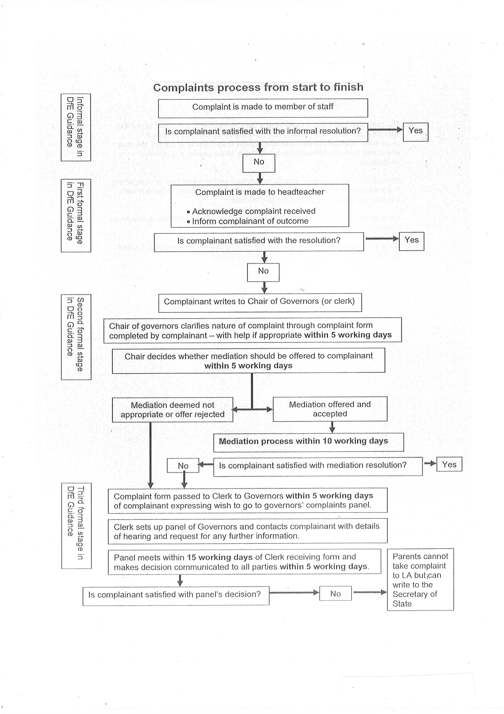

Page 8 of 11

APPENDIX B: COMPLAINTS FORM
Please complete and return to ………………………….. (complaints co-ordinator) who will acknowledge receipt and explain what action will be taken.

Your name: Pupil’s name: Your relationship to the pupil: Address:

Postcode:

Daytime telephone number:

Evening telephone number:

Please give details of your complaint:

What action, if any, have you already taken to try and resolve your complaint? (Who did you speak to and what was the response)?

What actions do you feel might resolve the problem at this stage?

Are you attaching any paperwork? If so, please give details.

Signature: Date:

Official use
Date acknowledgement sent: By whom:

Complaint referred to: Date:

APPENDIX C: CHECKLIST FOR A PANEL HEARING
The governors’ complaints panel needs to take the following points into account:

- The hearing is as informal as possible.
- Witnesses are only required to attend for the part of the hearing in which they give their evidence.
- After introductions, the complainant is invited to explain their complaint, and be followed by their witnesses.
- The Headteacher may question both the complainant and the witnesses after each has spoken.
- The Headteacher is then invited to explain the school’s actions and be followed by the school’s witnesses.
- The complainant may question both the Headteacher and the witnesses after each has spoken.
- The panel may ask questions at any point.
- The complainant is then invited to sum up their complaint.
- The Headteacher is then invited to sum up the school’s actions and response to the complaint.
- Both parties leave together while the panel decides on the issues.
- The chair explains that both parties will hear from the panel within a set time scale.

APPENDIX D

COMPLAINTS POLICY AND PROCEDURE
Implemented Spring 2018

Suitable for: all types of schools Status: statutory

This policy should be read in conjunction with the DFE note (not statutory guidance) School complaints procedure 2016 and the following CEFM documents: Education update January 2012ii – The Education Act 2011 and Governance guidance documents – Staffing.

Background

Since 1 September 2003, governing bodies of all maintained schools and maintained nursery schools in England have been required, under section 29 of the Education Act 2002, to have in place a formal procedure to deal with complaints relating to the school and to any community facilities or services that the school provides.

The Education (Independent School Standards) (England) Regulations 2010 No 1997 and the Education (Non-Maintained Special Schools) (England) Regulations 2011 No 1627 extended these requirements to include academies, free schools, independent schools (not state funded) and non- maintained special schools. The law has also required the procedure to be publicised. Ofsted inspectors will make a judgment of the complaints procedure statement that the school issues and information from any upheld complaints about the school from parents to Ofsted.

Where the school provides accommodation, the policy must be drawn up having regard to (as amended from January 2013) the National Minimum Standards for Boarding Schools or, where applicable, the National Minimum Standards for Residential Special Schools.

This policy does not include dealing with any of the matters listed below, all of which are addressed in separate policies and procedures:

- Staff grievances.
- Internal disciplinary matters relating to staff or pupils.
- Curriculum complaints.
- Admissions appeals.
- SEN appeals.
- Appeals to the staff dismissal committee.
- Whistle blowing (matters of impropriety eg a breach of law, school procedures or ethics).
- Discrimination.

Typical matters that might be considered under this policy include:

From parents
- To the tutor, year head or designated deputy Headteacher about suspected bullying.
- Detention and out-of-school activity arrangements.
- Complaints about matters such as facilities, lack of supervision etc.

From the general public
- Local residents complaining about the behaviour of pupils coming to, and going from, the school.
- A local trader feeling that the school should be trading with her or his company.
- Local community leaders concerned that the school is not involving itself sufficiently in particular aspects of community life.

DfE Best Practice Advice for School Complaints Procedures 2016

Click to open PDF.

