**Our Lady of Peace Catholic Primary and Nursery School**



**Year 3 2019**

**Term: Spring 1**

**Homework Booklet**

**Welcome to your homework booklet for this half term.**



In this booklet you will find six weeks’ worth of spellings. You need to learn these spellings carefully by using the look, say, cover and write method. You can also login to your **‘Spelling Shed’** account to practise your spellings. You then have some space at the bottom of the page to put each of your spelling words into a sentence.

Your teacher will test you on your spellings each week.



Login to your **‘Times Tables Rock Stars’** account to practise your times tables!

Your teacher will test you on your times tables each week.



Login to your ‘**Bug Club’** account for online reading challenges!

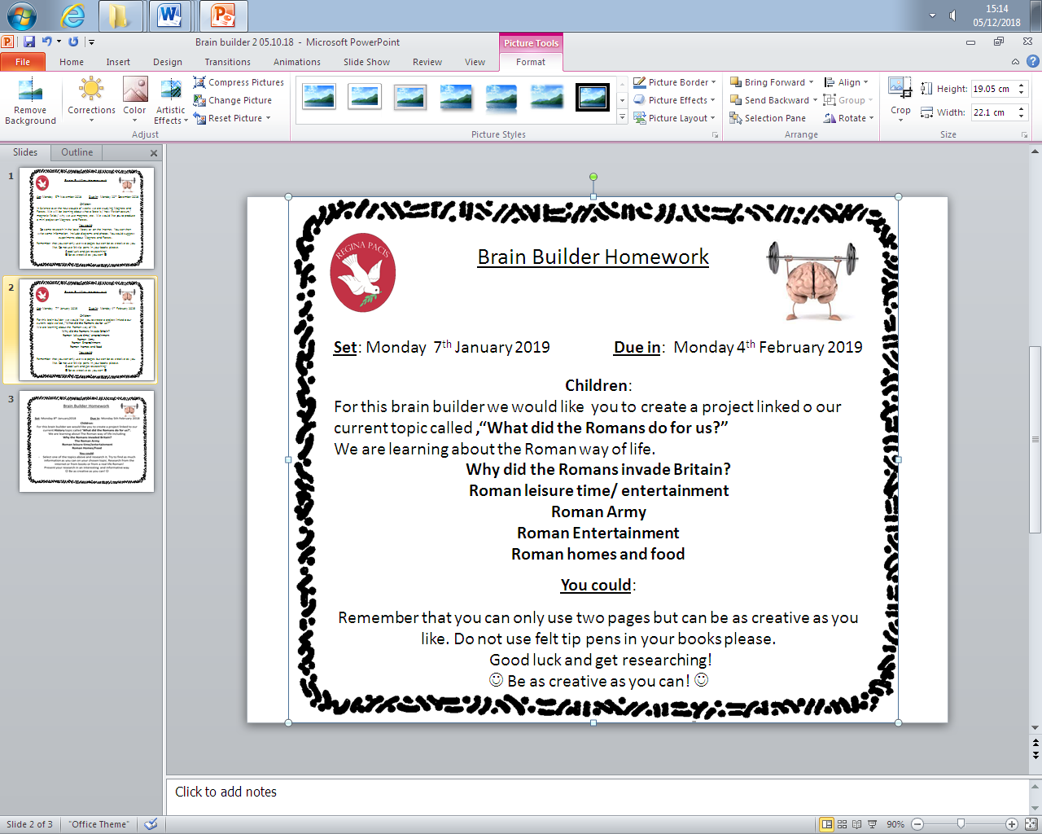

**BRAIN BUILDERS**

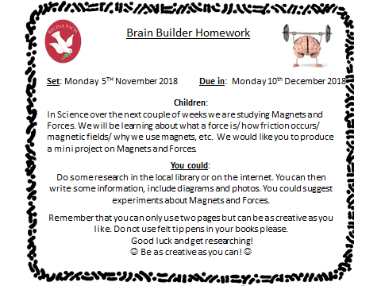**Maths for Spring 1**

Written multiplication and division: Multiply numbers between 10 and 25 by 1-digit numbers using the grid method; divide multiples of 10 by 1-digit numbers using known times tables facts; see the relation between multiplication and division

Mental addition and Subtraction: Use counting up as a strategy to perform mental subtraction (Frog); subtract pounds and pence from five pounds; use counting up (Frog) as a strategy to perform mental subtraction of amounts of money; subtract pounds and pence from ten pounds.

Fractions: Identify 1/2s, 1/3s, 1/4s, 1/6s, and 1/8s; realise how many of each make a whole; find equivalent fractions; place fractions on a 0 to 1 line; find fractions of amounts

Measurement:

Length and perimeter measure, compare, add and subtract: lengths (m/ cm/mm); mass (kg/g); volume/capacity (l/ml). Measure the perimeter of simple 2D shapes.

Problem Solving: Within each of the strands above, the children will continue to develop their problem solving skills.



Log-in to your **‘My Maths’** account and, each week, complete the activity listed in the table below.

|  |  |  |  |  |  |
| --- | --- | --- | --- | --- | --- |
| Week Beginning  11.01.19 | Week Beginning  18.01.19 | Week Beginning  25.01.19 | Week Beginning  01.02.19 | Week Beginning  08.02.19 | Week Beginning  15.02.18 |
| 3X  Times tables | 6x,  Times tables | 4x  Times tables | 8x,  Times tables | 3 and 6  Times tables | 4 and 8  Times tables |

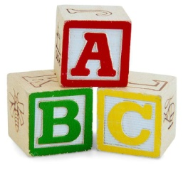[](http://www.google.co.uk/imgres?q=clipart+abc&safe=active&hl=en&biw=1280&bih=827&tbm=isch&tbnid=5R_iloF6PLG7QM:&imgrefurl=http://www.illustrationsof.com/1112353-royalty-free-abc-clipart-illustration&docid=lRG4ss-PISLCDM&imgurl=http://www.illustrationsof.com/royalty-free-abc-clipart-illustration-1112353.jpg&w=400&h=420&ei=eJTmUaPgDuzn7AaIi4DoBg&zoom=1&iact=hc&vpx=368&vpy=270&dur=1516&hovh=230&hovw=219&tx=134&ty=135&page=1&tbnh=145&tbnw=138&start=0&ndsp=38&ved=1t:429,r:26,s:0,i:163)

**Spelling practise:** Look, say, cover, write, check

**Week 1**

Spellings

|  |  |  |  |  |  |  |
| --- | --- | --- | --- | --- | --- | --- |
| **Look** | **Say** | **Cover** | **Write** | **Check** | **Write** | **Check** |
| **example** |  |  | ***example*** | **🗶** | ***example*** | **✓** |
| myth |  |  |  |  |  |  |
| gym |  |  |  |  |  |  |
| Egypt |  |  |  |  |  |  |
| pyramid |  |  |  |  |  |  |
| mystery |  |  |  |  |  |  |
| hymn |  |  |  |  |  |  |
| system |  |  |  |  |  |  |
| symbol |  |  |  |  |  |  |

**Sentence practise:** Now use your spellings in a sentence.

1)__________________________________________________________

2)__________________________________________________________

3)__________________________________________________________

4)__________________________________________________________

5)__________________________________________________________

6)__________________________________________________________

7)__________________________________________________________

8)__________________________________________________________

4.

5.

6.

7.

8.

|  |  |  |  |  |  |  |
| --- | --- | --- | --- | --- | --- | --- |
| **Look** | **Say** | **Cover** | **Write** | **Check** | **Write** | **Check** |
| **example** |  |  | ***example*** | **🗶** | ***example*** | **✓** |
| gardener |  |  |  |  |  |  |
| gardening |  |  |  |  |  |  |
| limited |  |  |  |  |  |  |
| limiting |  |  |  |  |  |  |
| offering |  |  |  |  |  |  |
| offered |  |  |  |  |  |  |
| benefited |  |  |  |  |  |  |
| benefiting |  |  |  |  |  |  |

**[](http://www.google.co.uk/imgres?q=clipart+abc&safe=active&hl=en&biw=1280&bih=827&tbm=isch&tbnid=5R_iloF6PLG7QM:&imgrefurl=http://www.illustrationsof.com/1112353-royalty-free-abc-clipart-illustration&docid=lRG4ss-PISLCDM&imgurl=http://www.illustrationsof.com/royalty-free-abc-clipart-illustration-1112353.jpg&w=400&h=420&ei=eJTmUaPgDuzn7AaIi4DoBg&zoom=1&iact=hc&vpx=368&vpy=270&dur=1516&hovh=230&hovw=219&tx=134&ty=135&page=1&tbnh=145&tbnw=138&start=0&ndsp=38&ved=1t:429,r:26,s:0,i:163)**

Spellings

**Week 2**

**Spelling practise:** Look, say, cover, write, check

**Sentence practise:** Now use your spellings in a sentence.

1)__________________________________________________________

2)__________________________________________________________

3)__________________________________________________________

4)__________________________________________________________

5)__________________________________________________________

6)__________________________________________________________

7)__________________________________________________________

8)__________________________________________________________

1

2.

3.

4.

5.

6.

7.

8.

|  |  |  |  |  |  |  |
| --- | --- | --- | --- | --- | --- | --- |
| **Look** | **Say** | **Cover** | **Write** | **Check** | **Write** | **Check** |
| **example** |  |  | ***example*** | **🗶** | ***example*** | **✓** |
| forgetting |  |  |  |  |  |  |
| forgotten |  |  |  |  |  |  |
| beginning |  |  |  |  |  |  |
| beginner |  |  |  |  |  |  |
| preferred |  |  |  |  |  |  |
| preferring |  |  |  |  |  |  |
| occurred |  |  |  |  |  |  |
| occurring |  |  |  |  |  |  |

**[](http://www.google.co.uk/imgres?q=clipart+abc&safe=active&hl=en&biw=1280&bih=827&tbm=isch&tbnid=5R_iloF6PLG7QM:&imgrefurl=http://www.illustrationsof.com/1112353-royalty-free-abc-clipart-illustration&docid=lRG4ss-PISLCDM&imgurl=http://www.illustrationsof.com/royalty-free-abc-clipart-illustration-1112353.jpg&w=400&h=420&ei=eJTmUaPgDuzn7AaIi4DoBg&zoom=1&iact=hc&vpx=368&vpy=270&dur=1516&hovh=230&hovw=219&tx=134&ty=135&page=1&tbnh=145&tbnw=138&start=0&ndsp=38&ved=1t:429,r:26,s:0,i:163)**

Spellings

**Week 3**

**Spelling practise:** Look, say, cover, write, check

**Sentence practise:** Now use your spellings in a sentence.

1)__________________________________________________________

2)__________________________________________________________

3)__________________________________________________________

4)__________________________________________________________

5)__________________________________________________________

6)__________________________________________________________

7)__________________________________________________________

8)__________________________________________________________

1

2.

3.

4.

5.

6.

7.

8.

**[](http://www.google.co.uk/imgres?q=clipart+abc&safe=active&hl=en&biw=1280&bih=827&tbm=isch&tbnid=5R_iloF6PLG7QM:&imgrefurl=http://www.illustrationsof.com/1112353-royalty-free-abc-clipart-illustration&docid=lRG4ss-PISLCDM&imgurl=http://www.illustrationsof.com/royalty-free-abc-clipart-illustration-1112353.jpg&w=400&h=420&ei=eJTmUaPgDuzn7AaIi4DoBg&zoom=1&iact=hc&vpx=368&vpy=270&dur=1516&hovh=230&hovw=219&tx=134&ty=135&page=1&tbnh=145&tbnw=138&start=0&ndsp=38&ved=1t:429,r:26,s:0,i:163)**

**Spelling practise:** Look, say, cover, write, check

Spellings

**Week 4**

|  |  |  |  |  |  |  |
| --- | --- | --- | --- | --- | --- | --- |
| **Look** | **Say** | **Cover** | **Write** | **Check** | **Write** | **Check** |
| **example** |  |  | ***example*** | **🗶** | ***example*** | **✓** |
| misspell |  |  |  |  |  |  |
| mislead |  |  |  |  |  |  |
| mistreat |  |  |  |  |  |  |
| misbehave |  |  |  |  |  |  |
| mistrust |  |  |  |  |  |  |
| misprint |  |  |  |  |  |  |
| misuse |  |  |  |  |  |  |
| misplace |  |  |  |  |  |  |

**Sentence practise:** Now use your spellings in a sentence.

1)__________________________________________________________

2)__________________________________________________________

3)__________________________________________________________

4)__________________________________________________________

5)__________________________________________________________

6)__________________________________________________________

7)__________________________________________________________

8)__________________________________________________________

2.

3.

4.

5.

6.

7.

8.

**[](http://www.google.co.uk/imgres?q=clipart+abc&safe=active&hl=en&biw=1280&bih=827&tbm=isch&tbnid=5R_iloF6PLG7QM:&imgrefurl=http://www.illustrationsof.com/1112353-royalty-free-abc-clipart-illustration&docid=lRG4ss-PISLCDM&imgurl=http://www.illustrationsof.com/royalty-free-abc-clipart-illustration-1112353.jpg&w=400&h=420&ei=eJTmUaPgDuzn7AaIi4DoBg&zoom=1&iact=hc&vpx=368&vpy=270&dur=1516&hovh=230&hovw=219&tx=134&ty=135&page=1&tbnh=145&tbnw=138&start=0&ndsp=38&ved=1t:429,r:26,s:0,i:163)**

**Week 5**

|  |  |  |  |  |  |  |
| --- | --- | --- | --- | --- | --- | --- |
| **Look** | **Say** | **Cover** | **Write** | **Check** | **Write** | **Check** |
| **example** |  |  | ***example*** | **🗶** | ***example*** | **✓** |
| dislike |  |  |  |  |  |  |
| disobey |  |  |  |  |  |  |
| discolour |  |  |  |  |  |  |
| discover |  |  |  |  |  |  |
| disappear |  |  |  |  |  |  |
| dishonest |  |  |  |  |  |  |
| disallow |  |  |  |  |  |  |
| disbelieve |  |  |  |  |  |  |

**Spelling practise:** Look, say, cover, write, check

Spellings

**Sentence practise:** Now use your spellings in a sentence.

1)__________________________________________________________

2)__________________________________________________________

3)__________________________________________________________

4)__________________________________________________________

5)__________________________________________________________

6)__________________________________________________________

7)__________________________________________________________

8)__________________________________________________________

1

2.

3.

4.

5.

6.

7.

8.

**[](http://www.google.co.uk/imgres?q=clipart+abc&safe=active&hl=en&biw=1280&bih=827&tbm=isch&tbnid=5R_iloF6PLG7QM:&imgrefurl=http://www.illustrationsof.com/1112353-royalty-free-abc-clipart-illustration&docid=lRG4ss-PISLCDM&imgurl=http://www.illustrationsof.com/royalty-free-abc-clipart-illustration-1112353.jpg&w=400&h=420&ei=eJTmUaPgDuzn7AaIi4DoBg&zoom=1&iact=hc&vpx=368&vpy=270&dur=1516&hovh=230&hovw=219&tx=134&ty=135&page=1&tbnh=145&tbnw=138&start=0&ndsp=38&ved=1t:429,r:26,s:0,i:163)**

**Week 6**

Spellings 

**Spelling practise:** Look, say, cover, write, check

|  |  |  |  |  |  |  |
| --- | --- | --- | --- | --- | --- | --- |
| **Look** | **Say** | **Cover** | **Write** | **Check** | **Write** | **Check** |
| **example** |  |  | ***example*** | **🗶** | ***example*** | **✓** |
| scheme |  |  |  |  |  |  |
| chorus |  |  |  |  |  |  |
| echo |  |  |  |  |  |  |
| character |  |  |  |  |  |  |
| ache |  |  |  |  |  |  |
| chaos |  |  |  |  |  |  |
| stomach |  |  |  |  |  |  |
| chemistry |  |  |  |  |  |  |

**Sentence practise:** Now use your spellings in a sentence.

1)__________________________________________________________

2)__________________________________________________________

3)__________________________________________________________

4)__________________________________________________________

5)__________________________________________________________

6)__________________________________________________________

7)__________________________________________________________

8)__________________________________________________________

2.

3.

4.

5.

6.

7.

8.

**Additional Mathematics and English Homework**

Some parents may wish their children to undertake additional maths and English homework.

The school endorses the use of ‘Workbooks’, which are carefully planned to support children with their learning, consolidate classroom teaching and provide an organisational structure which will enable pupils to manage homework effectively with positive results. Parents can order and purchase these books directly from Workbook at [http://www.workabook.co.uk](http://www.workabook.co.uk/). Parents can access the answers to each activity through the Workbook website.

Please note that Workbooks are intended for home-use only. There is no requirement for children to bring their Workbooks into school.

A sample of the Workbooks can be viewed at the main school office or alternatively more information can be found at http://www.workabook.co.uk

