Our Lady of Peace Catholic Primary and Nursery School
Year 3 2019
Term: Summer 1
Homework Booklet

Welcome to your homework booklet for this half term.
In this booklet you will find six weeks’ worth of spellings. You need to learn these spellings carefully by using the look, say, cover and write method. You can also login to your ‘Spelling Shed’ account to practise your spellings. You then have some space at the bottom of the page to put each of your spelling words into a sentence.
Your teacher will test you on your spellings each week.

Login to your ‘Times Tables Rock Stars’ account to practise your times tables!
Your teacher will test you on your times tables each week.

Login to your ‘Bug Club’ account for online reading challenges!

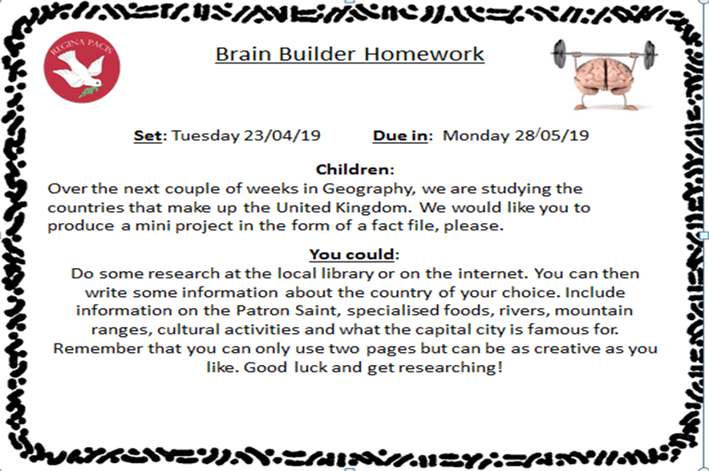

Maths for Summer 1
BRAIN BUILDERS
Written multiplication and division:
Multiply numbers between 10 and 25 by 1-digit numbers using the grid method; divide multiples of 10 by 1-digit numbers using known times tables facts; see the relation between multiplication and division.
Fractions:
Identify 1/2s, 1/3s, 1/4s, 1/6s, and 1/8s; realise how many of each make a whole; find equivalent fractions; place fractions on a 0 to 1 line; find fractions of a shape and amounts.
Measurement:
Children will learn to read and understand Roman Numerals, and analogue and digital clocks. They will be using the 12 and 24 hour time systems. They will also learn to measure using mass and capacity millilitres and litres, grams and kilograms.
Geometry: properties of shapes & Geometry: position and direction; Measurement:
Recognise right angles and know they are 90°; understand angles are measured in degrees; recognise ° as the symbol for the measurement of degrees; name and list simple properties of 2D shapes; begin to understand and use the term perimeter to mean the length/distance around the edge (border) of a 2D shape; begin to calculate using a ruler; know a right angle is a quarter turn; know 360° is a full turn; begin to understand angles and identify size of angles in relation to 90°

Log-in to your ‘My Maths’ account and, each week, complete the activity listed in the table below.
Week Beginning  22.04.19 | Week Beginning  29.04.19 | Week Beginning  05.05.19 | Week Beginning  13.05.19 | Week Beginning  20.05.19 | Week Beginning
2, 5 and 10  Times Tables | 3 and 6  Times Tables | 4 and 8  Times Tables | 7  Times Tables | 9  Times Tables

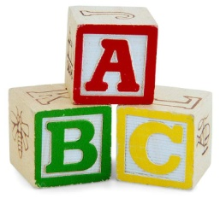
Spelling practise: Look, say, cover, write, check

Week 1
Spellings

Look | Say | Cover | Write | Check | Write | Check
example |  |  | example |  | example
library
February
dictionary
boundary
salary
summary
primary
secondary

Sentence practise: Now use your spellings in a sentence.
1)__________________________________________________________
2)__________________________________________________________
3)__________________________________________________________
4)__________________________________________________________
5)__________________________________________________________
6)__________________________________________________________
7)__________________________________________________________
8)__________________________________________________________

4.
5.
6.
7.
8.

Look | Say | Cover | Write | Check | Write | Check
example |  |  | example |  | example
woman
wonder
month
govern
brother
another
shovel
above
Spellings
Week 2
Spelling practise: Look, say, cover, write, check

Sentence practise: Now use your spellings in a sentence.
1)__________________________________________________________
2)__________________________________________________________
3)__________________________________________________________
4)__________________________________________________________
5)__________________________________________________________
6)__________________________________________________________
7)__________________________________________________________
8)__________________________________________________________
1
2.
3.
4.
5.
6.
7.
8.

Look | Say | Cover | Write | Check | Write | Check
example |  |  | example |  | example
enough
young
touch
double
trouble
country
courage
rough
Spellings
Week 3
Spelling practise: Look, say, cover, write, check

Sentence practise: Now use your spellings in a sentence.
1)__________________________________________________________
2)__________________________________________________________
3)__________________________________________________________
4)__________________________________________________________
5)__________________________________________________________
6)__________________________________________________________
7)__________________________________________________________
8)__________________________________________________________

1
2.
3.
4.
5.
6.
7.
8.

Spelling practise: Look, say, cover, write, check

Spellings
Week 4
Look | Say | Cover | Write | Check | Write | Check
example |  |  | example |  | example
instruct
structure
construction
instruction
instructor
unit
union
united

Sentence practise: Now use your spellings in a sentence.
1)__________________________________________________________
2)__________________________________________________________
3)__________________________________________________________
4)__________________________________________________________
5)__________________________________________________________
6)__________________________________________________________
7)__________________________________________________________
8)__________________________________________________________
2.
3.
4.
5.
6.
7.
8.

Week 5
Look | Say | Cover | Write | Check | Write | Check
example |  |  | example |  | example
scope
telescope
microscope
horoscope
periscope
inspect
spectator
respect
Spelling practise: Look, say, cover, write, check

Spellings

Sentence practise: Now use your spellings in a sentence.
1)__________________________________________________________
2)__________________________________________________________
3)__________________________________________________________
4)__________________________________________________________
5)__________________________________________________________
6)__________________________________________________________
7)__________________________________________________________
8)__________________________________________________________

1
2.
3.
4.
5.
6.
7.
8.

Additional Mathematics and English Homework
Some parents may wish their children to undertake additional maths and English homework.

The school endorses the use of ‘Workbooks’, which are carefully planned to support children with their learning, consolidate classroom teaching and provide an organisational structure which will enable pupils to manage homework effectively with positive results. Parents can order and purchase these books directly from Workbook at http://www.workabook.co.uk. Parents can access the answers to each activity through the Workbook website.

Please note that Workbooks are intended for home-use only. There is no requirement for children to bring their Workbooks into school.

A sample of the Workbooks can be viewed at the main school office or alternatively more information can be found at http://www.workabook.co.uk
