Dear Parent/Carer,

Re: Author talk (3rd March 2022)

We have invited a children’s author, Leysa Henderson, to deliver an assembly on the themes of her books George the Fraud and the Dragon, Lost Lives, The Day the Turtles Came Home and What a Load of Rubbish! The assembly focuses on Waste, Rubbish and Plastics.

All the books are based on environmental and social themes.

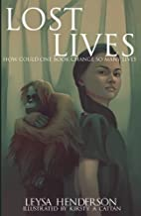
Lost Lives is a children’s eco-adventure book that has many environmental and social themes running through it. Predominantly, the message is highlighting the plight of orangutans and the loss of their habitat to make way for palm oil plantations. Megan finds a magic atlas which transports her to another world. Here she meets the Dayak tribe and finds out why their land is being destroyed and why the orangutans are under threat of extinction. She learns that she can talk to animals and how to use her new magical powers to take revenge. She makes friends in unlikely places and experiences a new life which she doesn’t want to leave. (http://www.kreativefutures.co.uk/lost-lives.html)

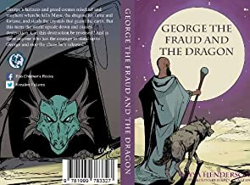
George the Fraud and the Dragon (Chapter book for ages 7 – 12) - George's laziness and greed creates mischief and mayhem when he kills Mays, the dragon, for fame and fortune, and steals the crystals that guard the earth. But this turns the world upside down and causes destruction. Can this destruction be reversed? And is there anyone who has the courage to stand up to George and stop the chaos he's released? (http://www.kreativefutures.co.uk/george-the-fraud-and-the-dragon.html)

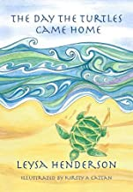
The Day the Turtles Came Home (Picture book for ages 4 – 9) - This moving story is based on a true event. Tendaji takes his grandma for one last trip to her beloved beach to see the turtles before she goes blind. But when they get there, the beach is full of rubbish. During his determination to make things better, he meets an old friend and makes new ones. When he brings grandma back, there is more than just a clean beach which greets her. A beautiful and inspiring story to engage your children in global environmental issues. http://www.kreativefutures.co.uk/the-day-the-turtles-came-home.html

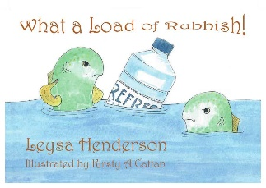
What a Load of Rubbish! (Picture book for ages 2 – 6) - The Clutterbuck family drop litter, upsetting the Fedup family and the other villagers. One day the make a wish which goes horribly wrong, but only for the Clutterbucks. (http://www.kreativefutures.co.uk/what-a-load-of-rubbish.html)

All the books are based on environmental and social themes and have a twofold purpose, firstly, to raise awareness of the effects of environmental damage and secondly, to raise money for wildlife charities.

If you would like to purchase a personalised signed copy of any of the books, please complete the form below and put the exact amount (we will not be able to give change) or a cheque addressed to Leysa Henderson with the form in a sealed envelope with your child’s full name, class and the name of the books being purchased. Please give the envelope to your class teacher.

Pupil’s full name:………………………………………………… Class:………………………

would like a signed copy of:

George the Fraud and the Dragon (£7.50)
The Day the Turtles Came Home (£9.50)
What a Load of Rubbish! (£8.50)
Lost Lives (£6.50)

(You can either pay by cash or cheque which needs to be made payable to Leysa Henderson)

Parent/carer’s signature:……………………………………….. Date:………………………....

