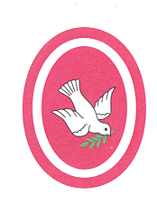Our Lady of Peace Catholic Primary and Nursery School
3CK Saint John Bosco Weekly Timetable – 2020
‘With Christ in our hearts, together we grow.’

 | Monday | Tuesday | Wednesday | Thursday | Friday
8.45 – 8.55am | Register/Morning Maths | Register/Morning Handwriting | Register/Morning Maths | Register/Morning Handwriting | Register/Morning Maths
9.00- 9.30am | Gospel Assembly | Assembly | Assembly | Assembly | Assembly
9.30 – 10.30am | Maths | Maths | Maths | Maths | Maths
10.30 – 10.45am | BREAK
10.45 – 11.00am | GPS | GPS | Spellings | GPS | Spelling Test
11.00 – 12.00pm | English | English | English | English | English
12.00 – 1.00pm | LUNCH
1.00 – 2.00pm | PE | T. Tables Rock stars | T. Tables Rock stars | T. Tables Rock stars | Spelling Test
 |  | RE | Topic /Science | ICT (1-40) | French(1-1:40)  Games(1:40-2)
2.00 – 3.00pm | RE | Music (2-2:30)  Guided Reading (2:30 – 3) | Guided Reading  PSHE | (1:40 to 2pm)  Guided Reading | Art (2-2:50)  Golden Time
3.00-3.15pm |  |  |  | Science/ Topic | PSHE

