FINANCES The Diocesan Finance office has made the following options available to allow parishioners to give ongoing support to their Parish.

- Giving Tuesday – Telephone Donation In addition to the online donation facilities currently available, the Diocese has begun a ‘Giving Tuesday’. Each Tuesday between 10:00am and 4:00pm, you can call this number, 01604 712065, and donate to your parish. Should you wish to use this option, you would be required to have your debit or credit card to hand when you call. You can make a one-off donation to cover your missed Sunday offerings or call each week knowing your offering is going to your parish.
- Online Donation We have an online donation facility on our main Diocesan website through Virgin Money giving (link below). If you use this option, we ask that you please indicate in the notes section which parish, including the parish name that you would like your donation to be attributed to. Please note that there is the facility to Gift Aid any donation to your Parish: https://northamptondiocese.org/donate/
- Standing Order via donor’s own bank: You can set up a standing order for donations to your parish using either your online bank account or in branch. You can also make a one-off payment to the parish.

Bank: NatWest.
Sort Code; 60-06-11.
Account Name; 46716203. Account Name; RCDN Our Lady of Peace.
Payment Ref: Our Lady of Peace, Slough
Standing Order through this link: https://northamptondiocese.org/wp-content/uploads/GAD-general-June-18-v2-revision.pdf
Donation Box now available in Our Lady of Peace for Mass intentions, offertory envelopes, donations, etc. The information you require to make the donation is as follows:

APPRECIATION We remain very grateful for your generous ongoing financial support to the parish. Thank you also to those rendering various services to the parish and parishioners. The Church wouldn’t survive during these challenging times without your support.

Our thoughts and prayers are with all those who are experiencing financial difficulties due to the lockdown and economic situation. If there’s any way the parish can help, please contact Fr Joe.

DECEASED – Thomas Joseph Hartigan, RIP Please pray for the repose of the soul of Tommy Joseph Hartigan, aged 83, who died recently. May his soul rest in peace, Amen. Kindly keep in your thoughts and prayers his family, especially his dear wife Jean, children, grandchildren and a greatgrandchild.

SICK CALL Fr Joe is happy to be contacted for any sick call. He will also be grateful for information on any parishioner or family member who has taken ill. If you or your loved ones are admitted to hospital, please remember to request to see a Catholic Chaplain.

MASS BOOKING Can now be dropped off at the Presbytery, or given to the stewards or Fr Joe when you visit the Church. You can still make request for Masses by email.
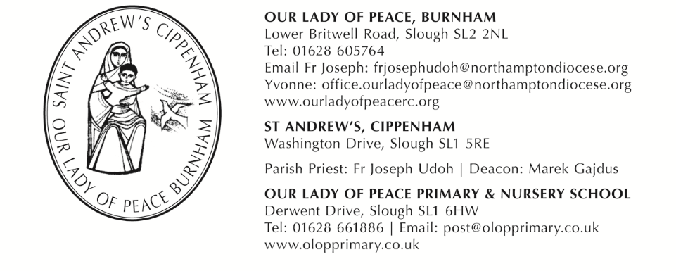
14TH SUNDAY IN ORDINARY TIME: 5TH JULY 2020: YEAR A

PARISH OFFICE Yvonne has been placed on ‘furlough’ until further notice. Please contact Fr Joseph for all Parish matters via email on frjosephudoh@northamptondiocese.org or you can telephone the Parish office on 01628 605764 and leave a message.
WELCOME BACK!!!!
Dear Parishioners
REINSTALLATION OF PUBLIC MASSES AT OUR LADY OF PEACE AND ST ANDREW’S
I am delighted to announce the reinstallation of Mass at Our Lady of Peace and St Andrew’s churches, in line with the Prime Minister’s recent announcement and with the support of Bishop David.
While this is welcome news indeed, as you would expect, we will have measures in place to ensure we are keeping everyone as safe as we possibly can.
We have decided to begin with our first three Masses taking place this weekend:
Saturday 4th July at 6:00pm - OLP
Sunday 5th July at 9:30am – OLP
Sunday 5th July at 11.30am – St Andrew’s and
Thursday 9th July at 9.30am – St Andrew’s
After that, and if we can recruit more volunteers to help, weekdays Masses with congregation will be offered. For now, Masses will continue as follows:
FROM SATURDAY 11TH JULY ONWARDS…
Day | Location | Time | Who can attend
Saturday 11th July and onwards | Our Lady of Peace | 10:00am | *Specifically for the elderly and those who need to take extra care, but who are permitted outside of the home
Saturday 11th July and onwards | Our Lady of Peace | 6:00pm | Anyone
Sunday 12th July and onwards | Our Lady of Peace | 9:30am | Anyone
Sunday 12th July and onwards | St Andrews | 11:30am | Anyone
- As you can see, Saturday morning Masses are reserved for those needing to take extra caution.
- If you are currently in the ‘At Risk’ or ‘Shielding’ categories, you should follow government guidelines and be aware that live streaming of Mass will continue every day.
- Dispensation from the obligation to attend Mass on Sunday and Holy Days of Obligation is still in place if you feel uncomfortable or if you cannot attend in person.
Doors will open 30 minutes before mass times and you should plan to arrive in plenty time so we can follow safety procedures as outlined below:
On arrival, please wait outside – keep 2 metres apart from non-family members – until a steward calls you in.
- Masks or face covering must be worn – we can provide if you forget to bring your own
- Your temperature will be taken by a steward
- Please bring your name and telephone number on a piece of paper. We will keep these safely for 2 weeks should we need to conduct contact tracing.
- You will be asked to sanitise your hands upon entering the church
- A steward will guide you to your seat
- Once we have reached maximum capacity, we will have to advise you to attend at another time
- All other instructions will be provided at the beginning and throughout each service as necessary
It is important to note that live streaming of daily Masses from Our Lady of Peace will continue as usual for those who feel they cannot attend in person.
Please also ensure that you limit attendance to one of these scheduled weekend Masses so we can accommodate as many as possible in safety.

And finally, we will discontinue private prayer at weekends to allow the Masses to take place.
I very much look forward to welcoming you back to the church and to another step back to normality. In the meantime, please feel free to come for private prayers at the times and dates shown below:
Private Prayer Sessions (will not take place on the days we have Mass) at Our Lady of Peace
Day | Open | Close
Tuesdays | 11:00am | 1:00pm
Thursdays | 6:00pm | 8:00pm
Private Prayer Sessions at St Andrew’s, Cippenham from Thursday July 9
Day | Open | Close
Thursdays | 10.30am | 12.00 noon
Sundays | 9.30am | 11.00am
Many thanks and God bless. Fr Joe
MASS TIMES AND INTENTIONS
Saturday 4th July
9.30am Our Lady of Peace All Volunteers in the Parish; For an end to the
COVID-19 Pandemic
Saturday, 4th July 14TH SUNDAY IN ORDINARY TIME
6.00pm Our Lady of Peace Mary Harris, RIP (Cafferty); Marjorie Rosemeyer, RIP (Potter); People of the Parish

Sunday, 5th July 14TH SUNDAY IN ORDINARY TIME
9.30am Our Lady of Peace McCann Family (B. O’Donnell); People of the Parish.
Sunday, 5th July 14TH SUNDAY IN ORDINARY TIME
11.30am St Andrew’s End to the Pandemic; People of the Parish
Monday, 6th June
9.30am Our Lady of Peace Barry (Foundation Mass);
Jose Tharakan, RIP (Family)
Tuesday, 7th June
9.30am Our Lady of Peace Tommy Hartigan, RIP; Green (Foundation Mass)
Prince Kwabena Fosu, RIP
Wednesday, 8th July
9.30am Our Lady of Peace Isabella & Dominic McGlynn, RIP (O’Donnell)
Thursday, 9th July
9.30am St Andrew’s Margery Christian, RIP (O’Donnell)
Friday, 10th July
9.30am Our Lady of Peace Caroline Achi: Bd; Adriana Burton
Saturday 11th July St Benedict, Abbot
10.00am Our Lady of Peace End to the Pandemic; Sick and Housebound
Saturday, 11th July 15TH SUNDAY IN ORDINARY TIME
6.00pm Our Lady of Peace Vincent Lambert, RIP (Rosary Group);
Liam, Claire and Danny
Sunday, 12th July 15TH SUNDAY IN ORDINARY TIME
9.30am Our Lady of Peace John Lawlor, RIP Anniv (Goldberg);
People of the Parish
Sunday, 12th July 15TH SUNDAY IN ORDINARY TIME
11.30am St Andrew’s People of the Parish; Millie & Thomas Fernandez

You can continue to participate from home in Masses that we stream live each day,
on facebook: ourladyofpeacecatholicchurchburnham
&
on YouTube: Our Lady of Peace Catholic Church Burnham https://www.youtube.com/channel/UCegtpwudlmz48G-m3gPNy4Q

