Our Lady of Peace Catholic Primary and Nursery School
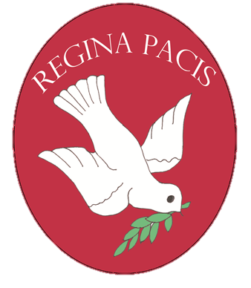
Year 6
Term: Pentecost 1
Homework Booklet
Welcome to your homework booklet for this half term.
In this booklet you will find six weeks’ worth of spellings. You need to learn these spellings carefully by using the look, say, cover and write method. You can also login to your ‘Spelling Shed’ account to practise your spellings. You then have some space at the bottom of the page to put each of your spelling words into a sentence.
Your teacher will test you on your spellings each week.

Login to your ‘Times Tables Rock Stars’ account to practise your times tables!
Your teacher will test you on your times tables each week.

Login to your ‘Bug Club’ account for online reading challenges!

Maths for Pentecost 1

In our geography lessons, we will be studying Rivers.
For your project, you may choose to research a variety of famous rivers from around the world, or choose one river to study in greater detail. You could find out key facts about rivers such as length, width, country of origin, famous features and any other interesting details.
As always, limit your project to two pages and be as creative as possible.
To be handed in: Monday 20th May 2019

BRAIN BUILDERS
Geometry: Properties of Shapes

Draw 2-D shapes using given dimensions and angles.
Compare and classify geometric shapes based on their properties and sizes and find unknown angles in any triangles, quadrilaterals and regular polygons.
Recognise angles where they meet at a point, are on a straight line, or are vertically opposite, and find missing angles.
Illustrate and name parts of circles, including radius, diameter and circumference and know that the diameter is twice the radius.
Interpret and construct pie charts and line graphs and use these to solve problems.
Calculate the mean as an average.
SATs preparation up to 10th May 2019.

Log-in to your ‘My Maths’ account and, each week, complete the activity listed in the table below.
Pupils should use their login details to access the MyMaths website.
They must complete all the tasks that have been assigned.
All tasks will allow the pupils to deepen their understanding of geometry (our first unit of work) as well as general revision of key mathematical concepts.

Additional Mathematics and English Homework

Some parents may wish their children to undertake additional maths and English homework.

The school endorses the use of ‘Workabooks’, which are carefully planned to support children with their learning, consolidate classroom teaching and provide an organisational structure which will enable pupils to manage homework effectively with positive results. Parents can order and purchase these books directly from Workabook at http://www.workabook.co.uk. Parents can access the answers to each activity through the Workabook website.

Please note that Workabooks are intended for home-use only. There is no requirement for children to bring their Workabooks into school.

A sample of the Workabooks can be viewed at the main school office or alternatively more information can be found at http://www.workabook.co.uk

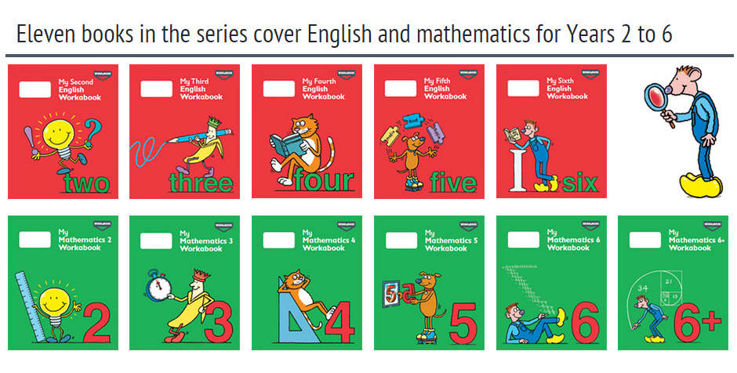

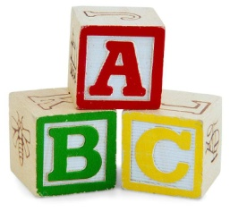
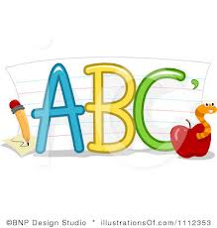
Spelling practise: Look, say, cover, write, check

Week 1
Spellings

Look | Say | Cover | Write | Check | Write | Check
example |  |  | exampel |  | example
programme
telegram
hologram
diagram
grammar
grammatical
parallelogram
monogram

Sentence practise: Now use your spellings in a sentence.
1)__________________________________________________________
2)__________________________________________________________
3)__________________________________________________________
4)__________________________________________________________
5)__________________________________________________________
6)__________________________________________________________
7)__________________________________________________________
8)__________________________________________________________

4.
5.
6.
7.
8.

Look | Say | Cover | Write | Check | Write | Check
example |  |  | exampel |  | example
challenge
damage
broadcast
benefit
charge
function
influence
interest
Spellings
Week 2
Spelling practise: Look, say, cover, write, check

Sentence practise: Now use your spellings in a sentence.
1)__________________________________________________________
2)__________________________________________________________
3)__________________________________________________________
4)__________________________________________________________
5)__________________________________________________________
6)__________________________________________________________
7)__________________________________________________________
8)__________________________________________________________
1
2.
3.
4.
5.
6.
7.
8.

Look | Say | Cover | Write | Check | Write | Check
example |  |  | exampel |  | example
produce
present
reason
silence
support
transport
surprise
scratch
Spellings
Week 3
Spelling practise: Look, say, cover, write, check

Sentence practise: Now use your spellings in a sentence.
1)__________________________________________________________
2)__________________________________________________________
3)__________________________________________________________
4)__________________________________________________________
5)__________________________________________________________
6)__________________________________________________________
7)__________________________________________________________
8)__________________________________________________________

1
2.
3.
4.
5.
6.
7.
8.

Spelling practise: Look, say, cover, write, check

Spellings
Week 4
Look | Say | Cover | Write | Check | Write | Check
example |  |  | exampel |  | example
shoulder
smoulder
mould
poultry
soul
shallow
window
blown

Sentence practise: Now use your spellings in a sentence.
1)__________________________________________________________
2)__________________________________________________________
3)__________________________________________________________
4)__________________________________________________________
5)__________________________________________________________
6)__________________________________________________________
7)__________________________________________________________
8)__________________________________________________________
2.
3.
4.
5.
6.
7.
8.

Spellings
Spelling practise: Look, say, cover, write, check

Week 5
Look | Say | Cover | Write | Check | Write | Check
example |  |  | exampel |  | example
possible
horrible
terrible
visible
incredible
sensible
forcible
legible

Sentence practise: Now use your spellings in a sentence.
1)__________________________________________________________
2)__________________________________________________________
3)__________________________________________________________
4)__________________________________________________________
5)__________________________________________________________
6)__________________________________________________________
7)__________________________________________________________
8)__________________________________________________________

1
2.
3.
4.
5.
6.
7.
8.

