This week in Year Six
We have been learning about Ancient Egypt in our History lessons this term.
This week, we explored how and why the Ancient Egyptians mummified people after their death.
The process of mummification is extremely gory! Nevertheless, the children were keen to practise their embalming skills, so we let them loose on some tomatoes!
Here is the process that the children followed:

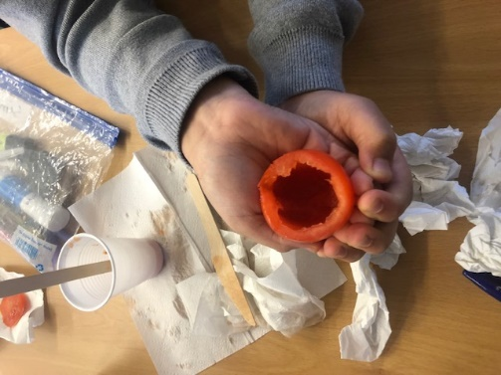
Step 2
To prevent bacteria growing inside the tomato, anti-bacterial sanitiser was used to clean the inside and outside of the fruit.
In Ancient Egypt, embalmers would have used palm wine and water from the Nile River.

Step 1
Make an incision near the top of the tomato and cut around its circumference to remove the top section.
Next scoop out the flesh of the tomato and place it in a canopic jar (plastic cup).

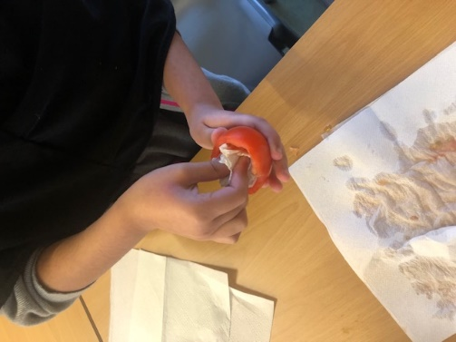
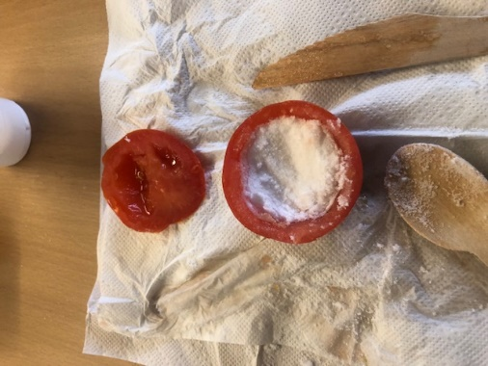
Step 4
Finally, the tomato is reunited with its lid and placed in its sarcophagus (a paper cup).
More ‘natron’ is poured over the tomato until it is completely covered.
After half-term, we will exhume the mummified tomato to see how it has changed.

Step 3
The cavity was packed with salt and bicarbonate of soda, to draw out the moisture from the tomato.
In Ancient Egypt, they used a substance called natron.

