Our Lady of Peace Catholic Primary and Nursery School



**Year 6**

**Term: Lenten 1**

**Homework Booklet**

**Welcome to your homework booklet for this half term.**



In this booklet you will find six weeks’ worth of spellings. You need to learn these spellings carefully by using the look, say, cover and write method. You can also login to your **‘Spelling Shed’** account to practise your spellings. You then have some space at the bottom of the page to put each of your spelling words into a sentence.

Your teacher will test you on your spellings each week.



Login to your **‘Times Tables Rock Stars’** account to practise your times tables!

Your teacher will test you on your times tables each week.



Login to your ‘**Bug Club’** account for online reading challenges!

**Maths for Lenten Term 1**

 

In our R.E. lessons, we will be considering how books can enrich our lives**.**

Your project should be about your favourite book or author. You may choose to focus upon a single book or a series of books. Alternatively, you may choose to base your project upon the life and work of your favourite author.

As always, limit your project to two pages and be as creative as possible.

**To be handed in: Monday 10th February 2020**

**BRAIN BUILDERS**

**Number: Decimals**

Identify the value of each digit in numbers given to 3 decimal places and multiply numbers by 10, 100 and 1,000 giving answers up to 3 decimal places.

Multiply one-digit numbers with up to 2 decimal places by whole numbers.

Use written division methods in cases where the answer has up to 2 decimal places.

Solve problems which require answers to be rounded to specified degrees of accuracy.

**Number: Percentages**

Solve problems involving the calculation of percentages [for example, of measures and such as 15% of 360] and the use of percentages for comparison.

Recall and use equivalences between simple fractions, decimals and percentages including in different contexts.

**Number: Algebra**

Use simple formulae

Generate and describe linear number sequences.

Express missing number problems algebraically.

Find pairs of numbers that satisfy an equation with two unknowns.

Enumerate possibilities of combinations of two variables.



Log-in to your **‘My Maths’** account and, each week, complete the activity listed in the table below.

|  |  |  |  |  |  |
| --- | --- | --- | --- | --- | --- |
| Week Beginning:  06.01.20 | Week Beginning:  13.01.20 | Week Beginning:  20.01.20 | Week Beginning:  27.01.20 | Week Beginning:  03.02.20 | Week Beginning:  10.02.20 |
| **Multiply decimals by 10 and 100** | **Multiply decimals by whole numbers** | **Fractions, Decimals and Percentages** | **Percentages of amounts** | **Algebra:**  **Equations (multi-step)** | **Algebra:**  **Rules and formulae** |

**Additional Mathematics and English Homework**

Some parents may wish their children to undertake additional maths and English homework.

The school endorses the use of ‘Workabooks’, which are carefully planned to support children with their learning, consolidate classroom teaching and provide an organisational structure which will enable pupils to manage homework effectively with positive results. Parents can order and purchase these books directly from Workabook at [http://www.workabook.co.uk](http://www.workabook.co.uk/). Parents can access the answers to each activity through the Workabook website.

Please note that Workabooks are intended for home-use only. There is no requirement for children to bring their Workabooks into school.

A sample of the Workabooks can be viewed at the main school office or alternatively more information can be found at http://www.workabook.co.uk

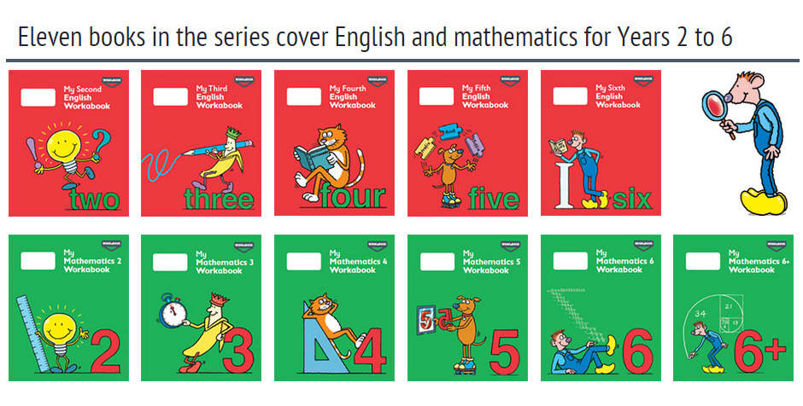

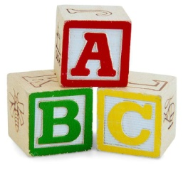[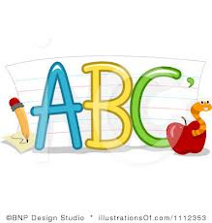](http://www.google.co.uk/imgres?q=clipart+abc&safe=active&hl=en&biw=1280&bih=827&tbm=isch&tbnid=5R_iloF6PLG7QM:&imgrefurl=http://www.illustrationsof.com/1112353-royalty-free-abc-clipart-illustration&docid=lRG4ss-PISLCDM&imgurl=http://www.illustrationsof.com/royalty-free-abc-clipart-illustration-1112353.jpg&w=400&h=420&ei=eJTmUaPgDuzn7AaIi4DoBg&zoom=1&iact=hc&vpx=368&vpy=270&dur=1516&hovh=230&hovw=219&tx=134&ty=135&page=1&tbnh=145&tbnw=138&start=0&ndsp=38&ved=1t:429,r:26,s:0,i:163)

**Spelling practise:** Look, say, cover, write, check

**Week 1**

Spellings

|  |  |  |  |  |  |  |
| --- | --- | --- | --- | --- | --- | --- |
| **Look** | **Say** | **Cover** | **Write** | **Check** | **Write** | **Check** |
| **example** |  |  | ***exampel*** | **🗶** | ***example*** | **✓** |
| referring |  |  |  |  |  |  |
| referred |  |  |  |  |  |  |
| referral |  |  |  |  |  |  |
| reference |  |  |  |  |  |  |
| referee |  |  |  |  |  |  |
| preferring |  |  |  |  |  |  |
| preferred |  |  |  |  |  |  |
| preference |  |  |  |  |  |  |

**Sentence practise:** Now use your spellings in a sentence.

1)__________________________________________________________

2)__________________________________________________________

3)__________________________________________________________

4)__________________________________________________________

5)__________________________________________________________

6)__________________________________________________________

7)__________________________________________________________

8)__________________________________________________________

4.

5.

6.

7.

8.

|  |  |  |  |  |  |  |
| --- | --- | --- | --- | --- | --- | --- |
| **Look** | **Say** | **Cover** | **Write** | **Check** | **Write** | **Check** |
| **example** |  |  | ***exampel*** | **🗶** | ***example*** | **✓** |
| siege |  |  |  |  |  |  |
| niece |  |  |  |  |  |  |
| grief |  |  |  |  |  |  |
| chief |  |  |  |  |  |  |
| fiend |  |  |  |  |  |  |
| shriek |  |  |  |  |  |  |
| believe |  |  |  |  |  |  |
| achieve |  |  |  |  |  |  |

**[](http://www.google.co.uk/imgres?q=clipart+abc&safe=active&hl=en&biw=1280&bih=827&tbm=isch&tbnid=5R_iloF6PLG7QM:&imgrefurl=http://www.illustrationsof.com/1112353-royalty-free-abc-clipart-illustration&docid=lRG4ss-PISLCDM&imgurl=http://www.illustrationsof.com/royalty-free-abc-clipart-illustration-1112353.jpg&w=400&h=420&ei=eJTmUaPgDuzn7AaIi4DoBg&zoom=1&iact=hc&vpx=368&vpy=270&dur=1516&hovh=230&hovw=219&tx=134&ty=135&page=1&tbnh=145&tbnw=138&start=0&ndsp=38&ved=1t:429,r:26,s:0,i:163)**

Spellings

**Week 2**

**Spelling practise:** Look, say, cover, write, check

**Sentence practise:** Now use your spellings in a sentence.

1)__________________________________________________________

2)__________________________________________________________

3)__________________________________________________________

4)__________________________________________________________

5)__________________________________________________________

6)__________________________________________________________

7)__________________________________________________________

8)__________________________________________________________

1

2.

3.

4.

5.

6.

7.

8.

|  |  |  |  |  |  |  |
| --- | --- | --- | --- | --- | --- | --- |
| **Look** | **Say** | **Cover** | **Write** | **Check** | **Write** | **Check** |
| **example** |  |  | ***exampel*** | **🗶** | ***example*** | **✓** |
| deceive |  |  |  |  |  |  |
| conceive |  |  |  |  |  |  |
| receive |  |  |  |  |  |  |
| perceive |  |  |  |  |  |  |
| ceiling |  |  |  |  |  |  |
| receipt |  |  |  |  |  |  |
| protein |  |  |  |  |  |  |
| caffeine |  |  |  |  |  |  |

**[](http://www.google.co.uk/imgres?q=clipart+abc&safe=active&hl=en&biw=1280&bih=827&tbm=isch&tbnid=5R_iloF6PLG7QM:&imgrefurl=http://www.illustrationsof.com/1112353-royalty-free-abc-clipart-illustration&docid=lRG4ss-PISLCDM&imgurl=http://www.illustrationsof.com/royalty-free-abc-clipart-illustration-1112353.jpg&w=400&h=420&ei=eJTmUaPgDuzn7AaIi4DoBg&zoom=1&iact=hc&vpx=368&vpy=270&dur=1516&hovh=230&hovw=219&tx=134&ty=135&page=1&tbnh=145&tbnw=138&start=0&ndsp=38&ved=1t:429,r:26,s:0,i:163)**

Spellings

**Week 3**

**Spelling practise:** Look, say, cover, write, check

**Sentence practise:** Now use your spellings in a sentence.

1)__________________________________________________________

2)__________________________________________________________

3)__________________________________________________________

4)__________________________________________________________

5)__________________________________________________________

6)__________________________________________________________

7)__________________________________________________________

8)__________________________________________________________

1

2.

3.

4.

5.

6.

7.

8.

|  |  |  |  |  |  |  |
| --- | --- | --- | --- | --- | --- | --- |
| **Look** | **Say** | **Cover** | **Write** | **Check** | **Write** | **Check** |
| **example** |  |  | ***exampel*** | **🗶** | ***example*** | **✓** |
| commit |  |  |  |  |  |  |
| committee |  |  |  |  |  |  |
| transmit |  |  |  |  |  |  |
| submit |  |  |  |  |  |  |
| commitment |  |  |  |  |  |  |
| emit |  |  |  |  |  |  |
| permit |  |  |  |  |  |  |
| intermittent |  |  |  |  |  |  |



**Spelling practise:** Look, say, cover, write, check

**Week 4**

Spellings

**Sentence practise:** Now use your spellings in a sentence.

1)__________________________________________________________

2)__________________________________________________________

3)__________________________________________________________

4)__________________________________________________________

5)__________________________________________________________

6)__________________________________________________________

7)__________________________________________________________

8)__________________________________________________________

2.

3.

4.

5.

6.

7.

8.

|  |  |  |  |  |  |  |
| --- | --- | --- | --- | --- | --- | --- |
| **Look** | **Say** | **Cover** | **Write** | **Check** | **Write** | **Check** |
| **example** |  |  | ***exampel*** | **🗶** | ***example*** | **✓** |
| interrupt |  |  |  |  |  |  |
| interfere |  |  |  |  |  |  |
| intercept |  |  |  |  |  |  |
| interject |  |  |  |  |  |  |
| intertwine |  |  |  |  |  |  |
| interim |  |  |  |  |  |  |
| internal |  |  |  |  |  |  |
| intersperse |  |  |  |  |  |  |



**Spelling practise:** Look, say, cover, write, check

**Week 5**

Spellings

**Sentence practise:** Now use your spellings in a sentence.

1)__________________________________________________________

2)__________________________________________________________

3)__________________________________________________________

4)__________________________________________________________

5)__________________________________________________________

6)__________________________________________________________

7)__________________________________________________________

8)__________________________________________________________

1

2.

3.

4.

5.

6.

7.

8.



**Week 6**

**Spelling practise:** Look, say, cover, write, check

Spellings 

|  |  |  |  |  |  |  |
| --- | --- | --- | --- | --- | --- | --- |
| **Look** | **Say** | **Cover** | **Write** | **Check** | **Write** | **Check** |
| **example** |  |  | ***exampel*** | **🗶** | ***example*** | **✓** |
| attached |  |  |  |  |  |  |
| available |  |  |  |  |  |  |
| average |  |  |  |  |  |  |
| competition |  |  |  |  |  |  |
| conscience |  |  |  |  |  |  |
| controversy |  |  |  |  |  |  |
| correspond |  |  |  |  |  |  |
| embarrass |  |  |  |  |  |  |

**Sentence practise:** Now use your spellings in a sentence.

1)__________________________________________________________

2)__________________________________________________________

3)__________________________________________________________

4)__________________________________________________________

5)__________________________________________________________

6)__________________________________________________________

7)__________________________________________________________

8)__________________________________________________________

2.

3.

4.

5.

6.

7.

8.