**Our Lady of Peace Catholic Primary and Nursery School**



**Year 3 - 2020**

**Term: Spring 2**

**Homework Booklet**

**Welcome to your homework booklet for this half term.**



In this booklet you will find six weeks worth of spellings. You need to learn these spellings carefully by using the look, say, cover and write method. You can also login to your **‘Spelling Shed’** account to practise your spellings. You then have some space at the bottom of the page to put each of your spelling words into a sentence.

Your teacher will test you on your spellings each week.



Login to your **‘Times Tables Rock Stars’** account to practise your times tables!

Your teacher will test you on your times tables each week.



Login to your ‘**Bug Club’** account for online reading challenges!

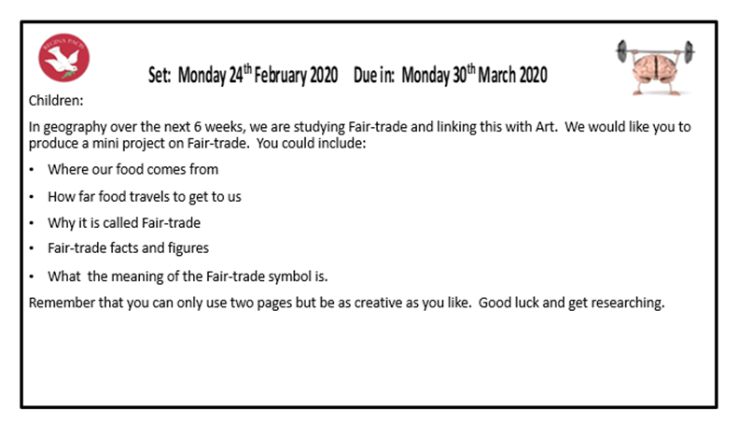

**Maths for Spring 2**

**BRAIN BUILDERS**

Fractions: To understand unit and non-unit fractions; to understand tenths; to be able place fractions on a numberline and find fractions of set objects.

Length and perimeter: To measure, compare, add and subtract lengths (m/ cm/mm); mass (kg/g); volume/capacity (l/ml). Measure the perimeter of simple 2D shapes.



Log-in to your **‘My Maths’** account and, each week, complete the activity listed in the table below.

|  |  |  |  |  |  |
| --- | --- | --- | --- | --- | --- |
| Week Beginning  24.02.20 | Week Beginning  02.03.20 | Week Beginning  09.03.20 | Week Beginning  16.03.20 | Week Beginning  23.03.20 | Week Beginning  30.03.20 |
| 3 and 6  Times tables | 4 and 8,  Times tables | 3x 4  Times tables | 6x8,  Times tables | 3,4,6  Times tables | 4,6,8  Times tables |

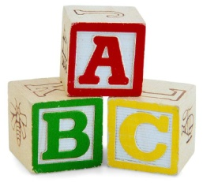[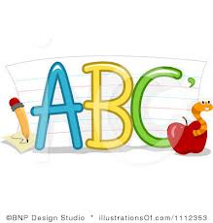](http://www.google.co.uk/imgres?q=clipart+abc&safe=active&hl=en&biw=1280&bih=827&tbm=isch&tbnid=5R_iloF6PLG7QM:&imgrefurl=http://www.illustrationsof.com/1112353-royalty-free-abc-clipart-illustration&docid=lRG4ss-PISLCDM&imgurl=http://www.illustrationsof.com/royalty-free-abc-clipart-illustration-1112353.jpg&w=400&h=420&ei=eJTmUaPgDuzn7AaIi4DoBg&zoom=1&iact=hc&vpx=368&vpy=270&dur=1516&hovh=230&hovw=219&tx=134&ty=135&page=1&tbnh=145&tbnw=138&start=0&ndsp=38&ved=1t:429,r:26,s:0,i:163)

**Spelling practise:** Look, say, cover, write, check

**Week 1**

Spellings

|  |  |  |  |  |  |  |
| --- | --- | --- | --- | --- | --- | --- |
| **Look** | **Say** | **Cover** | **Write** | **Check** | **Write** | **Check** |
| **example** |  |  | ***example*** | **🗶** | ***example*** | **✓** |
| grate |  |  |  |  |  |  |
| great |  |  |  |  |  |  |
| grown |  |  |  |  |  |  |
| groan |  |  |  |  |  |  |
| peace |  |  |  |  |  |  |
| piece |  |  |  |  |  |  |
| rain |  |  |  |  |  |  |
| reign |  |  |  |  |  |  |

**Sentence practise:** Now use your spellings in a sentence.

1)__________________________________________________________

2)__________________________________________________________

3)__________________________________________________________

4)__________________________________________________________

5)__________________________________________________________

6)__________________________________________________________

7)__________________________________________________________

8)__________________________________________________________

4.

5.

6.

7.

8.

|  |  |  |  |  |  |  |
| --- | --- | --- | --- | --- | --- | --- |
| **Look** | **Say** | **Cover** | **Write** | **Check** | **Write** | **Check** |
| **example** |  |  | ***example*** | **🗶** | ***example*** | **✓** |
| scent |  |  |  |  |  |  |
| sent |  |  |  |  |  |  |
| vain |  |  |  |  |  |  |
| vein |  |  |  |  |  |  |
| rode |  |  |  |  |  |  |
| road |  |  |  |  |  |  |
| steel |  |  |  |  |  |  |
| steal |  |  |  |  |  |  |

**[](http://www.google.co.uk/imgres?q=clipart+abc&safe=active&hl=en&biw=1280&bih=827&tbm=isch&tbnid=5R_iloF6PLG7QM:&imgrefurl=http://www.illustrationsof.com/1112353-royalty-free-abc-clipart-illustration&docid=lRG4ss-PISLCDM&imgurl=http://www.illustrationsof.com/royalty-free-abc-clipart-illustration-1112353.jpg&w=400&h=420&ei=eJTmUaPgDuzn7AaIi4DoBg&zoom=1&iact=hc&vpx=368&vpy=270&dur=1516&hovh=230&hovw=219&tx=134&ty=135&page=1&tbnh=145&tbnw=138&start=0&ndsp=38&ved=1t:429,r:26,s:0,i:163)**

Spellings

**Week 2**

**Spelling practise:** Look, say, cover, write, check

**Sentence practise:** Now use your spellings in a sentence.

1)__________________________________________________________

2)__________________________________________________________

3)__________________________________________________________

4)__________________________________________________________

5)__________________________________________________________

6)__________________________________________________________

7)__________________________________________________________

8)__________________________________________________________

1

2.

3.

4.

5.

6.

7.

8.

|  |  |  |  |  |  |  |
| --- | --- | --- | --- | --- | --- | --- |
| **Look** | **Say** | **Cover** | **Write** | **Check** | **Write** | **Check** |
| **example** |  |  | ***example*** | **🗶** | ***example*** | **✓** |
| bicycle |  |  |  |  |  |  |
| biplane |  |  |  |  |  |  |
| bisect |  |  |  |  |  |  |
| bilingual |  |  |  |  |  |  |
| biannual |  |  |  |  |  |  |
| reappear |  |  |  |  |  |  |
| redecorate |  |  |  |  |  |  |
| rebuild |  |  |  |  |  |  |

**[](http://www.google.co.uk/imgres?q=clipart+abc&safe=active&hl=en&biw=1280&bih=827&tbm=isch&tbnid=5R_iloF6PLG7QM:&imgrefurl=http://www.illustrationsof.com/1112353-royalty-free-abc-clipart-illustration&docid=lRG4ss-PISLCDM&imgurl=http://www.illustrationsof.com/royalty-free-abc-clipart-illustration-1112353.jpg&w=400&h=420&ei=eJTmUaPgDuzn7AaIi4DoBg&zoom=1&iact=hc&vpx=368&vpy=270&dur=1516&hovh=230&hovw=219&tx=134&ty=135&page=1&tbnh=145&tbnw=138&start=0&ndsp=38&ved=1t:429,r:26,s:0,i:163)**

Spellings

**Week 3**

**Spelling practise:** Look, say, cover, write, check

**Sentence practise:** Now use your spellings in a sentence.

1)__________________________________________________________

2)__________________________________________________________

3)__________________________________________________________

4)__________________________________________________________

5)__________________________________________________________

6)__________________________________________________________

7)__________________________________________________________

8)__________________________________________________________

1

2.

3.

4.

5.

6.

7.

8.

**[](http://www.google.co.uk/imgres?q=clipart+abc&safe=active&hl=en&biw=1280&bih=827&tbm=isch&tbnid=5R_iloF6PLG7QM:&imgrefurl=http://www.illustrationsof.com/1112353-royalty-free-abc-clipart-illustration&docid=lRG4ss-PISLCDM&imgurl=http://www.illustrationsof.com/royalty-free-abc-clipart-illustration-1112353.jpg&w=400&h=420&ei=eJTmUaPgDuzn7AaIi4DoBg&zoom=1&iact=hc&vpx=368&vpy=270&dur=1516&hovh=230&hovw=219&tx=134&ty=135&page=1&tbnh=145&tbnw=138&start=0&ndsp=38&ved=1t:429,r:26,s:0,i:163)**

**Spelling practise:** Look, say, cover, write, check

Spellings

**Week 4**

|  |  |  |  |  |  |  |
| --- | --- | --- | --- | --- | --- | --- |
| **Look** | **Say** | **Cover** | **Write** | **Check** | **Write** | **Check** |
| **example** |  |  | ***example*** | **🗶** | ***example*** | **✓** |
| league |  |  |  |  |  |  |
| plague |  |  |  |  |  |  |
| rogue |  |  |  |  |  |  |
| vague |  |  |  |  |  |  |
| fatigue |  |  |  |  |  |  |
| unique |  |  |  |  |  |  |
| antique |  |  |  |  |  |  |
| mosque |  |  |  |  |  |  |

**Sentence practise:** Now use your spellings in a sentence.

1)__________________________________________________________

2)__________________________________________________________

3)__________________________________________________________

4)__________________________________________________________

5)__________________________________________________________

6)__________________________________________________________

7)__________________________________________________________

8)__________________________________________________________

2.

3.

4.

5.

6.

7.

8.

**[](http://www.google.co.uk/imgres?q=clipart+abc&safe=active&hl=en&biw=1280&bih=827&tbm=isch&tbnid=5R_iloF6PLG7QM:&imgrefurl=http://www.illustrationsof.com/1112353-royalty-free-abc-clipart-illustration&docid=lRG4ss-PISLCDM&imgurl=http://www.illustrationsof.com/royalty-free-abc-clipart-illustration-1112353.jpg&w=400&h=420&ei=eJTmUaPgDuzn7AaIi4DoBg&zoom=1&iact=hc&vpx=368&vpy=270&dur=1516&hovh=230&hovw=219&tx=134&ty=135&page=1&tbnh=145&tbnw=138&start=0&ndsp=38&ved=1t:429,r:26,s:0,i:163)**

**Week 5**

|  |  |  |  |  |  |  |
| --- | --- | --- | --- | --- | --- | --- |
| **Look** | **Say** | **Cover** | **Write** | **Check** | **Write** | **Check** |
| **example** |  |  | ***example*** | **🗶** | ***example*** | **✓** |
| chef |  |  |  |  |  |  |
| chalet |  |  |  |  |  |  |
| machine |  |  |  |  |  |  |
| brochure |  |  |  |  |  |  |
| crochet |  |  |  |  |  |  |
| ricochet |  |  |  |  |  |  |
| parachute |  |  |  |  |  |  |
| moustache |  |  |  |  |  |  |

**Spelling practise:** Look, say, cover, write, check

Spellings

**Sentence practise:** Now use your spellings in a sentence.

1)__________________________________________________________

2)__________________________________________________________

3)__________________________________________________________

4)__________________________________________________________

5)__________________________________________________________

6)__________________________________________________________

7)__________________________________________________________

8)__________________________________________________________

1

2.

3.

4.

5.

6.

7.

8.

**[](http://www.google.co.uk/imgres?q=clipart+abc&safe=active&hl=en&biw=1280&bih=827&tbm=isch&tbnid=5R_iloF6PLG7QM:&imgrefurl=http://www.illustrationsof.com/1112353-royalty-free-abc-clipart-illustration&docid=lRG4ss-PISLCDM&imgurl=http://www.illustrationsof.com/royalty-free-abc-clipart-illustration-1112353.jpg&w=400&h=420&ei=eJTmUaPgDuzn7AaIi4DoBg&zoom=1&iact=hc&vpx=368&vpy=270&dur=1516&hovh=230&hovw=219&tx=134&ty=135&page=1&tbnh=145&tbnw=138&start=0&ndsp=38&ved=1t:429,r:26,s:0,i:163)**

**Week 6**

Spellings 

**Spelling practise:** Look, say, cover, write, check

|  |  |  |  |  |  |  |
| --- | --- | --- | --- | --- | --- | --- |
| **Look** | **Say** | **Cover** | **Write** | **Check** | **Write** | **Check** |
| **example** |  |  | ***example*** | **🗶** | ***example*** | **✓** |
| address |  |  |  |  |  |  |
| business |  |  |  |  |  |  |
| heart |  |  |  |  |  |  |
| fruit |  |  |  |  |  |  |
| breathe |  |  |  |  |  |  |
| strange |  |  |  |  |  |  |
| complete |  |  |  |  |  |  |
| extreme |  |  |  |  |  |  |

**Sentence practise:** Now use your spellings in a sentence.

1)__________________________________________________________

2)__________________________________________________________

3)__________________________________________________________

4)__________________________________________________________

5)__________________________________________________________

6)__________________________________________________________

7)__________________________________________________________

8)__________________________________________________________

2.

3.

4.

5.

6.

7.

8.

**Additional Mathematics and English Homework**