Our Lady of Peace Catholic Primary and Nursery School



**Year 4**

**Term: Lenten 2**

**Homework Booklet**

**Welcome to your homework booklet for this half term.**



In this booklet you will find six weeks’ worth of spellings. You need to learn these spellings carefully by using the look, say, cover and write method. You can also login to your **‘Spelling Shed’** account to practise your spellings (this will be given to you by your class teacher). You then have some space at the bottom of the page to put each of your spelling words into a sentence.

Your teacher will test you on your spellings each week.



Login to your **‘Times Tables Rock Stars’** account to practise your times tables!

Your teacher will test you on your times tables each week.



Login to your ‘**Bug Club’** account for online reading challenges!

**Maths for Lenten Term 2**

**BRAIN BUILDERS**

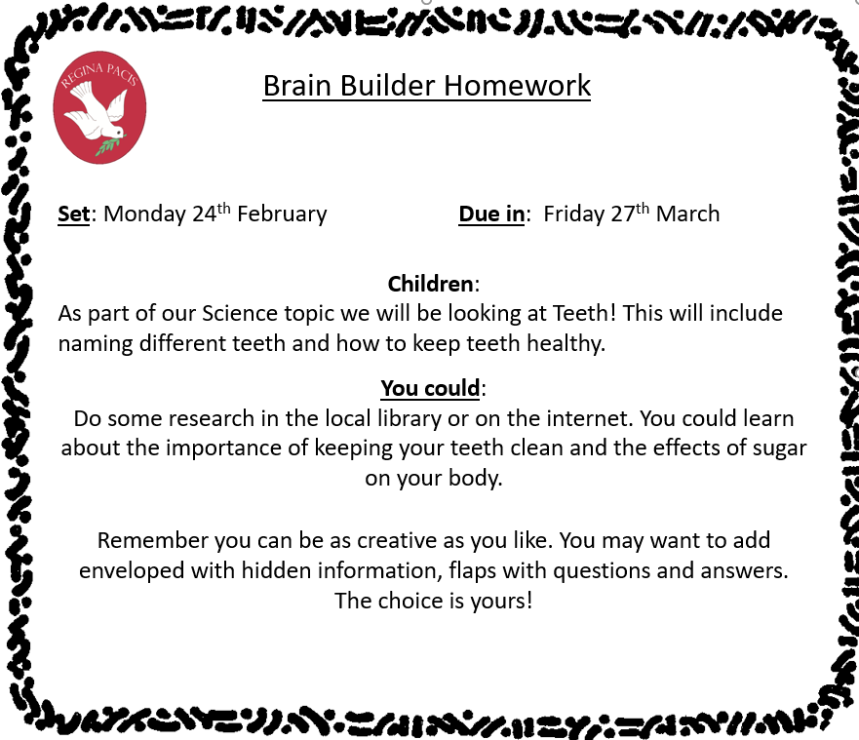

**Fractions**

Pupils will recognise and show, using diagrams, families of common equivalent fractions. They will count up and down in hundredths; recognise that hundredths arise when dividing an object by one hundred and dividing tenths by ten. Pupils will solve problems involving increasingly harder fractions to calculate quantities, and fractions to divide quantities, including non-unit fractions where the answer is a whole number. They will add and subtract fractions with the same denominator.

**Decimals**

Pupils will recognise and write decimal equivalents of any number of tenths or hundredths. They will find the effect of dividing a one or two digit number by 10 or 100, identifying the value of the digits in the answer as ones, tenths and hundredths. They will solve simple measure and money problems involving fractions and decimals to two decimal places. Pupils will convert between different units of measure [for example, kilometre to metre]

. 

Pupils will be assigned with homework on MyMaths.

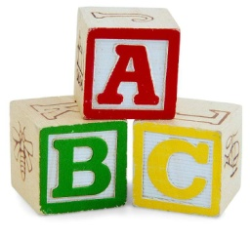[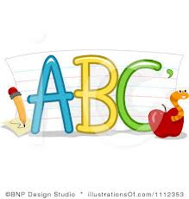](http://www.google.co.uk/imgres?q=clipart+abc&safe=active&hl=en&biw=1280&bih=827&tbm=isch&tbnid=5R_iloF6PLG7QM:&imgrefurl=http://www.illustrationsof.com/1112353-royalty-free-abc-clipart-illustration&docid=lRG4ss-PISLCDM&imgurl=http://www.illustrationsof.com/royalty-free-abc-clipart-illustration-1112353.jpg&w=400&h=420&ei=eJTmUaPgDuzn7AaIi4DoBg&zoom=1&iact=hc&vpx=368&vpy=270&dur=1516&hovh=230&hovw=219&tx=134&ty=135&page=1&tbnh=145&tbnw=138&start=0&ndsp=38&ved=1t:429,r:26,s:0,i:163)

**Spelling practise:** Look, say, cover, write, check

**Week 1**

Spellings

|  |  |  |  |  |  |  |
| --- | --- | --- | --- | --- | --- | --- |
| **Look** | **Say** | **Cover** | **Write** | **Check** | **Write** | **Check** |
| Science |  |  |  |  |  |  |
| Crescent |  |  |  |  |  |  |
| Discipline |  |  |  |  |  |  |
| Fascinate |  |  |  |  |  |  |
| Scent |  |  |  |  |  |  |
| Scissors |  |  |  |  |  |  |
| Ascent |  |  |  |  |  |  |
| Descent |  |  |  |  |  |  |

**Sentence practise:** Now use your spellings in a sentence.

1)__________________________________________________________

2)__________________________________________________________

3)__________________________________________________________

4)__________________________________________________________

5)__________________________________________________________

6)__________________________________________________________

7)__________________________________________________________

8)__________________________________________________________

4.

5.

6.

7.

8.

Spellings

**Spelling practise:** Look, say, cover, write, check

**[](http://www.google.co.uk/imgres?q=clipart+abc&safe=active&hl=en&biw=1280&bih=827&tbm=isch&tbnid=5R_iloF6PLG7QM:&imgrefurl=http://www.illustrationsof.com/1112353-royalty-free-abc-clipart-illustration&docid=lRG4ss-PISLCDM&imgurl=http://www.illustrationsof.com/royalty-free-abc-clipart-illustration-1112353.jpg&w=400&h=420&ei=eJTmUaPgDuzn7AaIi4DoBg&zoom=1&iact=hc&vpx=368&vpy=270&dur=1516&hovh=230&hovw=219&tx=134&ty=135&page=1&tbnh=145&tbnw=138&start=0&ndsp=38&ved=1t:429,r:26,s:0,i:163)**

**Week 2**

|  |  |  |  |  |  |  |
| --- | --- | --- | --- | --- | --- | --- |
| **Look** | **Say** | **Cover** | **Write** | **Check** | **Write** | **Check** |
| Centre |  |  |  |  |  |  |
| Century |  |  |  |  |  |  |
| Certain |  |  |  |  |  |  |
| Recent |  |  |  |  |  |  |
| Experience |  |  |  |  |  |  |
| Sentence |  |  |  |  |  |  |
| Notice |  |  |  |  |  |  |
| Celebrate |  |  |  |  |  |  |

**Sentence practise:** Now use your spellings in a sentence.

1)__________________________________________________________

2)__________________________________________________________

3)__________________________________________________________

4)__________________________________________________________

5)__________________________________________________________

6)__________________________________________________________

7)__________________________________________________________

8)__________________________________________________________

1

2.

3.

4.

5.

6.

7.

8.

Spellings

**Spelling practise:** Look, say, cover, write, check

**[](http://www.google.co.uk/imgres?q=clipart+abc&safe=active&hl=en&biw=1280&bih=827&tbm=isch&tbnid=5R_iloF6PLG7QM:&imgrefurl=http://www.illustrationsof.com/1112353-royalty-free-abc-clipart-illustration&docid=lRG4ss-PISLCDM&imgurl=http://www.illustrationsof.com/royalty-free-abc-clipart-illustration-1112353.jpg&w=400&h=420&ei=eJTmUaPgDuzn7AaIi4DoBg&zoom=1&iact=hc&vpx=368&vpy=270&dur=1516&hovh=230&hovw=219&tx=134&ty=135&page=1&tbnh=145&tbnw=138&start=0&ndsp=38&ved=1t:429,r:26,s:0,i:163)**

**Week 3**

|  |  |  |  |  |  |  |
| --- | --- | --- | --- | --- | --- | --- |
| **Look** | **Say** | **Cover** | **Write** | **Check** | **Write** | **Check** |
| Circle |  |  |  |  |  |  |
| Decide |  |  |  |  |  |  |
| Medicine |  |  |  |  |  |  |
| Exercise |  |  |  |  |  |  |
| Special |  |  |  |  |  |  |
| Cinema |  |  |  |  |  |  |
| Decimal |  |  |  |  |  |  |
| Accident |  |  |  |  |  |  |

**Sentence practise:** Now use your spellings in a sentence.

1)__________________________________________________________

2)__________________________________________________________

3)__________________________________________________________

4)__________________________________________________________

5)__________________________________________________________

6)__________________________________________________________

7)__________________________________________________________

8)__________________________________________________________

1

2.

3.

4.

5.

6.

7.

8.

**[](http://www.google.co.uk/imgres?q=clipart+abc&safe=active&hl=en&biw=1280&bih=827&tbm=isch&tbnid=5R_iloF6PLG7QM:&imgrefurl=http://www.illustrationsof.com/1112353-royalty-free-abc-clipart-illustration&docid=lRG4ss-PISLCDM&imgurl=http://www.illustrationsof.com/royalty-free-abc-clipart-illustration-1112353.jpg&w=400&h=420&ei=eJTmUaPgDuzn7AaIi4DoBg&zoom=1&iact=hc&vpx=368&vpy=270&dur=1516&hovh=230&hovw=219&tx=134&ty=135&page=1&tbnh=145&tbnw=138&start=0&ndsp=38&ved=1t:429,r:26,s:0,i:163)**

**Week 4**

Spellings

**Spelling practise:** Look, say, cover, write, check

|  |  |  |  |  |  |  |
| --- | --- | --- | --- | --- | --- | --- |
| **Look** | **Say** | **Cover** | **Write** | **Check** | **Write** | **Check** |
| Phone |  |  |  |  |  |  |
| Phonics |  |  |  |  |  |  |
| Microphone |  |  |  |  |  |  |
| Telephone |  |  |  |  |  |  |
| Homophone |  |  |  |  |  |  |
| Real |  |  |  |  |  |  |
| Reality |  |  |  |  |  |  |
| Realistic |  |  |  |  |  |  |

**Sentence practise:** Now use your spellings in a sentence.

1)__________________________________________________________

2)__________________________________________________________

3)__________________________________________________________

4)__________________________________________________________

5)__________________________________________________________

6)__________________________________________________________

7)__________________________________________________________

8)__________________________________________________________

2.

3.

4.

5.

6.

7.

8.

Spellings 

**Spelling practise:** Look, say, cover, write, check

**[](http://www.google.co.uk/imgres?q=clipart+abc&safe=active&hl=en&biw=1280&bih=827&tbm=isch&tbnid=5R_iloF6PLG7QM:&imgrefurl=http://www.illustrationsof.com/1112353-royalty-free-abc-clipart-illustration&docid=lRG4ss-PISLCDM&imgurl=http://www.illustrationsof.com/royalty-free-abc-clipart-illustration-1112353.jpg&w=400&h=420&ei=eJTmUaPgDuzn7AaIi4DoBg&zoom=1&iact=hc&vpx=368&vpy=270&dur=1516&hovh=230&hovw=219&tx=134&ty=135&page=1&tbnh=145&tbnw=138&start=0&ndsp=38&ved=1t:429,r:26,s:0,i:163)**

**Week 5**

|  |  |  |  |  |  |  |
| --- | --- | --- | --- | --- | --- | --- |
| **Look** | **Say** | **Cover** | **Write** | **Check** | **Write** | **Check** |
| Solve |  |  |  |  |  |  |
| Solution |  |  |  |  |  |  |
| Insoluble |  |  |  |  |  |  |
| Dissolve |  |  |  |  |  |  |
| Solvent |  |  |  |  |  |  |
| Sign |  |  |  |  |  |  |
| Signature |  |  |  |  |  |  |
| Assign |  |  |  |  |  |  |

**Sentence practise:** Now use your spellings in a sentence.

1)__________________________________________________________

2)__________________________________________________________

3)__________________________________________________________

4)__________________________________________________________

5)__________________________________________________________

6)__________________________________________________________

7)__________________________________________________________

8)__________________________________________________________

2.

3.

4.

5.

6.

7.

8.

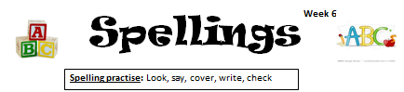

Spellings 

**[](http://www.google.co.uk/imgres?q=clipart+abc&safe=active&hl=en&biw=1280&bih=827&tbm=isch&tbnid=5R_iloF6PLG7QM:&imgrefurl=http://www.illustrationsof.com/1112353-royalty-free-abc-clipart-illustration&docid=lRG4ss-PISLCDM&imgurl=http://www.illustrationsof.com/royalty-free-abc-clipart-illustration-1112353.jpg&w=400&h=420&ei=eJTmUaPgDuzn7AaIi4DoBg&zoom=1&iact=hc&vpx=368&vpy=270&dur=1516&hovh=230&hovw=219&tx=134&ty=135&page=1&tbnh=145&tbnw=138&start=0&ndsp=38&ved=1t:429,r:26,s:0,i:163)**

**Spelling practise:** Look, say, cover, write, check



**Week 6**

|  |  |  |  |  |  |  |
| --- | --- | --- | --- | --- | --- | --- |
| **Look** | **Say** | **Cover** | **Write** | **Check** | **Write** | **Check** |
| Length |  |  |  |  |  |  |
| Strength |  |  |  |  |  |  |
| Purpose |  |  |  |  |  |  |
| History |  |  |  |  |  |  |
| Different |  |  |  |  |  |  |
| Difficult |  |  |  |  |  |  |
| Separate |  |  |  |  |  |  |
| Therefore |  |  |  |  |  |  |

**Sentence practise:** Now use your spellings in a sentence.

1)__________________________________________________________

2)__________________________________________________________

3)__________________________________________________________

4)__________________________________________________________

5)__________________________________________________________

6)__________________________________________________________

7)__________________________________________________________

8)__________________________________________________________

2.

3.

4.

5.

6.

7.

8.

**Additional Mathematics and English Homework**

Some parents may wish their children to undertake additional maths and English homework.

The school endorses the use of ‘Workabooks’, which are carefully planned to support children with their learning, consolidate classroom teaching and provide an organisational structure which will enable pupils to manage homework effectively with positive results. Parents can order and purchase these books directly from Workabook at [http://www.workabook.co.uk](http://www.workabook.co.uk/). Parents can access the answers to each activity through the Workabook website.

Please note that Workabooks are intended for home-use only. There is no requirement for children to bring their Workabooks into school.

A sample of the Workabooks can be viewed at the main school office or alternatively more information can be found at http://www.workabook.co.uk

