World Book Day 2022

It’s never too soon to start thinking about our favourite time of the year– World Book Day, taking place on 3rd March 2022! Last year’s World Book Day was incredibly challenging with most pupils learning at home, so we’re going all out with some extra special plans this year, which just so happens to tie in with World Book Day’s own exciting 25th anniversary celebrations taking place this year.
As usual we are expecting the children to come to school dressed as their favourite book character on the day. It’s the perfect opportunity for the children to bring their book characters to life. Clink on the link below for some great but easy ideas for costumes for your child.
World Book Day Dress Up Ideas
Extreme Reading Challenge!
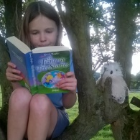
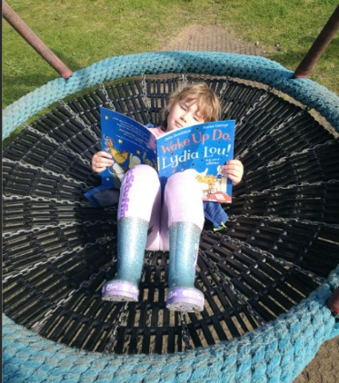
What is the weirdest most wonderful place you can read a book? Find a creative spot and get reading.
This year, we are hosting a challenge for our children, called the ‘Extreme Reading Competition 2022’. We would like children to get a photo of themselves reading their books in unusual and out-of-the-ordinary places. An example could be up a climbing frame or on a trampoline (children will need to be mindful of being safe and to check with an adult first). The more creative – the better! We would love for families to get involved as well so please feel free to join in. Children can bring in a hard copy of their photographs and send these to Mrs. Gunn or alternately a digital copy can be sent to the school office at post@olopprimary.co.uk.
Pictures will need to be sent in by Monday the 28th February at the latest.

Thank you for your support.

Here are a few examples to help with ideas!
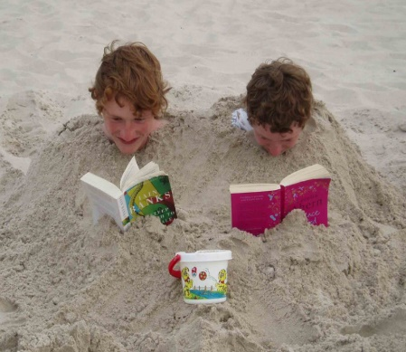

Author Visit
We have also invited a children’s author, Leysa Henderson, to deliver an assembly on World Book Day. The themes of her books George the Fraud and the Dragon, Lost Lives, The Day the Turtles Came Home. If you would like to purchase a personalised signed copy of any of the books, please complete the form attached and put the exact amount (we will not be able to give change) or a cheque addressed to Leysa Henderson with the form in a sealed envelope with your child’s full name, class and the name of the books being purchased. Please give the envelope to your child’s class teacher.

