Our Lady of Peace Catholic Primary and Nursery School
Year 1
Term: Pentecost 1
Homework Booklet
Year 1 Notices

Reading Day – Books changed each Monday
Please ensure that your child brings in their reading books and reading records each day.

Library Day – Friday
Please ensure your child brings in their black school bag every Friday.

P.E Days – Please make sure your child has a clearly labelled P.E kit in school at all times.
Year 1 St Teresa: Monday and Wednesday
Year 1 St Jude: Monday and Wednesday
Year 1 St Bernadette: Tuesday and Wednesday

Please note: Children are expected to get themselves dressed before and after PE. Please can you encourage your child to get dressed independently at home if they do not do so already, to help with this.

Welcome to your homework booklet for this half term.
In this booklet you will find six weeks’ worth of spellings. You need to learn these spellings carefully by using the look, say, cover and write method.
Your teacher will test you on your spellings each week on Thursday.
You can also login to your ‘Spelling Shed’ account to practise your spellings.

Login to your ‘Bug Club’ account for online reading challenges!

Pupils have been issued with their login details for the Times Tables Rock Stars website. You can now practise your 2, 5 and 10 timetables.

Your project for this half-term is…
This term in English we will be exploring the story of Hansel and Gretel. We would like your child to design and draw their own SWEET HOUSE. The project should also contain a written description of the house.
A descriptive text should include:
- Sentences: capital letters, finger spaces and the correct punctuation.
- Adjectives
- Joining conjunctions: and, because, so
To be handed in by 3/5/19

We would like to encourage you to support your child in the research; however they should complete the project independently.
To be handed in by:16.11.18

To be handed in: (date)

BRAIN BUILDERS

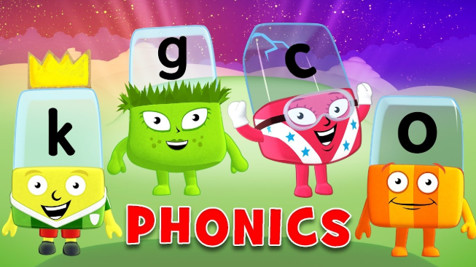
In this booklet you will find real and nonsense words which you should practise reading by segmenting and blending. This activity will help you in preparation for Phonics Screening test which will take place later in Year 1.

Maths for Pentecost 1

Number: Multiplication and Division

Count in multiples of twos, fives and tens.
Solve one step problems involving multiplication and division, by calculating the answer using concrete objects, pictorial representations and arrays with the support of the teacher

Fractions:

Recognise, find and name a half as one of two equal parts of an object, shape or quantity.
Recognise, find and name a quarter as one of four equal parts of an object, shape or quantity.

Log-in to your ‘My Maths’ account and, each week, complete the activity listed in the table below.
Week Beginning 22.4.19 | Week Beginning  29.4.19 | Week Beginning 6.5.19 | Week Beginning 13.5.19 | Week Beginning 20.5.19
Multiplication instructions | Division instructions | Multiplication and division 1 | http://www.snappymaths.com/counting/fractions/interactive/halfornotimm/halfornotimm.htm | https://www.topmarks.co.uk/times-tables/coconut-multiples

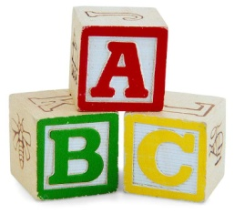
Week 1
Test 25.3.19
Spelling practise: Look, say, cover, write, check

Spellings

Look | Say | Cover | Write | Check | Write | Check
example |  |  | exampel |  | example
Monday
Tuesday
Wednesday
Thursday
Friday
Saturday
Sunday
week

Sentence practise: Now use your spellings in a sentence.
1)__________________________________________________________
2)__________________________________________________________
3)__________________________________________________________
4)__________________________________________________________
5)__________________________________________________________
6)__________________________________________________________
7)__________________________________________________________
8)__________________________________________________________

4.
5.
6.
7.
8.

Look | Say | Cover | Write | Check | Write | Check
example |  |  | exampel |  | example
January
February
March
April
May
June
July
August
Spellings
Week 2
Test 2.5.19
Spelling practise: Look, say, cover, write, check

Sentence practise: Now use your spellings in a sentence.
1)__________________________________________________________
2)__________________________________________________________
3)__________________________________________________________
4)__________________________________________________________
5)__________________________________________________________
6)__________________________________________________________
7)__________________________________________________________
8)__________________________________________________________
1
2.
3.
4.
5.
6.
7.
8.

Look | Say | Cover | Write | Check | Write | Check
example |  |  | exampel |  | example
September
October
November
December
year
month
hour
time
Week 3
Test 9.5.19
Spellings
Spelling practise: Look, say, cover, write, check

Sentence practise: Now use your spellings in a sentence.
1)__________________________________________________________
2)__________________________________________________________
3)__________________________________________________________
4)__________________________________________________________
5)__________________________________________________________
6)__________________________________________________________
7)__________________________________________________________
8)__________________________________________________________

1
2.
3.
4.
5.
6.
7.
8.

Week 4
Test 16.5.19
Spelling practise: Look, say, cover, write, check

Spellings
Look | Say | Cover | Write | Check | Write | Check
example |  |  | exampel |  | example
what
where
who
how
why
when
do
does

Sentence practise: Now use your spellings in a sentence.
1)__________________________________________________________
2)__________________________________________________________
3)__________________________________________________________
4)__________________________________________________________
5)__________________________________________________________
6)__________________________________________________________
7)__________________________________________________________
8)__________________________________________________________
2.
3.
4.
5.
6.
7.
8.

Week 5
Test 24.5.19
Spellings
Spelling practise: Look, say, cover, write, check

Look | Say | Cover | Write | Check | Write | Check
example |  |  | exampel |  | example
needle
noodle
tickle
uncle
angle
poodle
bundle
candle

Sentence practise: Now use your spellings in a sentence.
1)__________________________________________________________
2)__________________________________________________________
3)__________________________________________________________
4)__________________________________________________________
5)__________________________________________________________
6)__________________________________________________________
7)__________________________________________________________
8)__________________________________________________________

1
2.
3.
4.
5.
6.
7.
8.

Handwriting Homework

There is a page of a handwriting practice for each week. Please support your child in practising continuous cursive handwriting as well as correct pencil grip and sitting position when writing.
