Our Lady of Peace Catholic Primary and Nursery School
Year 2
Term: Lenten 1
Homework Booklet

Year 2 Notices

Reading Day – Books changed each Thursday
Please ensure that your child brings in their reading books and reading records each day.

Library Day – Friday
Please ensure your child brings in their black school bag every Friday.

P.E Days – Please make sure your child has a clearly labelled P.E kit in school at all times.
Year 2 St Christopher: Wednesday and Thursday
Year 2 St Mary-Magdalene: Tuesday and Thursday
Year 2 St Thomas Moore: Tuesday and Thursday

Please note: Children are expected to get themselves dressed before and after PE. Please can you encourage your child to get dressed independently at home if they do not do so already, to help with this.

Don’t forget to read your Bug Club Books!

These will be updated regularly.

Welcome to your homework booklet for this half term.
In this booklet you will find six weeks’ worth of spellings. You need to learn these spellings carefully by using the look, say, cover and write method. You then have some space at the bottom of the page to put each of your spelling words into a sentence.
Your teacher will test you on your spellings each Friday. The first spelling test will be on Friday 10th January 2020

Login to your ‘Times Tables Rock Stars’ account to practise your times tables!
Your teacher will test you on your times tables each week.

Your project for this half-term is…
Choose a journey that you have been on with your family. It can be a long or short journey; one you did recently, or one you did a long time ago. Make a collage of pictures, or photos or written memories from that journey: e.g What mode of transport did you use? How long were you travelling? Why were you travelling? What was it like when you got there? How did you feel?

You can present it in any way you like; handwritten or typed on a computer, pictures you have created or printed, or anything else you can think of! We look forward to hearing about your special journeys!

Due in Wednesday 5th February 2020

BRAIN BUILDERS

Maths for Lenten Term 1 (In class)
Multiplication and Division:

Shape
Pupils will soon be issued with their login details for the ‘MyMaths’ website. Further information about ‘MyMaths’ will be provided in the near future.

Additional Mathematics and English Homework

Some parents may wish their children to undertake additional maths and English homework.

The school endorses the use of ‘Workabooks’, which are carefully planned to support children with their learning, consolidate classroom teaching and provide an organisational structure which will enable pupils to manage homework effectively with positive results. Parents can order and purchase these books directly from Workabook at http://www.workabook.co.uk. Parents can access the answers to each activity through the Workabook website.

Please note that Workabooks are intended for home-use only. There is no requirement for children to bring their Workabooks into school.

A sample of the Workabooks can be viewed at the main school office or alternatively more information can be found at http://www.workabook.co.uk
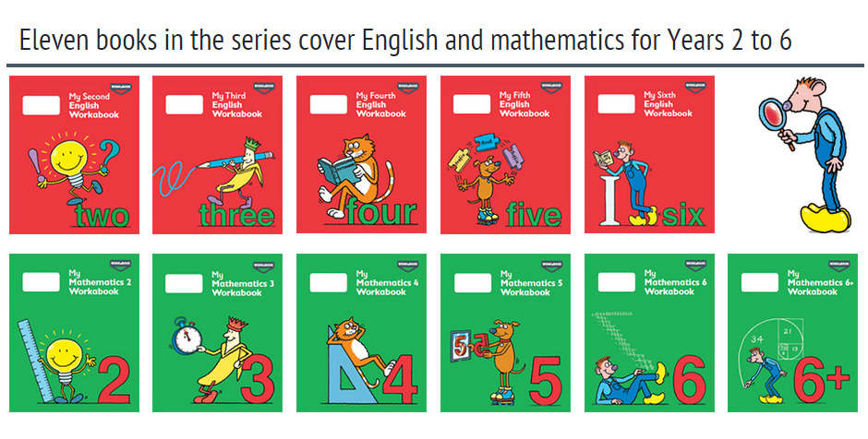

Spelling practise: Look, say, cover, write, check

Week 1
Spellings

Look | Say | Cover | Write | Check | Write | Check
example |  |  | exampel |  | example
draw
straw
claw
dragon
white
suddenly
why
where

Sentence practise: Now use your spellings in a sentence.
1)__________________________________________________________
2)__________________________________________________________
3)__________________________________________________________
4)__________________________________________________________
5)__________________________________________________________
6)__________________________________________________________
7)__________________________________________________________
8)__________________________________________________________

4.
5.
6.
7.
8.

Look | Say | Cover | Write | Check | Write | Check
example |  |  | exampel |  | example
who
what
when
went
half
lion
teach
taught
Spellings
Week 2
Spelling practise: Look, say, cover, write, check

Sentence practise: Now use your spellings in a sentence.
1)__________________________________________________________
2)__________________________________________________________
3)__________________________________________________________
4)__________________________________________________________
5)__________________________________________________________
6)__________________________________________________________
7)__________________________________________________________
8)__________________________________________________________
1
2.
3.
4.
5.
6.
7.
8.

Look | Say | Cover | Write | Check | Write | Check
example |  |  | exampel |  | example
eye
clothes
climate
used
finally
great
your
sure
Spellings
Week 3
Spelling practise: Look, say, cover, write, check

Sentence practise: Now use your spellings in a sentence.
1)__________________________________________________________
2)__________________________________________________________
3)__________________________________________________________
4)__________________________________________________________
5)__________________________________________________________
6)__________________________________________________________
7)__________________________________________________________
8)__________________________________________________________

1
2.
3.
4.
5.
6.
7.
8.

Look | Say | Cover | Write | Check | Write | Check
example |  |  | exampel |  | example
screw
drew
break
steak
shape
elephant
think
thought
Spelling practise: Look, say, cover, write, check

Week 4
Spellings

Sentence practise: Now use your spellings in a sentence.
1)__________________________________________________________
2)__________________________________________________________
3)__________________________________________________________
4)__________________________________________________________
5)__________________________________________________________
6)__________________________________________________________
7)__________________________________________________________
8)__________________________________________________________
2.
3.
4.
5.
6.
7.
8.

Look | Say | Cover | Write | Check | Write | Check
example |  |  | exampel |  | example
choice
choose
lost
lots
people
challenge
Africa
however
Week 5
Spelling practise: Look, say, cover, write, check

Spellings

Sentence practise: Now use your spellings in a sentence.
1)__________________________________________________________
2)__________________________________________________________
3)__________________________________________________________
4)__________________________________________________________
5)__________________________________________________________
6)__________________________________________________________
7)__________________________________________________________
8)__________________________________________________________

1
2.
3.
4.
5.
6.
7.
8.

