Our Lady of Peace Catholic Primary and Nursery School



**Year 2**

**Term: Lenten 2**

**Homework Booklet**

**Welcome to your homework booklet for this half term.**

**Year 2 Notices**

**Reading** **Day** **–** **Books changed each Thursday**

Pleaseensure that your child brings in their reading books and reading records each day.

**Library Day – Friday**

Please ensure your child brings in their black school bag every Friday.

**P.E Days –** Please make sure your child has a clearly labelled P.E kit in school at all times.

**Year 2 St Christopher:** Wednesday and Thursday

**Year 2 St Mary-Magdalene:** Tuesday and Wednesday

**Year 2 St Thomas Moore:** Wednesday and Thursday

***Please note:*** *Children are expected to get themselves dressed before and after PE. Please can you encourage your child to get dressed independently at home.*

**Don’t forget to read your Bug Club Books!**

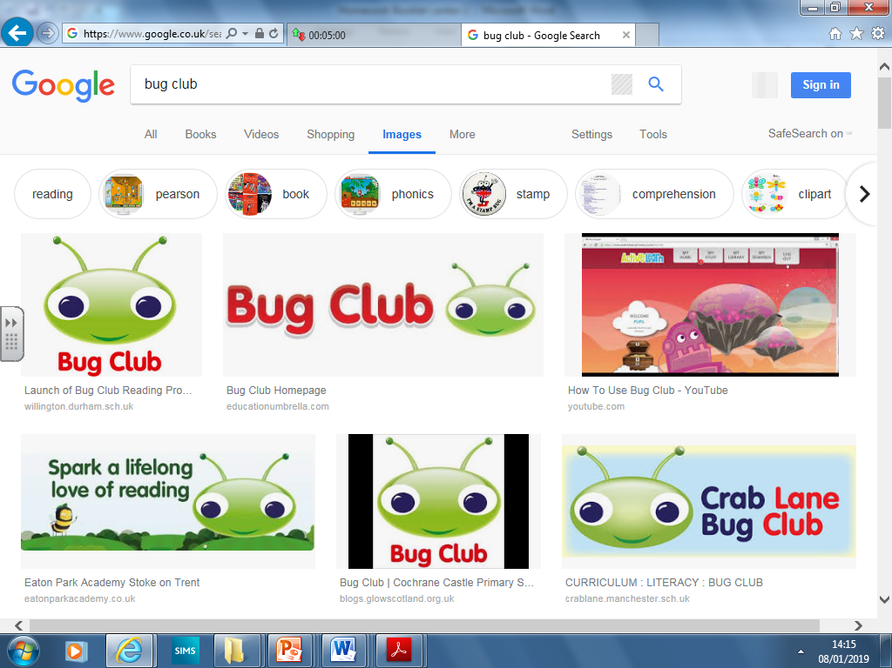 These will be updated regularly.



In this booklet you will find six weeks’ worth of spellings. You need to learn these spellings carefully by using the look, say, cover and write method. You then have some space at the bottom of the page to put each of your spelling words into a sentence.

Your teacher will test you on your spellings each Friday. **The first spelling test will be on Friday 28th February 2020**



Login to your **‘Times Tables Rock Stars’** account to practise your times tables!

Your teacher will test you on your times tables each week.



Your project for this half-term is…

To make a fact page about aeroplanes!

In history this half term we will be learning about the invention of flight. Please use books, the internet, or any knowledge from family members to help you make an exciting and informative fact page about aeroplanes. You can present it as a colourful poster or as paragraphs of text; you can do it by hand or on the computer. You might want to look into the sky (safely!) and see if you can spot many planes, take some photographs, or maybe you have been on a plane and can use that experience to describe what it was like!

**Due in Monday 30th March 2020.**

**BRAIN BUILDERS**

**Maths for Lenten Term 2**

**Fractions:**



**Measurement: Length and Height:**

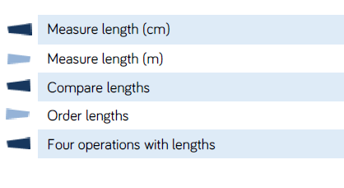



Log-in to your **‘My Maths’** account and, each week, complete the activity listed in the table below.

**The Importance of Times Tables:**

We all know that learning time tables is an essential part of your child's mathematical education. Children who have mastered their tables gain a solid foundation in mathematics that will help them throughout their progression within the subject. Many children are able to recite in order their timetables, but to truly know the answer to any times table question independently is a skill that takes a lot of hard work. The national expectation is that every child will be able to answer any times table question mentally within a five second period.

**Expectation:**

**By the end of Year 2 children should know the 2, 5 and 10 times table.** Please practice these each week with you child. There will be a times table quiz during the last week of the term.

|  |  |  |
| --- | --- | --- |
| **2’s** | **5’s** | **10’s** |
| 0x2=0  1x2=2  2x2=4  3x2=6  4x2=8  5x2=10  6x2=12  7x2=14  8x2=16  9x2=18  10x2=20 | 0x5=0  1x5=5  2x5=10  3x5=15  4x5=20  5x5=25  6x5=30  7x5=35  8x5=40  9x5=45  10x5=50 | 0x10=0  1x10=10  2x10=20  3x10=30  4x10=40  5x10=50  6x10=60  7x10=70  8x10=80  9x10=90  10x10=100 |

**Additional Mathematics and English Homework**

Some parents may wish their children to undertake additional maths and English homework.

The school endorses the use of ‘Workabooks’, which are carefully planned to support children with their learning, consolidate classroom teaching and provide an organisational structure which will enable pupils to manage homework effectively with positive results. Parents can order and purchase these books directly from Workabook at [http://www.workabook.co.uk](http://www.workabook.co.uk/). Parents can access the answers to each activity through the Workabook website.

Please note that Workabooks are intended for home-use only. There is no requirement for children to bring their Workabooks into school.

A sample of the Workabooks can be viewed at the main school office or alternatively more information can be found at http://www.workabook.co.uk

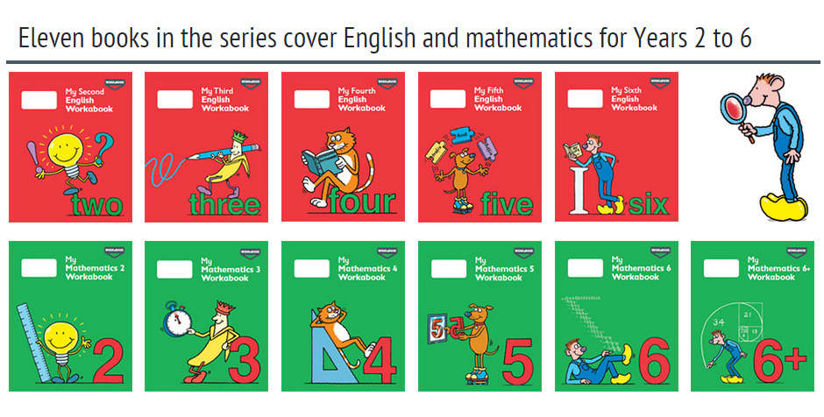



**Week 1**

Spellings

|  |  |  |  |  |  |  |
| --- | --- | --- | --- | --- | --- | --- |
| **Look** | **Say** | **Cover** | **Write** | **Check** | **Write** | **Check** |
| **example** |  |  | ***exampel*** | **🗶** | ***example*** | **✓** |
| other |  |  |  |  |  |  |
| mother |  |  |  |  |  |  |
| brother |  |  |  |  |  |  |
| nothing |  |  |  |  |  |  |
| Monday |  |  |  |  |  |  |
| money |  |  |  |  |  |  |
| cover |  |  |  |  |  |  |
| honey |  |  |  |  |  |  |
| discover |  |  |  |  |  |  |
| wonder |  |  |  |  |  |  |

**Sentence practise:** Now use your spellings in a sentence.

1)__________________________________________________________

2)__________________________________________________________

3)__________________________________________________________

4)__________________________________________________________

5)__________________________________________________________

6)__________________________________________________________

7)__________________________________________________________

8)__________________________________________________________

9)__________________________________________________________

10)_________________________________________________________

4.

5.

6.

7.

8.

|  |  |  |  |  |  |  |
| --- | --- | --- | --- | --- | --- | --- |
| **Look** | **Say** | **Cover** | **Write** | **Check** | **Write** | **Check** |
| **example** |  |  | ***exampel*** | **🗶** | ***example*** | **✓** |
| key |  |  |  |  |  |  |
| donkey |  |  |  |  |  |  |
| monkey |  |  |  |  |  |  |
| chimney |  |  |  |  |  |  |
| valley |  |  |  |  |  |  |
| trolley |  |  |  |  |  |  |
| turkey |  |  |  |  |  |  |
| hockey |  |  |  |  |  |  |
| parsley |  |  |  |  |  |  |
| journey |  |  |  |  |  |  |



**Sentence practise:** Now use your spellings in a sentence.

1)__________________________________________________________

2)__________________________________________________________

3)__________________________________________________________

4)__________________________________________________________

5)__________________________________________________________

6)__________________________________________________________

7)__________________________________________________________

8)__________________________________________________________

9)__________________________________________________________

10)_________________________________________________________

4.

5.

6.

7.

8.

**Week 2**

Spellings

**Week 3**

Spellings



|  |  |  |  |  |  |  |
| --- | --- | --- | --- | --- | --- | --- |
| **Look** | **Say** | **Cover** | **Write** | **Check** | **Write** | **Check** |
| **example** |  |  | ***exampel*** | **🗶** | ***example*** | **✓** |
| want |  |  |  |  |  |  |
| watch |  |  |  |  |  |  |
| wander |  |  |  |  |  |  |
| quantity |  |  |  |  |  |  |
| squash |  |  |  |  |  |  |
| quality |  |  |  |  |  |  |
| squabble |  |  |  |  |  |  |
| squad |  |  |  |  |  |  |
| quad |  |  |  |  |  |  |
| quarrel |  |  |  |  |  |  |

**Sentence practise:** Now use your spellings in a sentence.

1)__________________________________________________________

2)__________________________________________________________

3)__________________________________________________________

4)__________________________________________________________

5)__________________________________________________________

6)__________________________________________________________

7)__________________________________________________________

8)__________________________________________________________

9)__________________________________________________________

10)_________________________________________________________

4.

5.

6.

7.

8.



**Week 4**

Spellings

|  |  |  |  |  |  |  |
| --- | --- | --- | --- | --- | --- | --- |
| **Look** | **Say** | **Cover** | **Write** | **Check** | **Write** | **Check** |
| **example** |  |  | ***exampel*** | **🗶** | ***example*** | **✓** |
| word |  |  |  |  |  |  |
| work |  |  |  |  |  |  |
| worm |  |  |  |  |  |  |
| world |  |  |  |  |  |  |
| worth |  |  |  |  |  |  |
| worst |  |  |  |  |  |  |
| war |  |  |  |  |  |  |
| warm |  |  |  |  |  |  |
| towards |  |  |  |  |  |  |
| ward |  |  |  |  |  |  |

**Sentence practise:** Now use your spellings in a sentence.

1)__________________________________________________________

2)__________________________________________________________

3)__________________________________________________________

4)__________________________________________________________

5)__________________________________________________________

6)__________________________________________________________

7)__________________________________________________________

8)__________________________________________________________

9)__________________________________________________________

10)_________________________________________________________

4.

5.

6.

7.

8.

|  |  |  |  |  |  |  |
| --- | --- | --- | --- | --- | --- | --- |
| **Look** | **Say** | **Cover** | **Write** | **Check** | **Write** | **Check** |
| **example** |  |  | ***exampel*** | **🗶** | ***example*** | **✓** |
| television |  |  |  |  |  |  |
| treasure |  |  |  |  |  |  |
| usual |  |  |  |  |  |  |
| division |  |  |  |  |  |  |
| vision |  |  |  |  |  |  |
| pleasure |  |  |  |  |  |  |
| measure |  |  |  |  |  |  |
| occasion |  |  |  |  |  |  |
| usually |  |  |  |  |  |  |
| leisure |  |  |  |  |  |  |



**Sentence practise:** Now use your spellings in a sentence.

1)__________________________________________________________

2)__________________________________________________________

3)__________________________________________________________

4)__________________________________________________________

5)__________________________________________________________

6)__________________________________________________________

7)__________________________________________________________

8)__________________________________________________________

9)__________________________________________________________

10)_________________________________________________________

4.

5.

6.

7.

8.

**Week 5**

Spellings



|  |  |  |  |  |  |  |
| --- | --- | --- | --- | --- | --- | --- |
| **Look** | **Say** | **Cover** | **Write** | **Check** | **Write** | **Check** |
| **example** |  |  | ***exampel*** | **🗶** | ***example*** | **✓** |
| even |  |  |  |  |  |  |
| break |  |  |  |  |  |  |
| steak |  |  |  |  |  |  |
| great |  |  |  |  |  |  |
| move |  |  |  |  |  |  |
| prove |  |  |  |  |  |  |
| improve |  |  |  |  |  |  |
| sure |  |  |  |  |  |  |
| sugar |  |  |  |  |  |  |
| eye |  |  |  |  |  |  |

**Sentence practise:** Now use your spellings in a sentence.

1)__________________________________________________________

2)__________________________________________________________

3)__________________________________________________________

4)__________________________________________________________

5)__________________________________________________________

6)__________________________________________________________

7)__________________________________________________________

8)__________________________________________________________

9)__________________________________________________________

10)_________________________________________________________

4.

5.

6.

7.

8.

**Week 6**

Spellings 