DIOCESE OF NORTHAMPTON

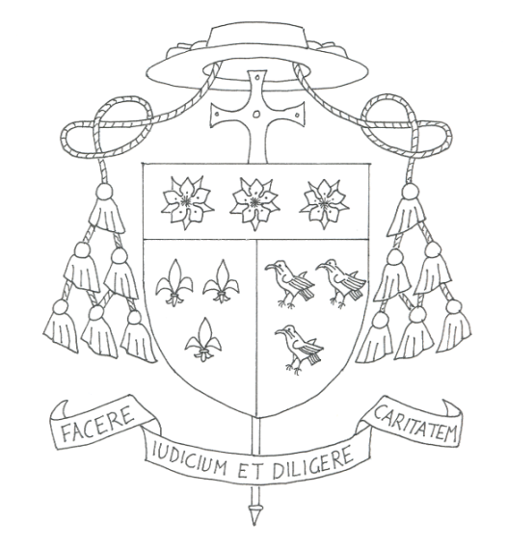

PASTORAL LETTER FOR THE DIOCESAN EDUCATION SUNDAY 2017

Dear Brothers and Sisters

Last Friday I celebrated the Diocesan Schools’ Mass in Dunstable with about 800 children, young people and staff representing all the schools of the Diocese as part of our Diocesan Schools Week. It was a particularly joyful occasion bringing so many of the young together in prayer. It is one reason why I want to speak to you today about the education of our young people.

I want to begin by thanking you who are parents. You are the first and principal educators of your children. As the local Church, we want to support you in your responsibility for this. Where we can, we do this through providing Catholic schools. I want also to thank most sincerely all those people in the parishes who are committed to the work of catechesis for our young people, especially where you do not have a Catholic school within reach.

In our schools, we hope that all our young people who study there, will come to know Jesus Christ as the Way, the Truth and the Life. We believe he is the fullness of life and should be at the centre of our lives. This is why the Church is so committed to maintaining and strengthening our schools as a vital part of the mission of the Gospel today. Our schools are privileged places where young and old alike meet Christ, hear his Word, and are helped to understand the teaching of our Church and her traditions.

Secondly, as you all know, our society, and education in particular, is experiencing significant change. For our schools to be faithful to their mission, the work of those who lead, direct and govern our schools is more important than ever. I want to take this opportunity to record our deep gratitude to those of you who are teachers, other staff, leaders, directors or governors in our Catholic Schools. You all have demanding roles, and I am very grateful for the time you give to serving the children in our schools and supporting the many parents who have entrusted their children to your care.

The leaders, governors and directors of our Catholic schools are central to ensuring that the spiritual and academic life is the best it can be. Helping them and supporting more people to take on these roles is crucial for the future of Catholic education in our Diocese.

So my third point is to ask you all to pray and do whatever you can to help us to recruit more practising Catholics to work as teachers, leaders, governors, and directors in our schools. We need people who, in the midst of all changes to education policy, will keep Christ at the centre of everything they do. I would like you to consider whether you are someone who could serve our children as they grow in faith by teaching or working in another capacity in our Catholic schools. Could you serve as a governor or director? If you feel that you are called to this particular service then please speak with your priest or contact NORES, the diocesan education service for more information. The details can be found in your newsletter.

With all the Bishops of England and Wales, I recognise the great value of our Catholic schools as vital to the life of the Church and our society. We are committed to continue to provide and invest in Catholic education in England and Wales. This depends on your commitment, too, and on your support at this crucial time. Please remember our schools, our young people and their families, all the staff, governors and directors in your daily prayers.

Finally I want to thank all who do so much for our schools in every way. They are places where we trust and pray that our young people, like the young Jesus “will increase in wisdom and stature, and grow in favour with God and all people.” (Luke 2:52)

With every blessing,
Bishop of Northampton

To be read and/or made available at all Masses of
the Twenty Eighth Ordinary Sunday of the Year
on the weekend of the 14/15 October 2017.

