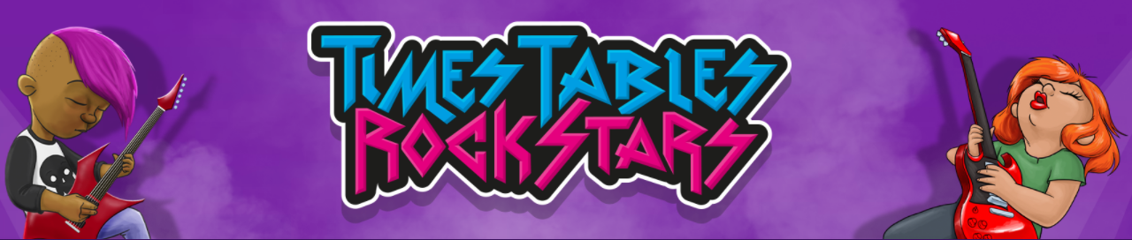A big well done to all those who contributed in the TTRS battles which have been going on this week. Below are the results for the year group battles.
A special mention to Harrison, Karolina and Avisha who earnt the highest number of coins over the last week.
The winner of the entire tournament was Harrison who has earned himself an Amazon £10 voucher! Many certificates, wristbands and badges were handed out this week. Keep up the good work!

Results
Year 3

Year 4

Year 5
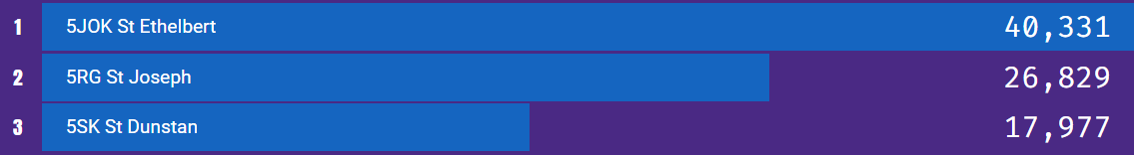

Year 6

New tournaments have started! Girls Vs Boys. Best of luck!

