Our Lady of Peace Catholic Primary and Nursery School



**Year 2**

**Term: Advent Term 2 2018**

**Homework Booklet**

**Year 2 Notices**

**Reading** **Day** **–** **Books changed each Thursday**

Pleaseensure that your child brings in their reading books and reading records each day.

**Library Day – Friday**

Please ensure your child brings in their black school bag every Friday.

**P.E Days –** Please make sure your child has a clearly labelled P.E kit in school at all times.

**Year 2 St Christopher:** Wednesday and Thursday

**Year 2 St Mary-Magdalene:** Wednesday and Thursday

**Year 2 St Thomas Moore:** Monday and Tuesday

***Please note:*** *Children are expected to get themselves dressed before and after PE. Please can you encourage your child to get dressed independently at home if they do not do so already, to help with this.*

**Welcome to your homework booklet for this half term.**



In this booklet you will find six weeks’ worth of spellings. You need to learn these spellings carefully by using the look, say, cover and write method. You can also login to your **‘Spelling Shed’** account to practise your spellings. You then have some space at the bottom of the page to put each of your spelling words into a sentence.

Your teacher will test you on your spellings each week.



Login to your **‘Times Tables Rock Stars’** account to practise your times tables!



Login to your ‘**Bug Club’** account for online reading challenges! More information to follow.

**BRAIN BUILDERS**

 

**Your project for this half-term is**…to find out about your family history. Can you find out the names of all the people in your family and where they live? Make a simple family tree.

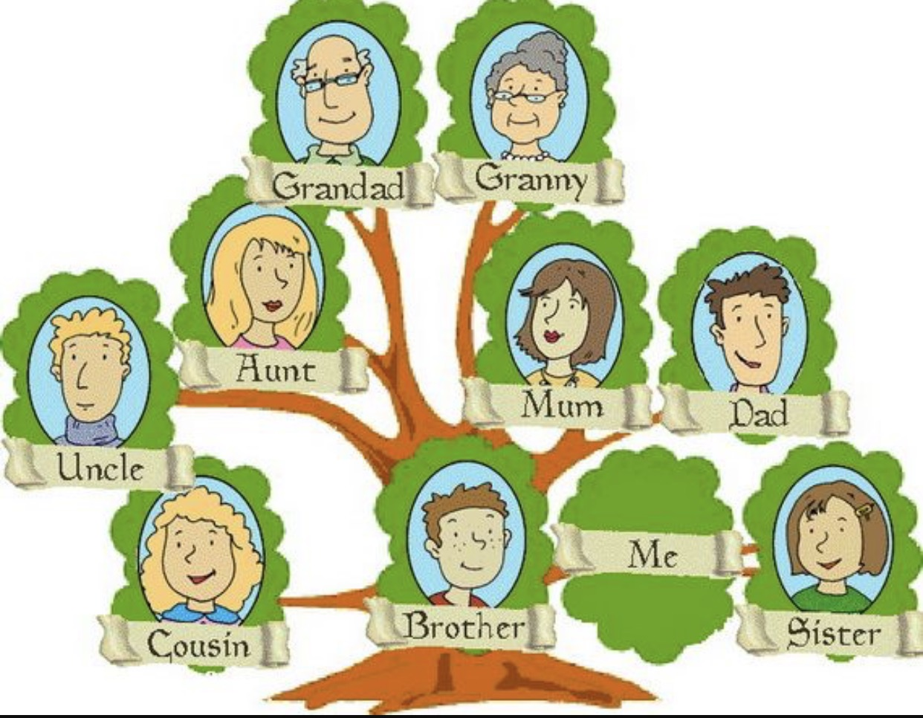 **To be handed in: Monday 3rd December**

**Maths for Advent Term 2**

**Number – Addition and Subtraction**

* Recall and use addition and subtraction facts to 20 fluently, and derive and use related facts up to 100.
* Add and subtract numbers using concrete objects, pictorial representations, and mentally, including: a two-digit number and ones; a two-digit number and tens; two two-digit numbers; adding three one-digit numbers.
* Show that the addition of two numbers can be done in any order (commutative) and subtraction of one number from another cannot.
* Solve problems with addition and subtraction: using concrete objects and pictorial representations, including those involving numbers, quantities and measures; applying their increasing knowledge of mental and written methods.
* Recognise and use the inverse relationship between addition and subtraction and use this to check calculations and solve missing number problems.

**Measurement: Money**

* Recognise and use symbols for pounds (£) and pence (p); combine amounts to make a particular value.
* Find different combinations of coins that equal the same amounts of money.
* Solve simple problems in a practical context involving addition and subtraction of money of the same unit, including giving change.



Log-in to your **‘My Maths’** account and, each week, complete the activity listed in the table below.

|  |  |  |  |  |  |
| --- | --- | --- | --- | --- | --- |
| **Week Beginning:**  5th November | **Week Beginning:**  12th November | **Week Beginning:**  19th November | **Week Beginning:**  26th November | **Week Beginning:**  3rd December | **Week Beginning:**  10th December |
| Place Value to 30 | Place Value: Tens and Ones | Add Single Digits | Subtract Single Digits | Adding and Taking Away | Using Money |

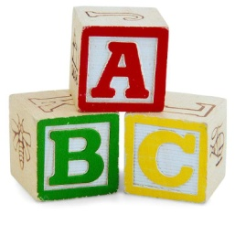[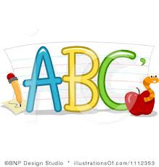](http://www.google.co.uk/imgres?q=clipart+abc&safe=active&hl=en&biw=1280&bih=827&tbm=isch&tbnid=5R_iloF6PLG7QM:&imgrefurl=http://www.illustrationsof.com/1112353-royalty-free-abc-clipart-illustration&docid=lRG4ss-PISLCDM&imgurl=http://www.illustrationsof.com/royalty-free-abc-clipart-illustration-1112353.jpg&w=400&h=420&ei=eJTmUaPgDuzn7AaIi4DoBg&zoom=1&iact=hc&vpx=368&vpy=270&dur=1516&hovh=230&hovw=219&tx=134&ty=135&page=1&tbnh=145&tbnw=138&start=0&ndsp=38&ved=1t:429,r:26,s:0,i:163)

**Spelling practise:** Look, say, cover, write, check

**Week 1**

Spellings

|  |  |  |  |  |  |  |
| --- | --- | --- | --- | --- | --- | --- |
| **Look** | **Say** | **Cover** | **Write** | **Check** | **Write** | **Check** |
| **example** |  |  | ***exampel*** | **🗶** | ***example*** | **✓** |
| sea |  |  |  |  |  |  |
| see |  |  |  |  |  |  |
| be |  |  |  |  |  |  |
| bee |  |  |  |  |  |  |
| grey |  |  |  |  |  |  |
| today |  |  |  |  |  |  |
| play |  |  |  |  |  |  |
| dragon |  |  |  |  |  |  |

**Sentence practise:** Now use your spellings in a sentence.

1)__________________________________________________________

2)__________________________________________________________

3)__________________________________________________________

4)__________________________________________________________

5)__________________________________________________________

6)__________________________________________________________

7)__________________________________________________________

8)__________________________________________________________

4.

5.

6.

7.

8.

**[](http://www.google.co.uk/imgres?q=clipart+abc&safe=active&hl=en&biw=1280&bih=827&tbm=isch&tbnid=5R_iloF6PLG7QM:&imgrefurl=http://www.illustrationsof.com/1112353-royalty-free-abc-clipart-illustration&docid=lRG4ss-PISLCDM&imgurl=http://www.illustrationsof.com/royalty-free-abc-clipart-illustration-1112353.jpg&w=400&h=420&ei=eJTmUaPgDuzn7AaIi4DoBg&zoom=1&iact=hc&vpx=368&vpy=270&dur=1516&hovh=230&hovw=219&tx=134&ty=135&page=1&tbnh=145&tbnw=138&start=0&ndsp=38&ved=1t:429,r:26,s:0,i:163)**

Spellings

**Week 2**

**Spelling practise:** Look, say, cover, write, check

|  |  |  |  |  |  |  |
| --- | --- | --- | --- | --- | --- | --- |
| **Look** | **Say** | **Cover** | **Write** | **Check** | **Write** | **Check** |
| **example** |  |  | ***exampel*** | **🗶** | ***example*** | **✓** |
| blue |  |  |  |  |  |  |
| blew |  |  |  |  |  |  |
| flour |  |  |  |  |  |  |
| flower |  |  |  |  |  |  |
| whole |  |  |  |  |  |  |
| hole |  |  |  |  |  |  |
| bear |  |  |  |  |  |  |
| castle |  |  |  |  |  |  |

**Sentence practise:** Now use your spellings in a sentence.

1)__________________________________________________________

2)__________________________________________________________

3)__________________________________________________________

4)__________________________________________________________

5)__________________________________________________________

6)__________________________________________________________

7)__________________________________________________________

8)__________________________________________________________

1

2.

3.

4.

5.

6.

7.

8.

**[](http://www.google.co.uk/imgres?q=clipart+abc&safe=active&hl=en&biw=1280&bih=827&tbm=isch&tbnid=5R_iloF6PLG7QM:&imgrefurl=http://www.illustrationsof.com/1112353-royalty-free-abc-clipart-illustration&docid=lRG4ss-PISLCDM&imgurl=http://www.illustrationsof.com/royalty-free-abc-clipart-illustration-1112353.jpg&w=400&h=420&ei=eJTmUaPgDuzn7AaIi4DoBg&zoom=1&iact=hc&vpx=368&vpy=270&dur=1516&hovh=230&hovw=219&tx=134&ty=135&page=1&tbnh=145&tbnw=138&start=0&ndsp=38&ved=1t:429,r:26,s:0,i:163)**

Spellings

**Week 3**

**Spelling practise:** Look, say, cover, write, check

|  |  |  |  |  |  |  |
| --- | --- | --- | --- | --- | --- | --- |
| **Look** | **Say** | **Cover** | **Write** | **Check** | **Write** | **Check** |
| **example** |  |  | ***exampel*** | **🗶** | ***example*** | **✓** |
| to |  |  |  |  |  |  |
| too |  |  |  |  |  |  |
| two |  |  |  |  |  |  |
| night |  |  |  |  |  |  |
| knight |  |  |  |  |  |  |
| there |  |  |  |  |  |  |
| their |  |  |  |  |  |  |
| queen |  |  |  |  |  |  |

**Sentence practise:** Now use your spellings in a sentence.

1)__________________________________________________________

2)__________________________________________________________

3)__________________________________________________________

4)__________________________________________________________

5)__________________________________________________________

6)__________________________________________________________

7)__________________________________________________________

8)__________________________________________________________

1

2.

3.

4.

5.

6.

7.

8.

**[](http://www.google.co.uk/imgres?q=clipart+abc&safe=active&hl=en&biw=1280&bih=827&tbm=isch&tbnid=5R_iloF6PLG7QM:&imgrefurl=http://www.illustrationsof.com/1112353-royalty-free-abc-clipart-illustration&docid=lRG4ss-PISLCDM&imgurl=http://www.illustrationsof.com/royalty-free-abc-clipart-illustration-1112353.jpg&w=400&h=420&ei=eJTmUaPgDuzn7AaIi4DoBg&zoom=1&iact=hc&vpx=368&vpy=270&dur=1516&hovh=230&hovw=219&tx=134&ty=135&page=1&tbnh=145&tbnw=138&start=0&ndsp=38&ved=1t:429,r:26,s:0,i:163)**

**Spelling practise:** Look, say, cover, write, check

Spellings

**Week 4**

|  |  |  |  |  |  |  |
| --- | --- | --- | --- | --- | --- | --- |
| **Look** | **Say** | **Cover** | **Write** | **Check** | **Write** | **Check** |
| **example** |  |  | ***exampel*** | **🗶** | ***example*** | **✓** |
| some |  |  |  |  |  |  |
| come |  |  |  |  |  |  |
| here |  |  |  |  |  |  |
| friend |  |  |  |  |  |  |
| school |  |  |  |  |  |  |
| house |  |  |  |  |  |  |
| said |  |  |  |  |  |  |
| king |  |  |  |  |  |  |

**Sentence practise:** Now use your spellings in a sentence.

1)__________________________________________________________

2)__________________________________________________________

3)__________________________________________________________

4)__________________________________________________________

5)__________________________________________________________

6)__________________________________________________________

7)__________________________________________________________

8)__________________________________________________________

2.

3.

4.

5.

6.

7.

8.

**[](http://www.google.co.uk/imgres?q=clipart+abc&safe=active&hl=en&biw=1280&bih=827&tbm=isch&tbnid=5R_iloF6PLG7QM:&imgrefurl=http://www.illustrationsof.com/1112353-royalty-free-abc-clipart-illustration&docid=lRG4ss-PISLCDM&imgurl=http://www.illustrationsof.com/royalty-free-abc-clipart-illustration-1112353.jpg&w=400&h=420&ei=eJTmUaPgDuzn7AaIi4DoBg&zoom=1&iact=hc&vpx=368&vpy=270&dur=1516&hovh=230&hovw=219&tx=134&ty=135&page=1&tbnh=145&tbnw=138&start=0&ndsp=38&ved=1t:429,r:26,s:0,i:163)**

Spellings

**Spelling practise:** Look, say, cover, write, check

**Week 5**

|  |  |  |  |  |  |  |
| --- | --- | --- | --- | --- | --- | --- |
| **Look** | **Say** | **Cover** | **Write** | **Check** | **Write** | **Check** |
| **example** |  |  | ***exampel*** | **🗶** | ***example*** | **✓** |
| beautiful |  |  |  |  |  |  |
| here |  |  |  |  |  |  |
| there |  |  |  |  |  |  |
| where |  |  |  |  |  |  |
| love |  |  |  |  |  |  |
| our |  |  |  |  |  |  |
| hour |  |  |  |  |  |  |
| princess |  |  |  |  |  |  |

**Sentence practise:** Now use your spellings in a sentence.

1)__________________________________________________________

2)__________________________________________________________

3)__________________________________________________________

4)__________________________________________________________

5)__________________________________________________________

6)__________________________________________________________

7)__________________________________________________________

8)__________________________________________________________

1

2.

3.

4.

5.

6.

7.

8.

**[](http://www.google.co.uk/imgres?q=clipart+abc&safe=active&hl=en&biw=1280&bih=827&tbm=isch&tbnid=5R_iloF6PLG7QM:&imgrefurl=http://www.illustrationsof.com/1112353-royalty-free-abc-clipart-illustration&docid=lRG4ss-PISLCDM&imgurl=http://www.illustrationsof.com/royalty-free-abc-clipart-illustration-1112353.jpg&w=400&h=420&ei=eJTmUaPgDuzn7AaIi4DoBg&zoom=1&iact=hc&vpx=368&vpy=270&dur=1516&hovh=230&hovw=219&tx=134&ty=135&page=1&tbnh=145&tbnw=138&start=0&ndsp=38&ved=1t:429,r:26,s:0,i:163)**

**Week 6**

Spellings 

**Spelling practise:** Look, say, cover, write, check

|  |  |  |  |  |  |  |
| --- | --- | --- | --- | --- | --- | --- |
| **Look** | **Say** | **Cover** | **Write** | **Check** | **Write** | **Check** |
| **example** |  |  | ***exampel*** | **🗶** | ***example*** | **✓** |
| find |  |  |  |  |  |  |
| kind |  |  |  |  |  |  |
| mind |  |  |  |  |  |  |
| behind |  |  |  |  |  |  |
| child |  |  |  |  |  |  |
| wild |  |  |  |  |  |  |
| climb |  |  |  |  |  |  |
| prince |  |  |  |  |  |  |

**Sentence practise:** Now use your spellings in a sentence.

1)__________________________________________________________

2)__________________________________________________________

3)__________________________________________________________

4)__________________________________________________________

5)__________________________________________________________

6)__________________________________________________________

7)__________________________________________________________

8)__________________________________________________________

2.

3.

4.

5.

6.

7.

8.

**Additional Mathematics and English Homework**

Some parents may wish their children to undertake additional maths and English homework.

The school endorses the use of ‘Workabooks’, which are carefully planned to support children with their learning, consolidate classroom teaching and provide an organisational structure which will enable pupils to manage homework effectively with positive results. Parents can order and purchase these books directly from Workabook at [http://www.workabook.co.uk](http://www.workabook.co.uk/). Parents can access the answers to each activity through the Workabook website.

Please note that Workabooks are intended for home-use only. There is no requirement for children to bring their Workabooks into school.

A sample of the Workabooks can be viewed at the main school office or alternatively more information can be found at http://www.workabook.co.uk

