Our Lady of Peace Catholic Primary and Nursery School



**Year 4**

**Term: Pentecost 1**

**Homework Booklet**

**Welcome to your homework booklet for this half term.**



In this booklet you will find six weeks’ worth of spellings. You need to learn these spellings carefully by using the look, say, cover and write method. You can also login to your **‘Spelling Shed’** account to practise your spellings (this will be given to you by your class teacher). You then have some space at the bottom of the page to put each of your spelling words into a sentence.

Your teacher will test you on your spellings each week.



Login to your **‘Times Tables Rock Stars’** account to practise your times tables!

Your teacher will test you on your times tables each week.



Login to your ‘**Bug Club’** account for online reading challenges!

**Maths for Pentecost Term 1**

**BRAIN BUILDERS**

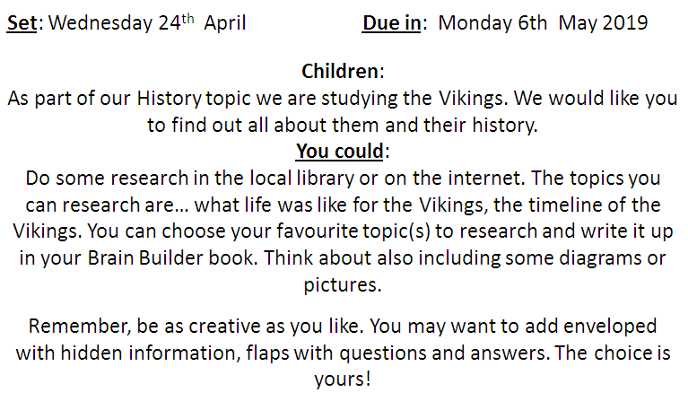

**Decimals**

To compare numbers with the same number of decimal places up to two decimal places. Round decimals with one decimal place to the nearest whole number. Recognise and write decimal equivalents to ½, ¼ and ¾. To find the effect of dividing a one or two digit number by 10 or 100,identifying the value of the digits in the answer as ones, tenths and hundredths.

**Money**

To estimate, compare and calculate different measures, including money in pounds and pence. To solve simple measure and money problems involving fractions and decimals to two decimal places.

**Time**

To read, write and convert time between analogue and digital 12-and 24-hour clocks.

Solve problems involving converting from hours to minutes; minutes to seconds; years to months; weeks to days.

.

. 

Pupils will soon be issued with their login details for the MyMaths website. Further information about MyMaths will be provided in the near future.

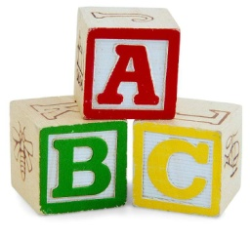[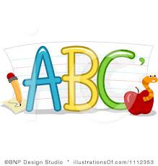](http://www.google.co.uk/imgres?q=clipart+abc&safe=active&hl=en&biw=1280&bih=827&tbm=isch&tbnid=5R_iloF6PLG7QM:&imgrefurl=http://www.illustrationsof.com/1112353-royalty-free-abc-clipart-illustration&docid=lRG4ss-PISLCDM&imgurl=http://www.illustrationsof.com/royalty-free-abc-clipart-illustration-1112353.jpg&w=400&h=420&ei=eJTmUaPgDuzn7AaIi4DoBg&zoom=1&iact=hc&vpx=368&vpy=270&dur=1516&hovh=230&hovw=219&tx=134&ty=135&page=1&tbnh=145&tbnw=138&start=0&ndsp=38&ved=1t:429,r:26,s:0,i:163)

**Spelling practise:** Look, say, cover, write, check

**Week 1**

Spellings

|  |  |  |  |  |  |  |
| --- | --- | --- | --- | --- | --- | --- |
| **Look** | **Say** | **Cover** | **Write** | **Check** | **Write** | **Check** |
| Interact |  |  |  |  |  |  |
| Interfere |  |  |  |  |  |  |
| International |  |  |  |  |  |  |
| Intermediate |  |  |  |  |  |  |
| Internet |  |  |  |  |  |  |
| Interrupt |  |  |  |  |  |  |
| Intervene |  |  |  |  |  |  |
| Interlude |  |  |  |  |  |  |

**Sentence practise:** Now use your spellings in a sentence.

1)__________________________________________________________

2)__________________________________________________________

3)__________________________________________________________

4)__________________________________________________________

5)__________________________________________________________

6)__________________________________________________________

7)__________________________________________________________

8)__________________________________________________________

4.

5.

6.

7.

8.

Spellings

**Spelling practise:** Look, say, cover, write, check

**[](http://www.google.co.uk/imgres?q=clipart+abc&safe=active&hl=en&biw=1280&bih=827&tbm=isch&tbnid=5R_iloF6PLG7QM:&imgrefurl=http://www.illustrationsof.com/1112353-royalty-free-abc-clipart-illustration&docid=lRG4ss-PISLCDM&imgurl=http://www.illustrationsof.com/royalty-free-abc-clipart-illustration-1112353.jpg&w=400&h=420&ei=eJTmUaPgDuzn7AaIi4DoBg&zoom=1&iact=hc&vpx=368&vpy=270&dur=1516&hovh=230&hovw=219&tx=134&ty=135&page=1&tbnh=145&tbnw=138&start=0&ndsp=38&ved=1t:429,r:26,s:0,i:163)**

**Week 2**

|  |  |  |  |  |  |  |
| --- | --- | --- | --- | --- | --- | --- |
| **Look** | **Say** | **Cover** | **Write** | **Check** | **Write** | **Check** |
| Antiseptic |  |  |  |  |  |  |
| Anticlockwise |  |  |  |  |  |  |
| Antisocial |  |  |  |  |  |  |
| Antibiotic |  |  |  |  |  |  |
| Anti-aging |  |  |  |  |  |  |
| Antifreeze |  |  |  |  |  |  |
| Antiperspirant |  |  |  |  |  |  |
| Antigravity |  |  |  |  |  |  |

**Sentence practise:** Now use your spellings in a sentence.

1)__________________________________________________________

2)__________________________________________________________

3)__________________________________________________________

4)__________________________________________________________

5)__________________________________________________________

6)__________________________________________________________

7)__________________________________________________________

8)__________________________________________________________

1

2.

3.

4.

5.

6.

7.

8.

Spellings

**Spelling practise:** Look, say, cover, write, check

**[](http://www.google.co.uk/imgres?q=clipart+abc&safe=active&hl=en&biw=1280&bih=827&tbm=isch&tbnid=5R_iloF6PLG7QM:&imgrefurl=http://www.illustrationsof.com/1112353-royalty-free-abc-clipart-illustration&docid=lRG4ss-PISLCDM&imgurl=http://www.illustrationsof.com/royalty-free-abc-clipart-illustration-1112353.jpg&w=400&h=420&ei=eJTmUaPgDuzn7AaIi4DoBg&zoom=1&iact=hc&vpx=368&vpy=270&dur=1516&hovh=230&hovw=219&tx=134&ty=135&page=1&tbnh=145&tbnw=138&start=0&ndsp=38&ved=1t:429,r:26,s:0,i:163)**

**Week 3**

|  |  |  |  |  |  |  |
| --- | --- | --- | --- | --- | --- | --- |
| **Look** | **Say** | **Cover** | **Write** | **Check** | **Write** | **Check** |
| Autograph |  |  |  |  |  |  |
| Autobiography |  |  |  |  |  |  |
| Automatic |  |  |  |  |  |  |
| Autocorrect |  |  |  |  |  |  |
| Autopilot |  |  |  |  |  |  |
| Automobile |  |  |  |  |  |  |
| Autocue |  |  |  |  |  |  |
| Autonomy |  |  |  |  |  |  |

**Sentence practise:** Now use your spellings in a sentence.

1)__________________________________________________________

2)__________________________________________________________

3)__________________________________________________________

4)__________________________________________________________

5)__________________________________________________________

6)__________________________________________________________

7)__________________________________________________________

8)__________________________________________________________

1

2.

3.

4.

5.

6.

7.

8.

**[](http://www.google.co.uk/imgres?q=clipart+abc&safe=active&hl=en&biw=1280&bih=827&tbm=isch&tbnid=5R_iloF6PLG7QM:&imgrefurl=http://www.illustrationsof.com/1112353-royalty-free-abc-clipart-illustration&docid=lRG4ss-PISLCDM&imgurl=http://www.illustrationsof.com/royalty-free-abc-clipart-illustration-1112353.jpg&w=400&h=420&ei=eJTmUaPgDuzn7AaIi4DoBg&zoom=1&iact=hc&vpx=368&vpy=270&dur=1516&hovh=230&hovw=219&tx=134&ty=135&page=1&tbnh=145&tbnw=138&start=0&ndsp=38&ved=1t:429,r:26,s:0,i:163)**

**Week 4**

Spellings

**Spelling practise:** Look, say, cover, write, check

|  |  |  |  |  |  |  |
| --- | --- | --- | --- | --- | --- | --- |
| **Look** | **Say** | **Cover** | **Write** | **Check** | **Write** | **Check** |
| Exit |  |  |  |  |  |  |
| Extend |  |  |  |  |  |  |
| Explode |  |  |  |  |  |  |
| Exchange |  |  |  |  |  |  |
| Export |  |  |  |  |  |  |
| Exclaim |  |  |  |  |  |  |
| External |  |  |  |  |  |  |
| Exterior |  |  |  |  |  |  |

**Sentence practise:** Now use your spellings in a sentence.

1)__________________________________________________________

2)__________________________________________________________

3)__________________________________________________________

4)__________________________________________________________

5)__________________________________________________________

6)__________________________________________________________

7)__________________________________________________________

8)__________________________________________________________

2.

3.

4.

5.

6.

7.

8.

**Week 5**

Spellings 

**[](http://www.google.co.uk/imgres?q=clipart+abc&safe=active&hl=en&biw=1280&bih=827&tbm=isch&tbnid=5R_iloF6PLG7QM:&imgrefurl=http://www.illustrationsof.com/1112353-royalty-free-abc-clipart-illustration&docid=lRG4ss-PISLCDM&imgurl=http://www.illustrationsof.com/royalty-free-abc-clipart-illustration-1112353.jpg&w=400&h=420&ei=eJTmUaPgDuzn7AaIi4DoBg&zoom=1&iact=hc&vpx=368&vpy=270&dur=1516&hovh=230&hovw=219&tx=134&ty=135&page=1&tbnh=145&tbnw=138&start=0&ndsp=38&ved=1t:429,r:26,s:0,i:163)**

**Spelling practise:** Look, say, cover, write, check



|  |  |  |  |  |  |  |
| --- | --- | --- | --- | --- | --- | --- |
| **Look** | **Say** | **Cover** | **Write** | **Check** | **Write** | **Check** |
| Non-stick |  |  |  |  |  |  |
| Non-stop |  |  |  |  |  |  |
| Non-starter |  |  |  |  |  |  |
| Nonsense |  |  |  |  |  |  |
| Non-fiction |  |  |  |  |  |  |
| Non-drip |  |  |  |  |  |  |
| Non-profit |  |  |  |  |  |  |
| Non-believer |  |  |  |  |  |  |

**Sentence practise:** Now use your spellings in a sentence.

1)__________________________________________________________

2)__________________________________________________________

3)__________________________________________________________

4)__________________________________________________________

5)__________________________________________________________

6)__________________________________________________________

7)__________________________________________________________

8)__________________________________________________________

2.

3.

4.

5.

6.

7.

8.

**Additional Mathematics and English Homework**

Some parents may wish their children to undertake additional maths and English homework.

The school endorses the use of ‘Workabooks’, which are carefully planned to support children with their learning, consolidate classroom teaching and provide an organisational structure which will enable pupils to manage homework effectively with positive results. Parents can order and purchase these books directly from Workabook at [http://www.workabook.co.uk](http://www.workabook.co.uk/). Parents can access the answers to each activity through the Workabook website.

Please note that Workabooks are intended for home-use only. There is no requirement for children to bring their Workabooks into school.

A sample of the Workabooks can be viewed at the main school office or alternatively more information can be found at http://www.workabook.co.uk

