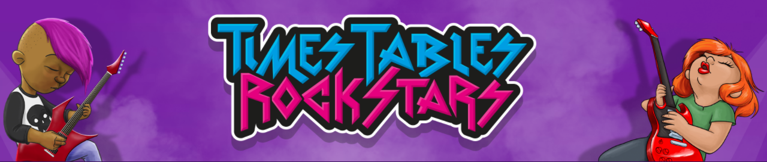

A big well done to all those who contributed in the TTRS battles which have been going on this week. Below are the results for the battles.

A special mention to Sen, David and Karolina who collected the highest number of coins over the last week. The winner of the entire tournament was Sen who has earned himself an Amazon £10 voucher! Many certificates, wristbands and Rock Hero badges were handed out again this week. Keep up the good work!

Over the last 2 weeks alone, students have provided over 1,171,843 correct answers!
Year 6 alone have contributed an astonishing 656,248 correct answers.
An incredible achievement. Keep up the great work

Results

Year 3

Year 4

Year 5

Year 6

New tournaments will be added next week (11.01.22).

Keep on rocking!

