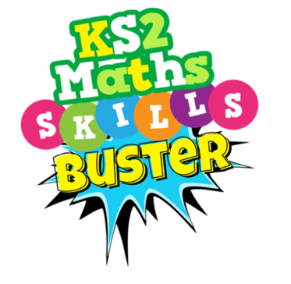

Dear Parents and Carers,

As part of Year 6 children’s ongoing revision, and in response to requests from parents at the open evening, we have made available a pack of Maths resources to help support every pupil on the lead-up to the official SATs in May (Monday 14th May – Thursday 17th May 2018). Included are topic boosters and past papers with video tutorials to help target specific weaknesses. The resources can be used on PCs, laptops, tablets and mobile phones via our school website.

Go to: http://www.olopprimary.co.uk/web/mathematics and click on the KS2 Maths Skills Buster PDF.

The pack, entitled ‘KS2 Maths Skills Buster, is a collection of Maths problems and previous SATs questions geared towards helping pupils to revise effectively through the completion of quick bite-sized tasks. Should pupils encounter difficulty in solving any of the questions, each short activity is accompanied by a brief video masterclass that will help support and strengthen their mathematical understanding.

All of these video tutorials are YouTube enabled and therefore link directly to the YouTube website. Despite diligent sampling by Year 6 staff, we regret that the absence and removal of ‘pop-ups’ and adverts on each of the 100+ videos cannot be guaranteed. Although unlikely, in the interests of safeguarding our children, we recommend parents oversee the use of a video tutorial prior to their child watching it. We appreciate your support with this. We hope and anticipate that all of our pupils will find the tasks and tutorials supportive.

Thank you for your continued support.

Yours sincerely,
Mr. O’Keeffe

