Our Lady of Peace Catholic Primary and Nursery School



**Year 6**

**Term: Lenten 2**

**Homework Booklet**

**Welcome to your homework booklet for this half term.**



In this booklet you will find six weeks’ worth of spellings. You need to learn these spellings carefully by using the look, say, cover and write method. You can also login to your **‘Spelling Shed’** account to practise your spellings. You then have some space at the bottom of the page to put each of your spelling words into a sentence.

Your teacher will test you on your spellings each week.



Login to your **‘Times Tables Rock Stars’** account to practise your times tables!

Your teacher will test you on your times tables each week.



Login to your ‘**Bug Club’** account for online reading challenges!

**Maths for Lenten Term 2**

 

In our History lessons, we will be studying **Ancient Egypt.**

For your project, you may choose to research famous people from Ancient Egypt, important moments in the history of Ancient Egypt, famous buildings from the period or any other aspect you care to investigate!

As always, limit your project to two pages and be as creative as possible.

**To be handed in: Monday 30th March 2020**

**BRAIN BUILDERS**

|  |
| --- |
| **Measurement Converting Units**  Solve problems involving the calculation and conversion of units of measure, using decimal notation up to three decimal places where appropriate.  Use, read, write and convert between standard units, converting measurements of length, mass, volume and time from a smaller unit of measure to a larger unit, and vice versa, using decimal notation to up to 3dp.  Convert between miles and kilometres.  **Measurement: Perimeter, Area and Volume**  Recognise that shapes with the same areas can have different perimeters and vice versa.  Recognise when it is possible to use formulae for area and volume of shapes.  Calculate the area of parallelograms and triangles.  Calculate, estimate and compare volume of cubes and cuboids using standard units, including cm3, m3 and extending to other units (mm3, km3) |

|  |
| --- |
| **Number: Ratio**  Solve problems involving the relative sizes of two quantities where missing values can be found by using integer multiplication and division facts.  Solve problems involving similar shapes where the scale factor is known or can be found.  Solve problems involving unequal sharing and grouping using knowledge of fractions and multiples. |



Log-in to your **‘My Maths’** account and, each week, complete the activity listed in the table below.

|  |  |  |  |  |  |
| --- | --- | --- | --- | --- | --- |
| Week Beginning:  24.02.20 | Week Beginning:  02.03.20 | Week Beginning:  09.03.20 | Week Beginning:  16.03.20 | Week Beginning:  24.03.20 | Week Beginning:  30.03.20 |
| Converting Measures | Units of Length | Units of Mass | Units of Capacity | Areas of Rectangles | Area of a Triangle |

**Additional Mathematics and English Homework**

Some parents may wish their children to undertake additional maths and English homework.

The school endorses the use of ‘Workabooks’, which are carefully planned to support children with their learning, consolidate classroom teaching and provide an organisational structure which will enable pupils to manage homework effectively with positive results. Parents can order and purchase these books directly from Workabook at [http://www.workabook.co.uk](http://www.workabook.co.uk/). Parents can access the answers to each activity through the Workabook website.

Please note that Workabooks are intended for home-use only. There is no requirement for children to bring their Workabooks into school.

A sample of the Workabooks can be viewed at the main school office or alternatively more information can be found at http://www.workabook.co.uk

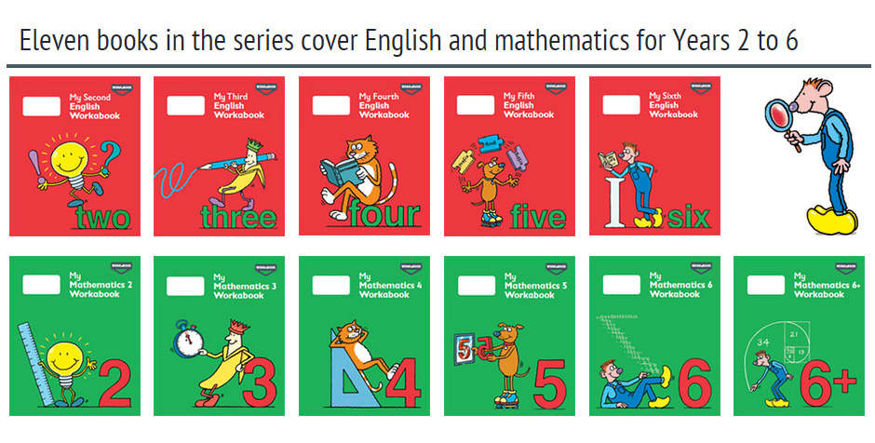

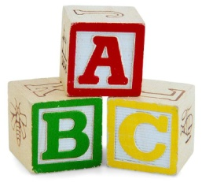[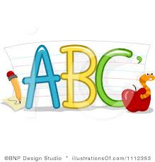](http://www.google.co.uk/imgres?q=clipart+abc&safe=active&hl=en&biw=1280&bih=827&tbm=isch&tbnid=5R_iloF6PLG7QM:&imgrefurl=http://www.illustrationsof.com/1112353-royalty-free-abc-clipart-illustration&docid=lRG4ss-PISLCDM&imgurl=http://www.illustrationsof.com/royalty-free-abc-clipart-illustration-1112353.jpg&w=400&h=420&ei=eJTmUaPgDuzn7AaIi4DoBg&zoom=1&iact=hc&vpx=368&vpy=270&dur=1516&hovh=230&hovw=219&tx=134&ty=135&page=1&tbnh=145&tbnw=138&start=0&ndsp=38&ved=1t:429,r:26,s:0,i:163)

**Spelling practise:** Look, say, cover, write, check

**Week 1**

Spellings

|  |  |  |  |  |  |  |
| --- | --- | --- | --- | --- | --- | --- |
| **Look** | **Say** | **Cover** | **Write** | **Check** | **Write** | **Check** |
| **example** |  |  | ***exampel*** | **🗶** | ***example*** | **✓** |
| official |  |  |  |  |  |  |
| special |  |  |  |  |  |  |
| artificial |  |  |  |  |  |  |
| social |  |  |  |  |  |  |
| racial |  |  |  |  |  |  |
| crucial |  |  |  |  |  |  |
| facial |  |  |  |  |  |  |
| beneficial |  |  |  |  |  |  |

**Sentence practise:** Now use your spellings in a sentence.

1)__________________________________________________________

2)__________________________________________________________

3)__________________________________________________________

4)__________________________________________________________

5)__________________________________________________________

6)__________________________________________________________

7)__________________________________________________________

8)__________________________________________________________

4.

5.

6.

7.

8.

|  |  |  |  |  |  |  |
| --- | --- | --- | --- | --- | --- | --- |
| **Look** | **Say** | **Cover** | **Write** | **Check** | **Write** | **Check** |
| **example** |  |  | ***exampel*** | **🗶** | ***example*** | **✓** |
| partial |  |  |  |  |  |  |
| confidential |  |  |  |  |  |  |
| essential |  |  |  |  |  |  |
| substantial |  |  |  |  |  |  |
| torrential |  |  |  |  |  |  |
| sequential |  |  |  |  |  |  |
| potential |  |  |  |  |  |  |
| spatial |  |  |  |  |  |  |

**[](http://www.google.co.uk/imgres?q=clipart+abc&safe=active&hl=en&biw=1280&bih=827&tbm=isch&tbnid=5R_iloF6PLG7QM:&imgrefurl=http://www.illustrationsof.com/1112353-royalty-free-abc-clipart-illustration&docid=lRG4ss-PISLCDM&imgurl=http://www.illustrationsof.com/royalty-free-abc-clipart-illustration-1112353.jpg&w=400&h=420&ei=eJTmUaPgDuzn7AaIi4DoBg&zoom=1&iact=hc&vpx=368&vpy=270&dur=1516&hovh=230&hovw=219&tx=134&ty=135&page=1&tbnh=145&tbnw=138&start=0&ndsp=38&ved=1t:429,r:26,s:0,i:163)**

Spellings

**Week 2**

**Spelling practise:** Look, say, cover, write, check

**Sentence practise:** Now use your spellings in a sentence.

1)__________________________________________________________

2)__________________________________________________________

3)__________________________________________________________

4)__________________________________________________________

5)__________________________________________________________

6)__________________________________________________________

7)__________________________________________________________

8)__________________________________________________________

1

2.

3.

4.

5.

6.

7.

8.

|  |  |  |  |  |  |  |
| --- | --- | --- | --- | --- | --- | --- |
| **Look** | **Say** | **Cover** | **Write** | **Check** | **Write** | **Check** |
| **example** |  |  | ***exampel*** | **🗶** | ***example*** | **✓** |
| cemetery |  |  |  |  |  |  |
| certificate |  |  |  |  |  |  |
| celebrate |  |  |  |  |  |  |
| necessary |  |  |  |  |  |  |
| deceased |  |  |  |  |  |  |
| December |  |  |  |  |  |  |
| sacrifice |  |  |  |  |  |  |
| hindrance |  |  |  |  |  |  |

**[](http://www.google.co.uk/imgres?q=clipart+abc&safe=active&hl=en&biw=1280&bih=827&tbm=isch&tbnid=5R_iloF6PLG7QM:&imgrefurl=http://www.illustrationsof.com/1112353-royalty-free-abc-clipart-illustration&docid=lRG4ss-PISLCDM&imgurl=http://www.illustrationsof.com/royalty-free-abc-clipart-illustration-1112353.jpg&w=400&h=420&ei=eJTmUaPgDuzn7AaIi4DoBg&zoom=1&iact=hc&vpx=368&vpy=270&dur=1516&hovh=230&hovw=219&tx=134&ty=135&page=1&tbnh=145&tbnw=138&start=0&ndsp=38&ved=1t:429,r:26,s:0,i:163)**

Spellings

**Week 3**

**Spelling practise:** Look, say, cover, write, check

**Sentence practise:** Now use your spellings in a sentence.

1)__________________________________________________________

2)__________________________________________________________

3)__________________________________________________________

4)__________________________________________________________

5)__________________________________________________________

6)__________________________________________________________

7)__________________________________________________________

8)__________________________________________________________

1

2.

3.

4.

5.

6.

7.

8.

|  |  |  |  |  |  |  |
| --- | --- | --- | --- | --- | --- | --- |
| **Look** | **Say** | **Cover** | **Write** | **Check** | **Write** | **Check** |
| **example** |  |  | ***exampel*** | **🗶** | ***example*** | **✓** |
| accommodate |  |  |  |  |  |  |
| accompany |  |  |  |  |  |  |
| access |  |  |  |  |  |  |
| accuse |  |  |  |  |  |  |
| accost |  |  |  |  |  |  |
| accommodate |  |  |  |  |  |  |
| accrue |  |  |  |  |  |  |
| accuracy |  |  |  |  |  |  |



**Week 4**

Spellings

**Spelling practise:** Look, say, cover, write, check

**Sentence practise:** Now use your spellings in a sentence.

1)__________________________________________________________

2)__________________________________________________________

3)__________________________________________________________

4)__________________________________________________________

5)__________________________________________________________

6)__________________________________________________________

7)__________________________________________________________

8)__________________________________________________________

2.

3.

4.

5.

6.

7.

8.

|  |  |  |  |  |  |  |
| --- | --- | --- | --- | --- | --- | --- |
| **Look** | **Say** | **Cover** | **Write** | **Check** | **Write** | **Check** |
| **example** |  |  | ***exampel*** | **🗶** | ***example*** | **✓** |
| signature |  |  |  |  |  |  |
| assign |  |  |  |  |  |  |
| design |  |  |  |  |  |  |
| designate |  |  |  |  |  |  |
| significant |  |  |  |  |  |  |
| signature |  |  |  |  |  |  |
| resignation |  |  |  |  |  |  |
| resign |  |  |  |  |  |  |



**Week 5**

**Spelling practise:** Look, say, cover, write, check

Spellings

**Sentence practise:** Now use your spellings in a sentence.

1)__________________________________________________________

2)__________________________________________________________

3)__________________________________________________________

4)__________________________________________________________

5)__________________________________________________________

6)__________________________________________________________

7)__________________________________________________________

8)__________________________________________________________

1

2.

3.

4.

5.

6.

7.

8.

**[](http://www.google.co.uk/imgres?q=clipart+abc&safe=active&hl=en&biw=1280&bih=827&tbm=isch&tbnid=5R_iloF6PLG7QM:&imgrefurl=http://www.illustrationsof.com/1112353-royalty-free-abc-clipart-illustration&docid=lRG4ss-PISLCDM&imgurl=http://www.illustrationsof.com/royalty-free-abc-clipart-illustration-1112353.jpg&w=400&h=420&ei=eJTmUaPgDuzn7AaIi4DoBg&zoom=1&iact=hc&vpx=368&vpy=270&dur=1516&hovh=230&hovw=219&tx=134&ty=135&page=1&tbnh=145&tbnw=138&start=0&ndsp=38&ved=1t:429,r:26,s:0,i:163)**

**Week 6**

Spellings 

**Spelling practise:** Look, say, cover, write, check

|  |  |  |  |  |  |  |
| --- | --- | --- | --- | --- | --- | --- |
| **Look** | **Say** | **Cover** | **Write** | **Check** | **Write** | **Check** |
| **example** |  |  | ***exampel*** | **🗶** | ***example*** | **✓** |
| foreign |  |  |  |  |  |  |
| apparent |  |  |  |  |  |  |
| appreciate |  |  |  |  |  |  |
| persuade |  |  |  |  |  |  |
| individual |  |  |  |  |  |  |
| language |  |  |  |  |  |  |
| sufficient |  |  |  |  |  |  |
| determined |  |  |  |  |  |  |

**Sentence practise:** Now use your spellings in a sentence.

1)__________________________________________________________

2)__________________________________________________________

3)__________________________________________________________

4)__________________________________________________________

5)__________________________________________________________

6)__________________________________________________________

7)__________________________________________________________

8)__________________________________________________________

2.

3.

4.

5.

6.

7.

8.