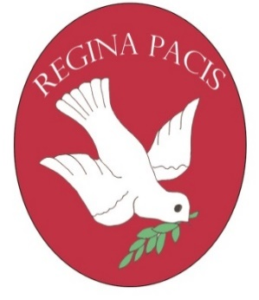 OFSTED Registration no: 110035 22th June 2020
Our Lady of Peace Out of School Club
Derwent Drive, Slough, SL1 6HW
Tel: 07932 721390

Dear Parents / Guardians
We are currently updating our records and need to confirm that you wish to continue using our Breakfast / After School Club in September 2020.

The cost per session is £4 for Breakfast Club and £12 (first child) & £10 (additional siblings) for After School Club. Please note that if you book a day for your child the session will still need to be paid for, regardless of use, as there is a very long waiting list of people desperate to take places. Attached is a ‘Terms of Use’ agreement which must be signed, dated and returned to ensure continued use of this service.

Please could you complete the slip below and return with the ‘Terms of Use’ agreement, to either the Breakfast Club or After School club no later than Friday 3 ^{rd} July 2020. Should you request any changes, we will endeavour to accommodate, where possible. If we do not hear back from you by the above date, we will presume you no longer require your place in September.

Thank you for your continued support.

Karen Brown
After School Club Manager

Name: ……………………………………………………………..

Class: ………………………………..

BREAKFAST CLUB (days they attend)
Monday | Tuesday | Wednesday | Thursday | Friday
BREAKFAST CLUB (days required )
Monday | Tuesday | Wednesday | Thursday | Friday

AFTER SCHOOL CLUB (days they attend)
Monday | Tuesday | Wednesday | Thursday | Friday
AFTER SCHOOL CLUB (days required)
Monday | Tuesday | Wednesday | Thursday | Friday
(These sessions will need to be paid for, regardless of attendance)

Signed:____________________________ parent/guardian Date:______________________

